**FPT ACADEMY INTERNATIONAL**



**FPT – APTECH COMPUTER EDUCATION**

**MOONBAY HOTEL**

|  |  |  |
| --- | --- | --- |
| **Supervisor.** | **Lê Mộng Thúy** | |
| **Batch.** | **T1.2406.E1** | |
| **Group.** | **2** | |
| **Serial No.** | **Student Name** | **Enrollment Number** |
| **1** | **ĐỖ THANH HÙNG** | Student1574909 |
| **2** | **PHÙ VĨNH HUY** | Student1571989 |
| **3** | **LÊ QUỐC ĐẠT** | Student1571990 |
| **4** | **NGÔ TRƯỜNG LONG** | Student1513437 |

Month 04 Year 2025

CONTENT

REVIEW 1 3

ACKNOWLEDGE 3

INTRODUCTION 3

PROBLEM DEFINITION 4

CUSTOMER'S REQUIREMENTS SPECIFICATIONS (CRS) 4

CLIENT: 5

TASK SHEET REVIEW 1 9

REVIEW 2 10

1. DATA FLOW DIAGRAM (DFD) 10
2. ENTITY PROPERTIES 26
3. TABLE DESIGN 32
4. TASK SHEET REVIEW 2 38

REVIEW 3 39

1. SITE MAP 40
2. MOONBAY HOTELS WIREFRAME 43
3. MOONBAY HOTELS SCREENSHOT 59
4. TASK SHEET REVIEW 371

# REVIEW 1

## ACKNOWLEDGE

Our group would like to devote this chapter to express our sincere appreciation to all those who offered us valuable assistance during in carrying out this Project.

Firstly, we owe a debt of gratitude to our dedicated instructor, MS. Le Mong Thuy, whose suggestions and encouragement helped us to overcome not only technological challenges but also psychological tension. Without him, our work could not complete successfully.

Secondly, we highly appreciate the Project Team at the Head Office, which has provided us an excellent opportunity to apply what we learned into practice. We are certain that the experiences we gained from this project will facilitate our future career greatly.

Thirdly, we would also like to express my gratitude to all the staff members of my center for not only providing me with the opportunity to work with them on this project, but also for their support and encouragement throughout the process.

Finally yet importantly, we wish to say a personal thank you to all our dear classmates and team members who are always willing to support us openly and enthusiastically.

## INTRODUCTION

**Moonbay Hotel – Easy Booking, Perfect Stay!** Welcome to the official website of Moonbay Hotel, a hospitality brand with 9 branches across Vietnam – from serene beaches to vibrant city centers. Our smart online booking platform offers you a fast, convenient, and fully flexible reservation experience – anytime, anywhere, with just a few clicks.

Whether you're traveling for leisure or business, our website lets you explore detailed room information, amenities, real images, and transparent pricing. With a flexible search system, you can filter rooms by location, date, budget, and personal preferences. All bookings are processed securely, with 24/7 support and instant confirmation**. Moonbay – your ideal stay begins with the convenience of our online booking experience.**

For Moonbay hotel’s customer base:

• Unregistered visitors can register for a member account.  
• Registered visitors can log in and manage their personal account information.  
• Visitors can search for hotel branches by location across Vietnam.  
• Visitors can search rooms by date, price range, and room type.  
• Visitors can view detailed room descriptions, amenities, and real images before booking.

• Visitors can select and reserve rooms by adding them to their booking cart.  
• Visitors can view their current and past booking history.  
• Visitors can proceed to secure and instant checkout.  
• Visitors can review, modify, or cancel upcoming bookings (according to hotel policy).  
• Visitors can contact the hotel for inquiries or feedback via the "Contact Us" function.

## PROBLEM DEFINITION

After analyzing the project specifications of Moonbay Hotel, and to properly meet the requirements of modern customers, we concluded that to achieve optimal functionality and user experience, the system should address the following queries::

**FROM THE VIEW POINT OF VISITORS**

• A homepage will highlight hotel branches, featured rooms, promotions, and display a consistent logo across all pages.  
• A navigation header and footer will include all available functionalities of the website.  
• Visitors can search for branches, view room details, check availability, and make online reservations.  
• Registered visitors can log in, manage their profile, view booking history, cancel or modify upcoming bookings, and receive promotional emails or member-only offers.

**FROM THE VIEW POINT OF THE ADMINISTRATOR**

• An admin login page will provide access to the Moonbay Hotel management panel.  
• Admin can view, add, update, delete, and manage hotel branches and room types.  
• Admin can view, search, lock/unlock, or delete customer accounts.  
• Admin can view, update, cancel, or manage booking orders.  
• Admin can manage registered user accounts, including updating details or resetting passwords.  
• Admin can send newsletters or promotional campaigns to subscribed users.  
• Admin can register and assign roles to hotel staff or customer service representatives.

**CUSTOMER'S REQUIREMENTS SPECIFICATIONS (CRS) CLIENT: MOONBAY HOTEL**

**BUSINESS/PROJECT OBJECTIVE:**

The objective of the Moonbay Hotel website project is to create an easy-to-use online booking system that enhances customer experience and streamlines hotel management across all 9 branches. The platform will enable users to book rooms, manage reservations, and allow administrators to oversee operations efficiently..

**INPUT TO THE SYSTEM:**

**Moonbay Hotels administrators need to provide:**

* Information required to create admin accounts for accessing the hotel management system.
* Details of hotel branches, room types, and availability that will be displayed on the website.
* Payment methods and pricing for room bookings, as well as any applicable discounts or promotions.
* Information required to create staff accounts within the admin system, including roles and responsibilities.

**Customers Moonbay Hotels need to provide:**

* Personal information for booking rooms (name, contact details, etc.).
* Email information to receive promotional offers, newsletters, or booking confirmations.

**OUTPUT FROM THE SYSTEM:**

**Moonbay Hotels administrators will be able to:**

* Login/Logout to the admin system.
* Manage (view, add, update, delete, hide) hotel branches, room types, availability, and pricing.
* Manage (view, add, update, delete, find, lock, unlock) customer accounts.
* Manage (view, add, update, delete) news and promotions.
* Manage (view, add, update) bookings and orders.

**Moonbay Hotels guests will be able to:**

* Register customer account.
* Book rooms after entering personal and payment informatio.
* View rooms and bookings that they have selected.
* View booking history.

**Moonbay Hotels customer will be able to:**

* Register account.
* Login/Logout to the account.
* Search for rooms by name, price, or other filters.
* Add rooms to the cart and proceed to checkout.
* View booking history.

**SCOPE OF WORK**

The application should perform the following functions:

**LOGIN:**

• There are 3 types of accounts in the system: **admin**, **staff**, and **inspector**.  
 – Administrator logs in as **admin**.  
 – Hotel staff logs in as **staff**.  
 – Supervisor or auditor logs in as **inspector**.

**For “admin”:**

• Can view, add, update, and delete information related to hotel branches, room types, availability, and pricing.  
• Can view customer information (ID, name), add new customers, update details, delete, lock, and unlock accounts.  
• Can view and manage news and promotional content.  
• Can view and manage room bookings and reservation records.  
• Can assign roles and manage staff accounts.

**For “staff”:**

• Can perform similar tasks as admin but limited to **view**, **add**, and **update** only.  
• Cannot delete data, or lock/unlock customer accounts.  
• Cannot manage staff or admin-level settings.

**For “inspector”:**

• Can only view the admin dashboard and hotel data for monitoring purposes.  
• Cannot add, update, or delete any data.

**ORDERING ROOMS:**

• When a customer selects a room, the chosen room will be added to the booking cart.  
• Customers can book rooms from the booking cart by clicking the “Checkout” button and filling in the required information.

**DATABASE:**

• Information about rooms, customers, news, and reservations will be stored in the database.  
• Data submitted from the “Contact Us” page will also be saved in the database.

**HARDWARE/ SOFTWARE REQUIREMENTS:**

**HARDWARE**

**Web Server**

|  |  |
| --- | --- |
| **Processor** | Intel Core I7 or higher. |
| **Memory** | 32 GB RAM or greater. |
| **Modem/ADSL** | Internet access is required. |

**Client**

|  |  |
| --- | --- |
| **Processor** | Intel Core I5 or higher. |
| **Memory** | 8 GB RAM or greater. |
| **Monitor** | Super VGA (1024x768) or higher resolution. |
| **Modem/ADSL** | Internet access is required. |

**SOFTWARE**

**Web Server**

|  |  |
| --- | --- |
| **Operation System** | Window 7 or later. |
| **Browser** | Google Chrome version 35. |
| **Database** | MySQL. |
| **Software** | Internet Information Service |
| PHP - Laravel framework |

**Client**

|  |  |
| --- | --- |
| **Operation System** | Window 7 or higher. |
| **Browser** | Google Chrome version 35. |

**DEVELOPMENT SOFTWARE**

* Microsoft Windows 10.
* MySQL.
* Visual Studio Code.
* Google Chrome.
* XAMPP.

**TECHNOLOGY**

* PHP - Laravel framework.
* JQuery.
* Javascript.
* HTML/CSS/Bootstrap.
* React

## TASK SHEET REVIEW 1

|  |  |  |  |  |  |  |  |  |  |  |
| --- | --- | --- | --- | --- | --- | --- | --- | --- | --- | --- |
| **Project: Moonbay Hotels** | | **Project Name** | **Activity Plan Prepared By** | | **Date of Preparation of Activity Plan:** | | | | | |
| **Sr./No.** | **Task** | **Actual Start Date** | **Actual Days** | **Team member name** | **Status** | | |
| **1** | **Acknowledgment** | **Moonbay Hotels** | Hùng | | 22-Apr-  25 | 1 | Huy | Completed | | |
| **2** | **Introduction** | 22-Apr-  25 | 1 | Đạt | Completed | | |
| **3** | **Problem Definition** | 22-Apr-  25 | 1 | Long | Completed | | |
| **4** | **Customer Requirement Specification (CRS)** | 22-Apr-  25 | 1 | Hùng/Huy | Completed | | |
| **5** | **Scope of Work** |  |  | | 22-Apr-  25 | 1 | Đạt/Long | Completed | |
| **6** | **Hardware/Software Requirement** | 22-Apr-  25 | 1 | Huy/Đạt | Completed | |
| **7** | **Task Sheet** | 22-Apr-  25 | 1 | Hùng | Completed | |
| Date: 22 APRIL 2025 | | | | | | | | |  |
| **Signature of Instructor:**  **Ms. LE MONG THUY** | | | | **Signature of Team Leader:**  **ĐỖ THANH HÙNG** | | | | |  |

# REVIEW 2

## DATA FLOW DIAGRAM (DFD)

**LEVEL 0**

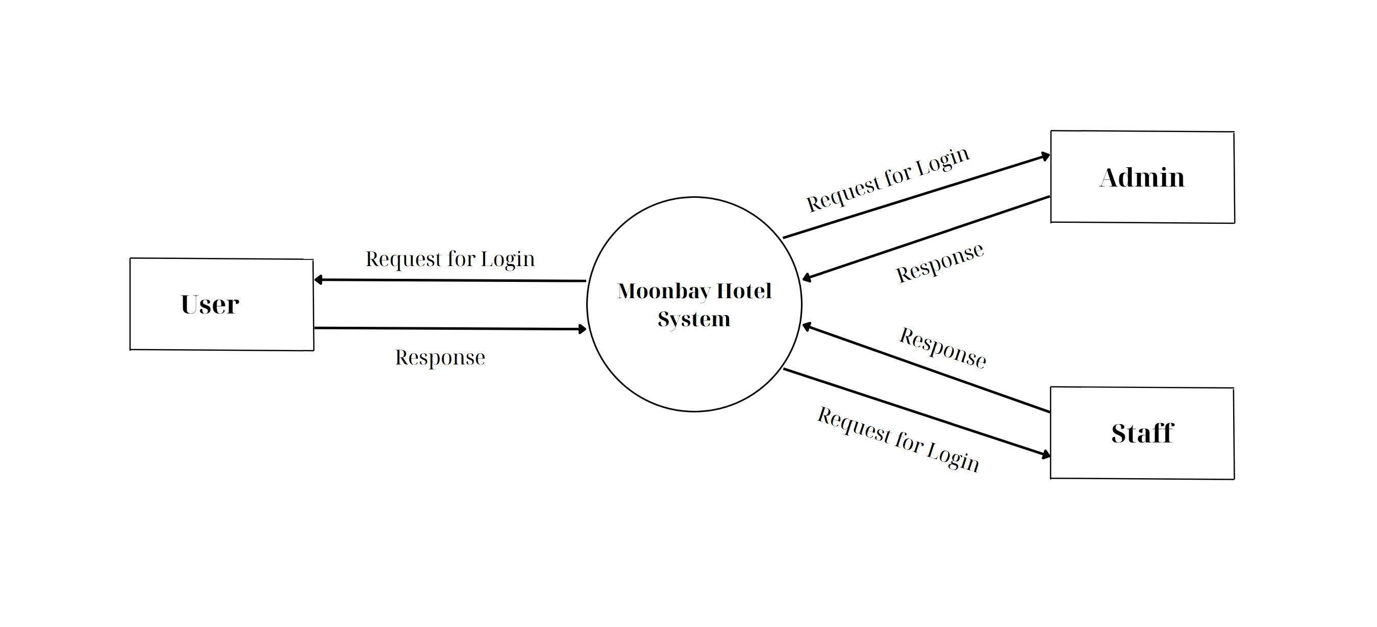

**ADMINSIDE LEVEL 1**

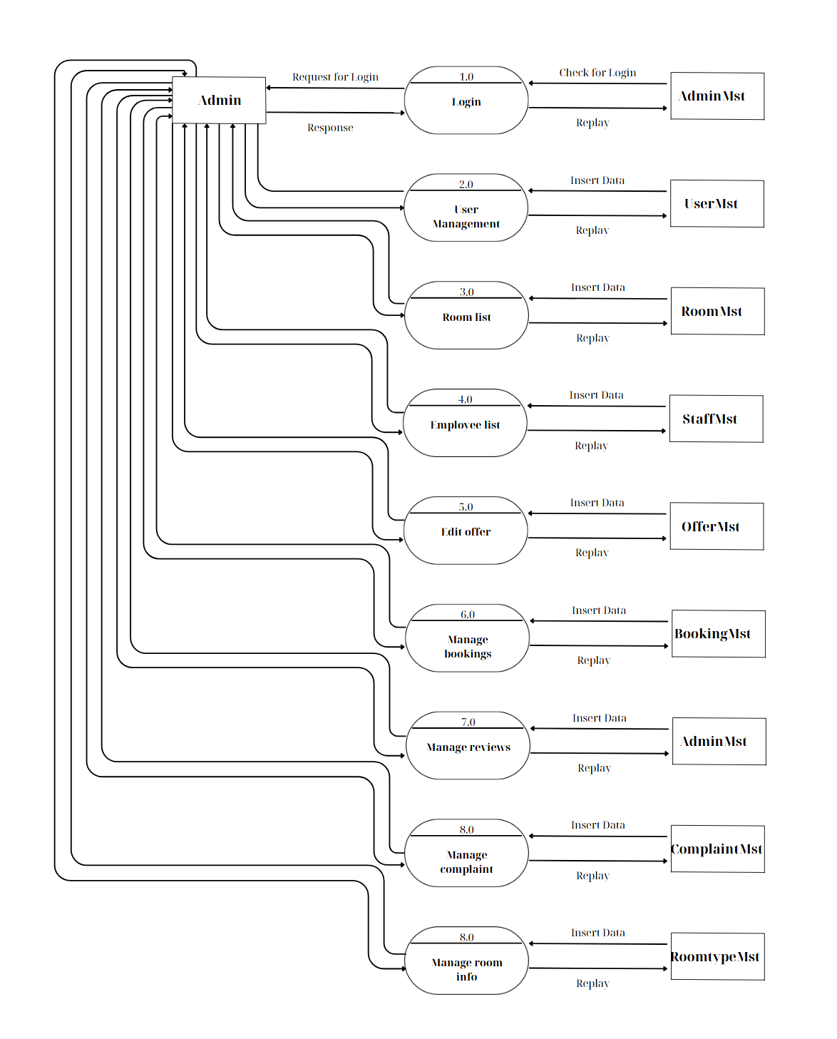

**ADMINSIDE LEVEL 2**

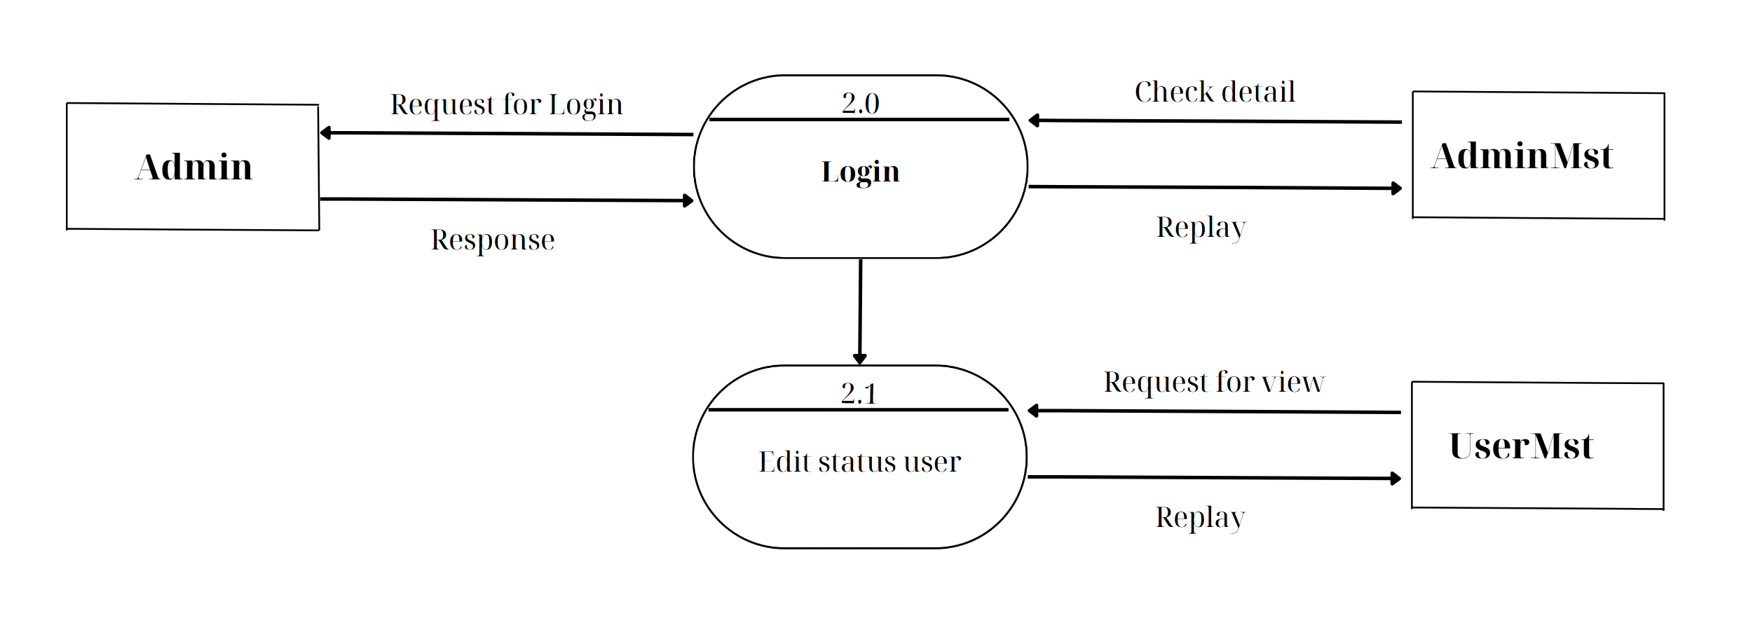

**ADMINSIDE LEVEL 3**

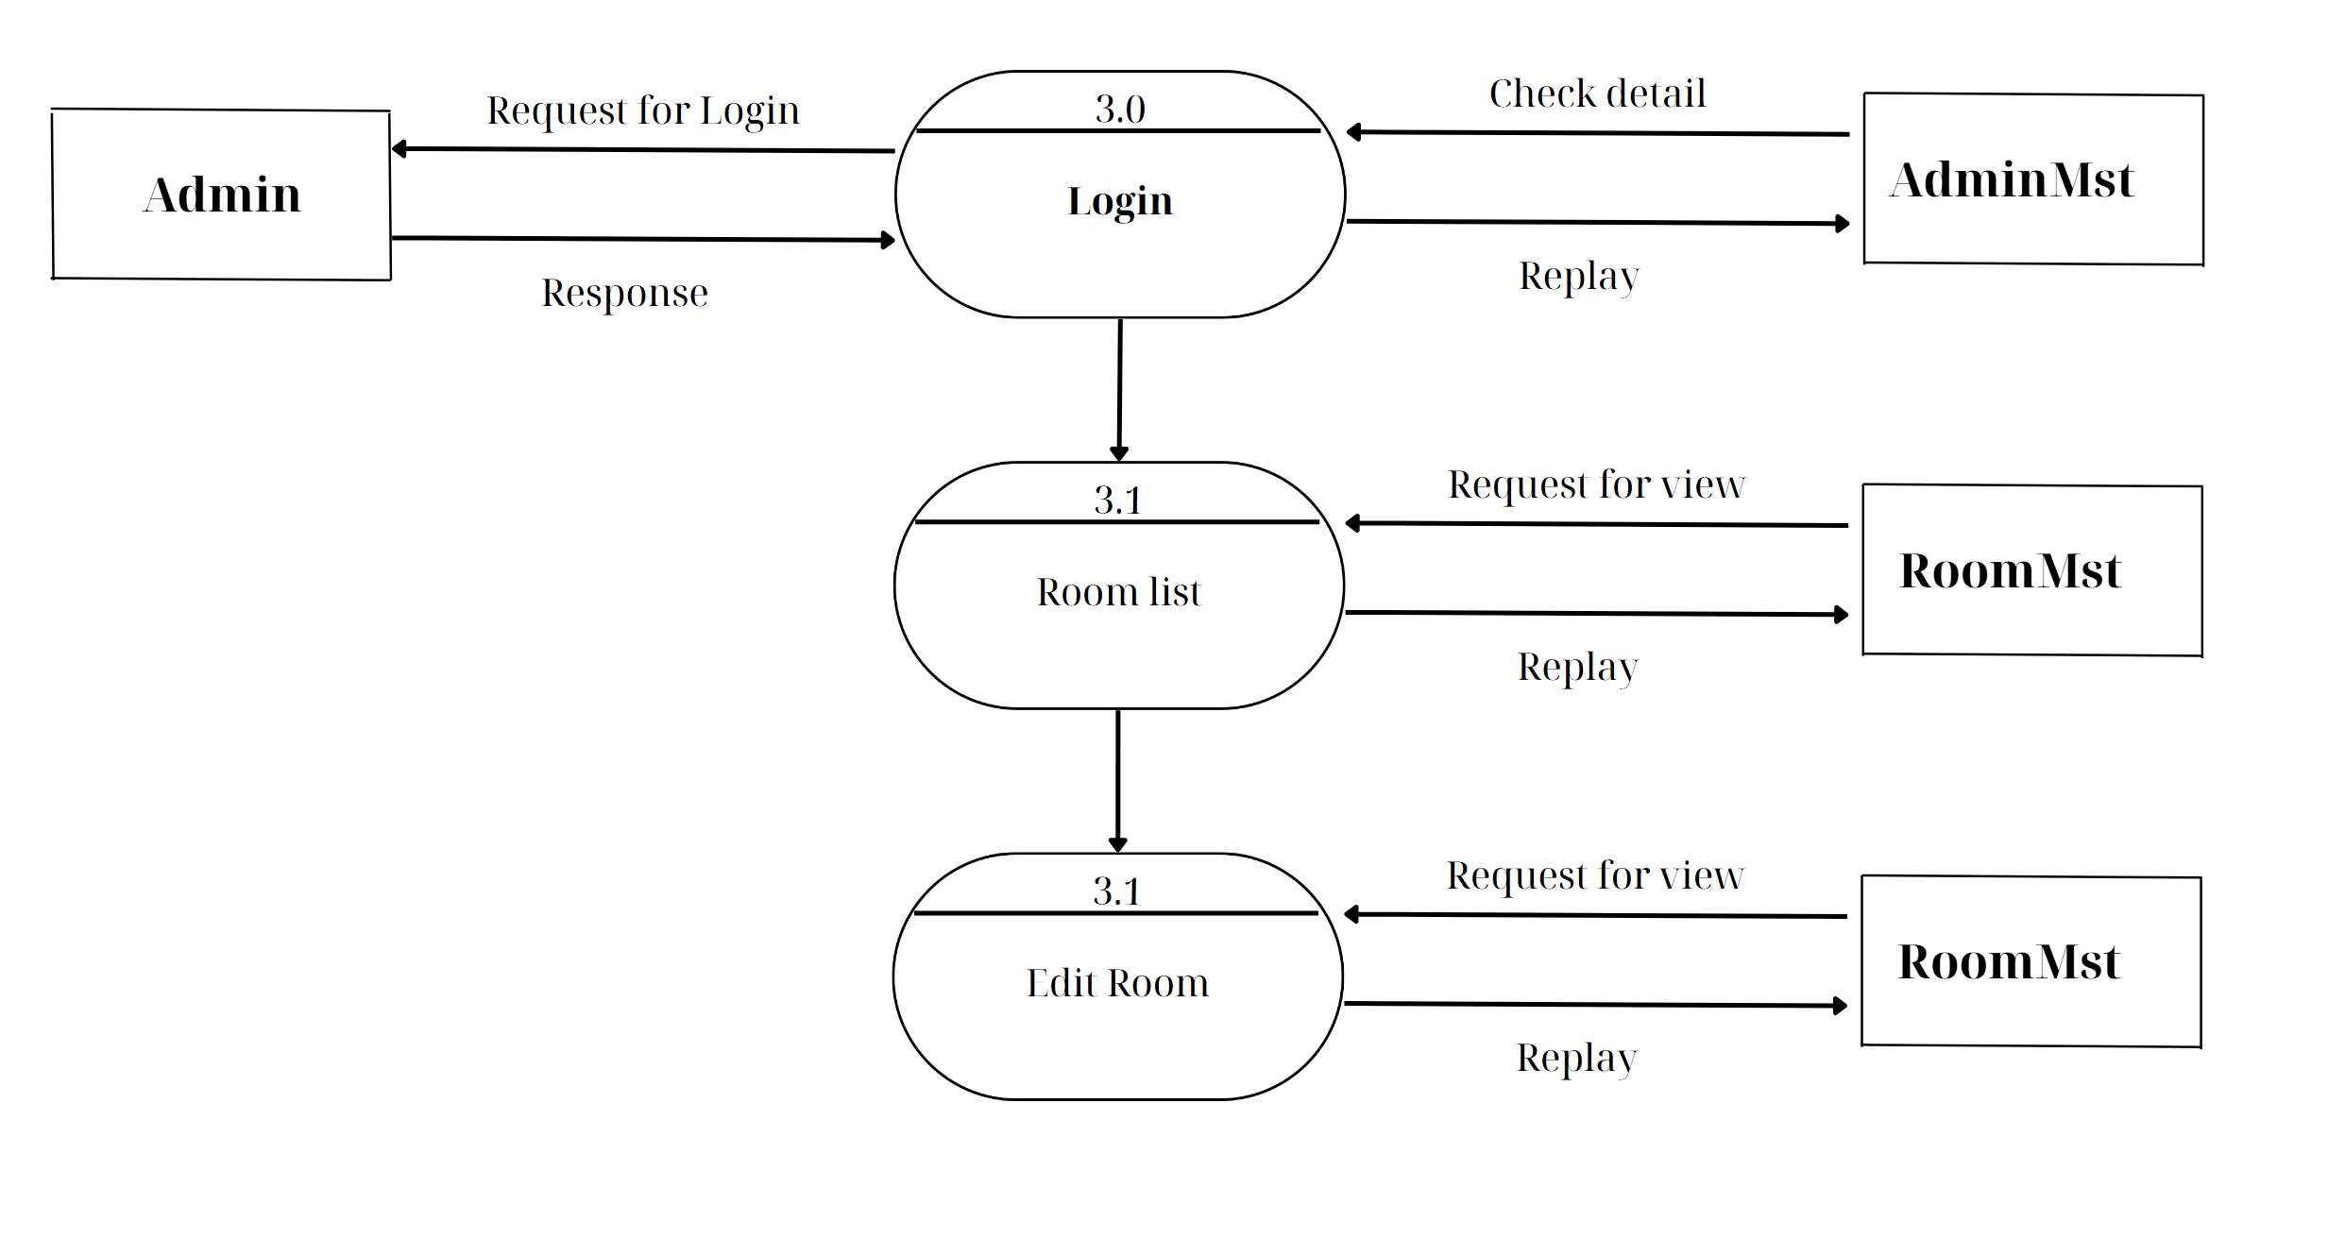

**ADMINSIDE LEVEL 4**

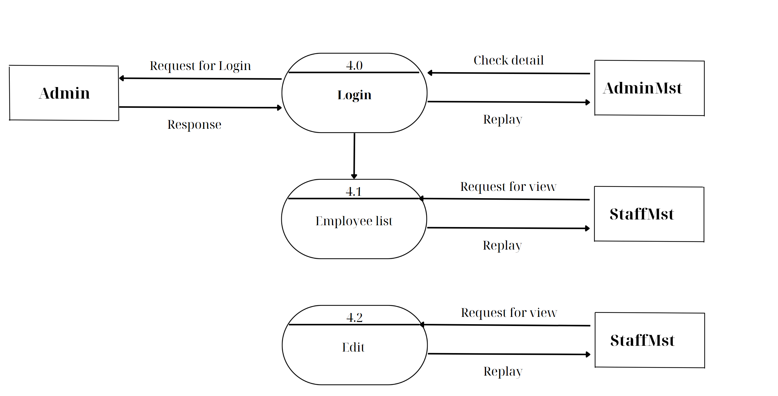

**ADMINSIDE LEVEL 5**

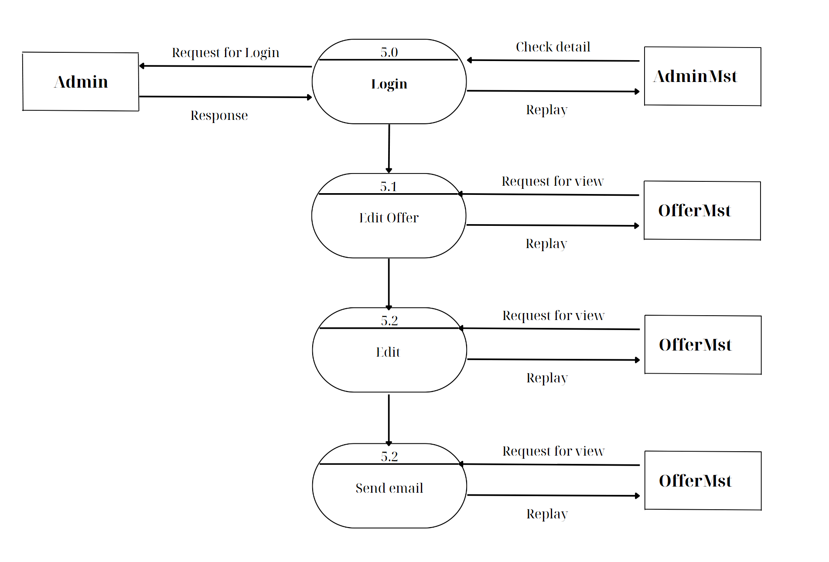

**ADMINSIDE LEVEL 6**

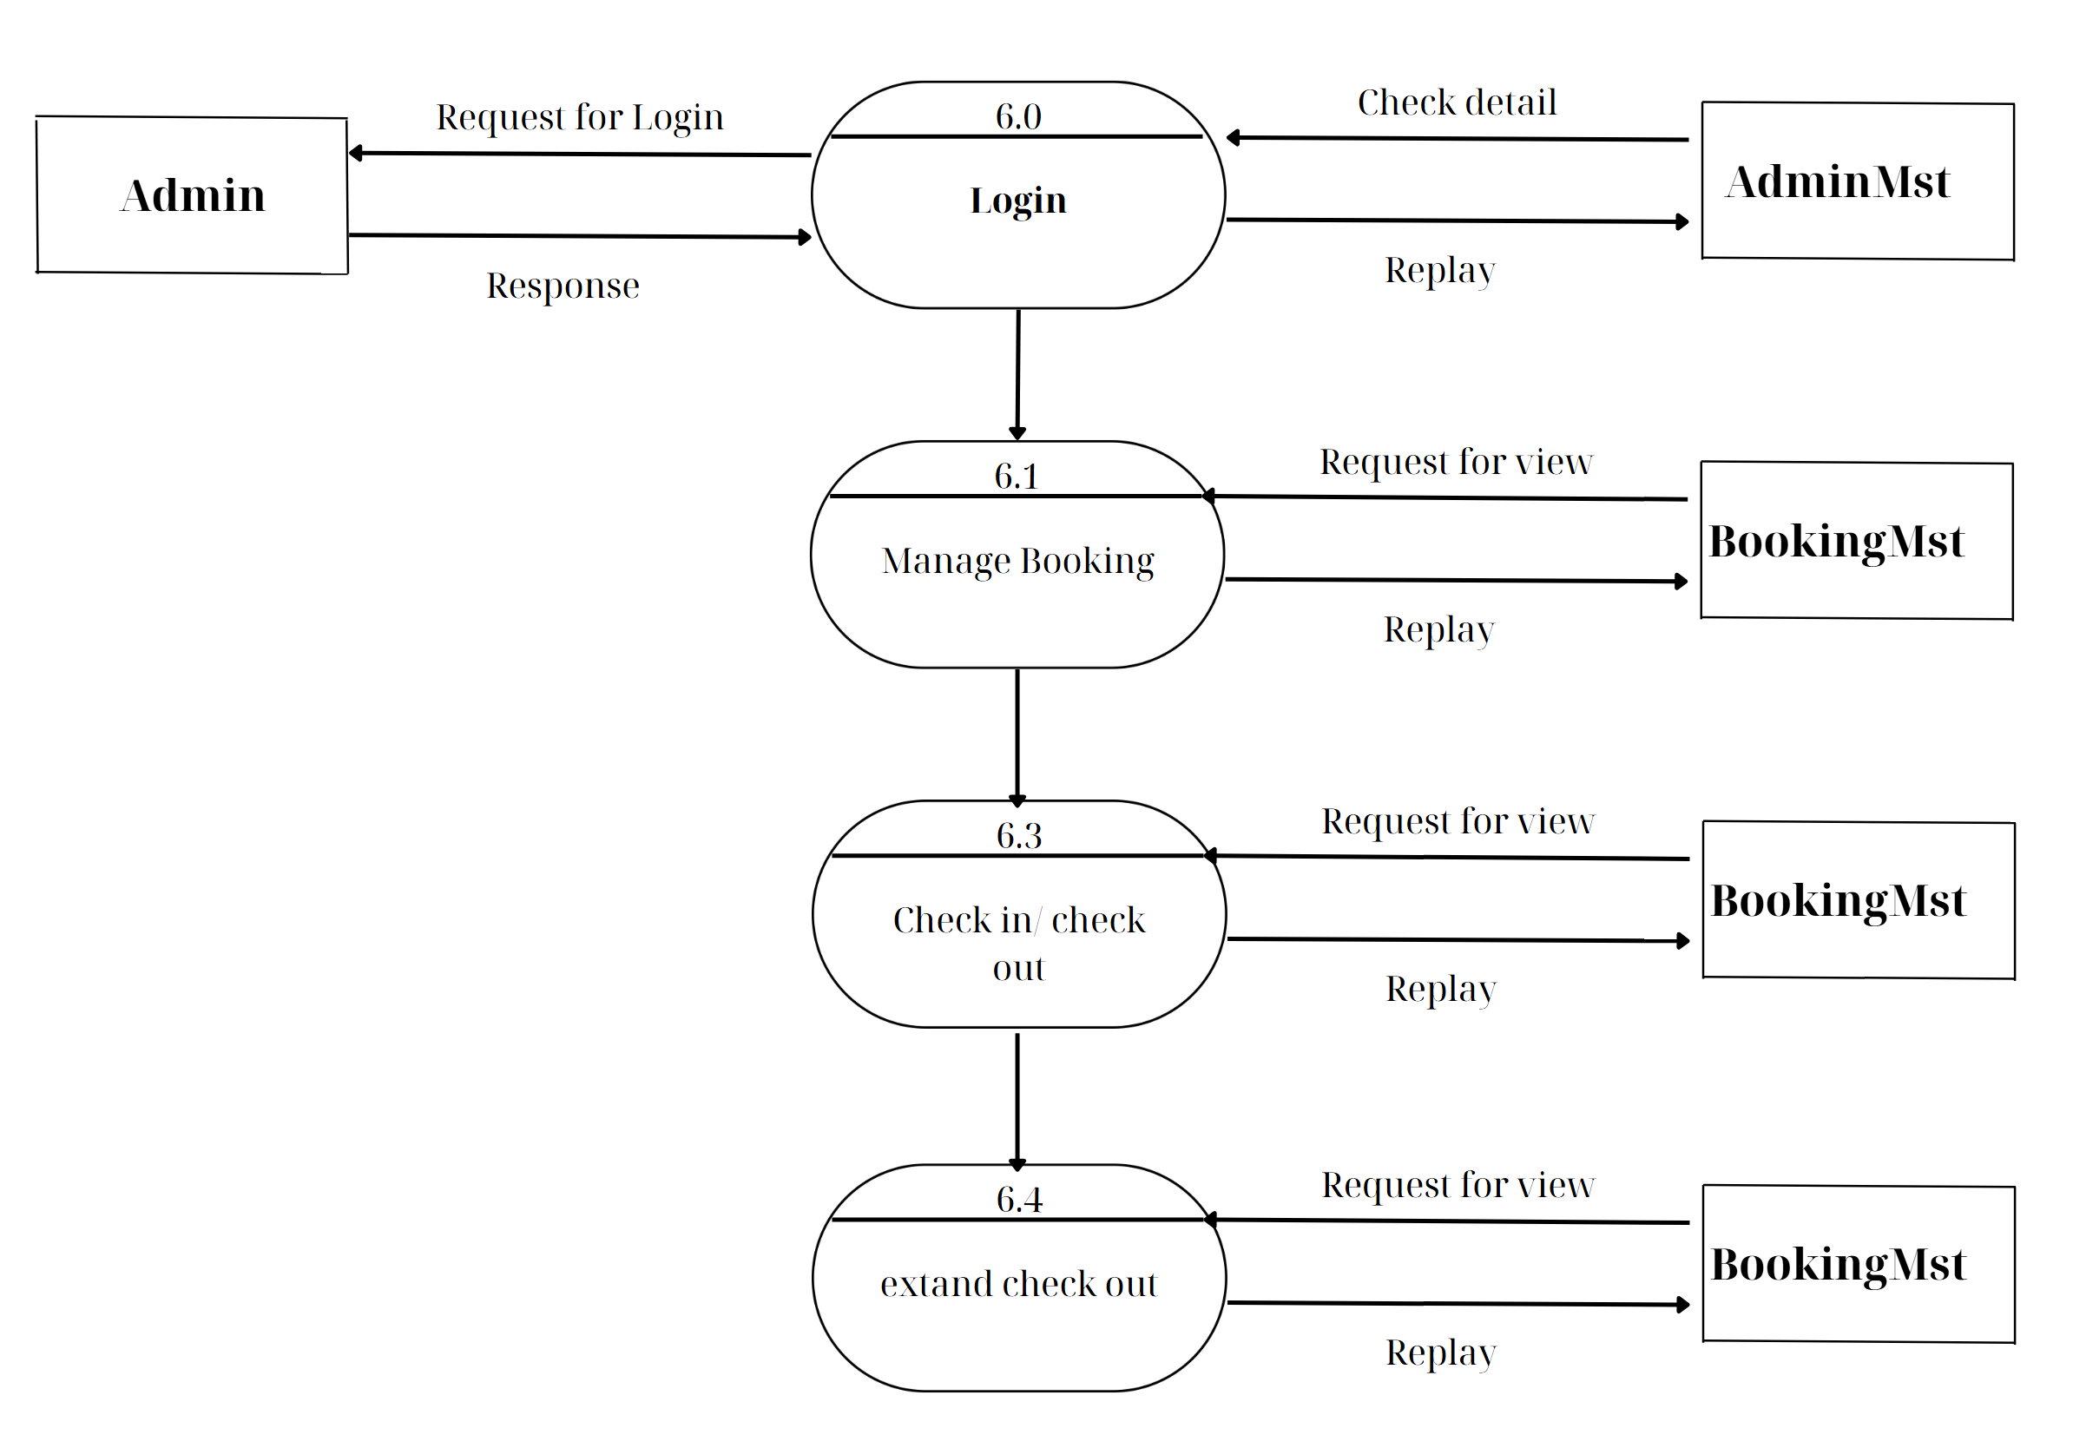

**ADMINSIDE LEVEL 7**

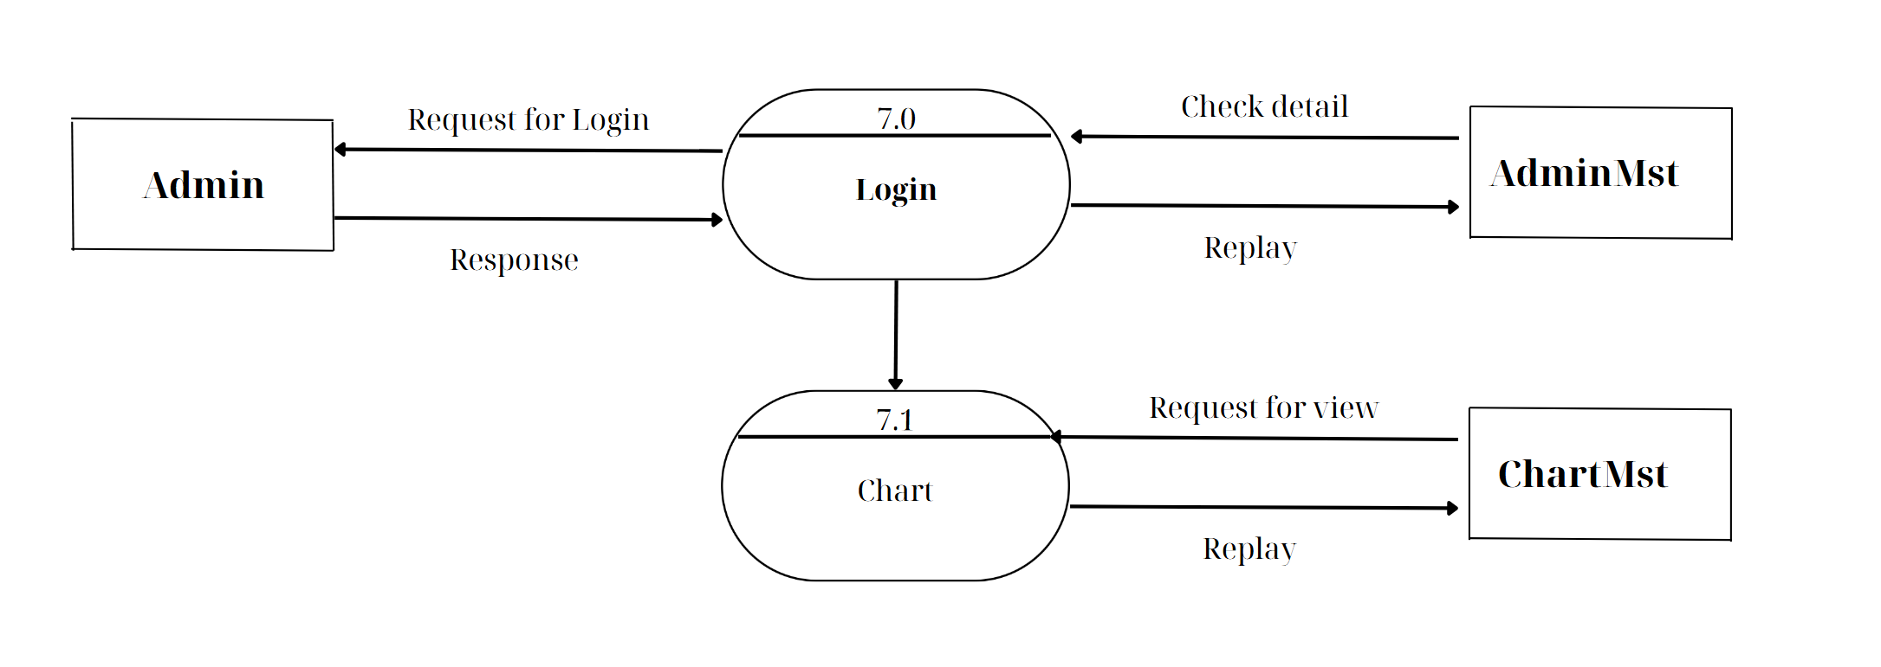

**ADMINSIDE LEVEL 8**

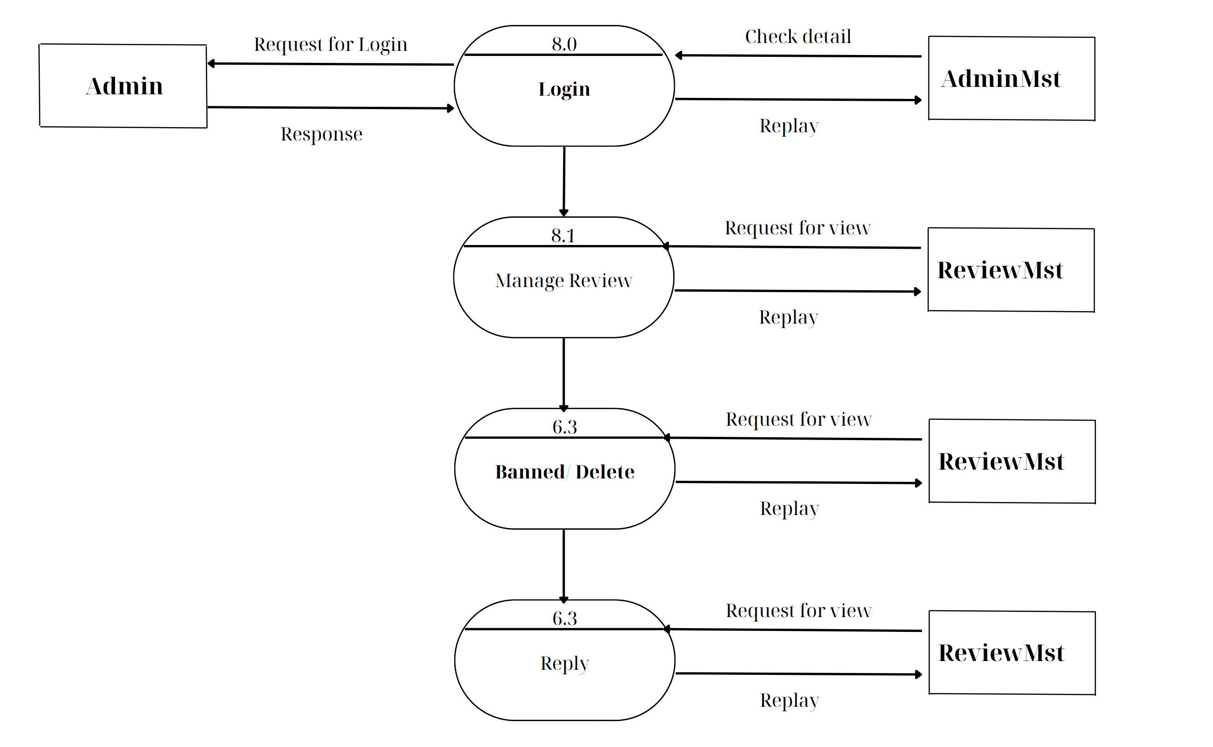

**ADMINSIDE LEVEL 9**

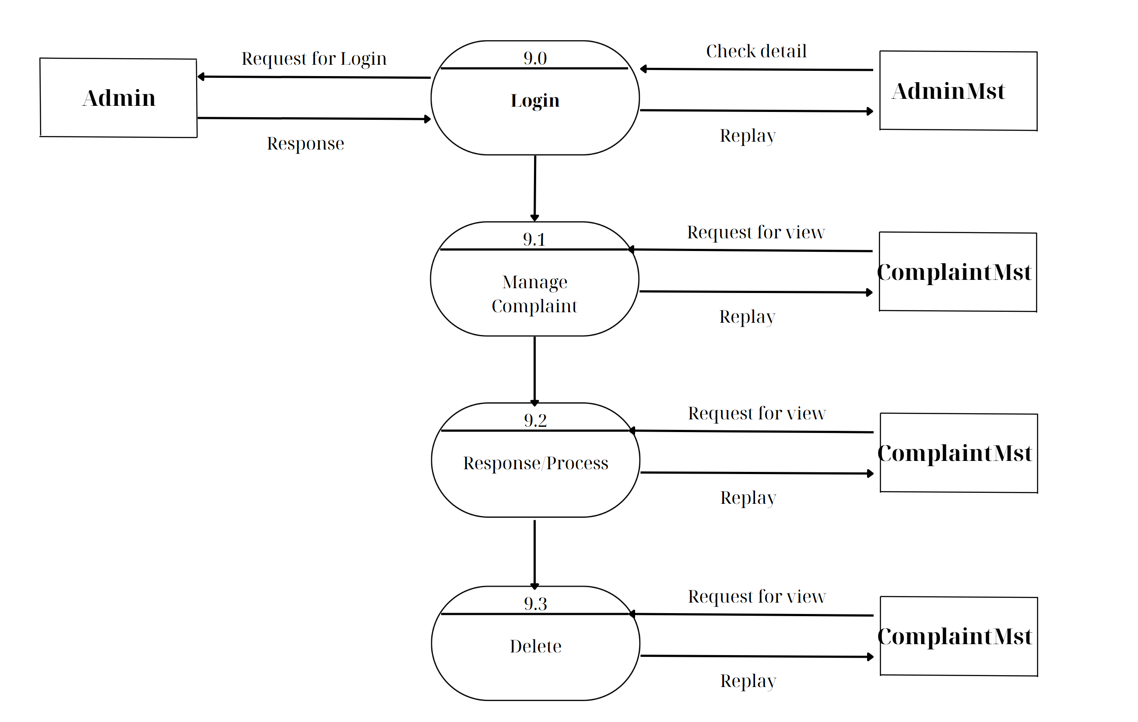

**ADMINSIDE LEVEL 10**

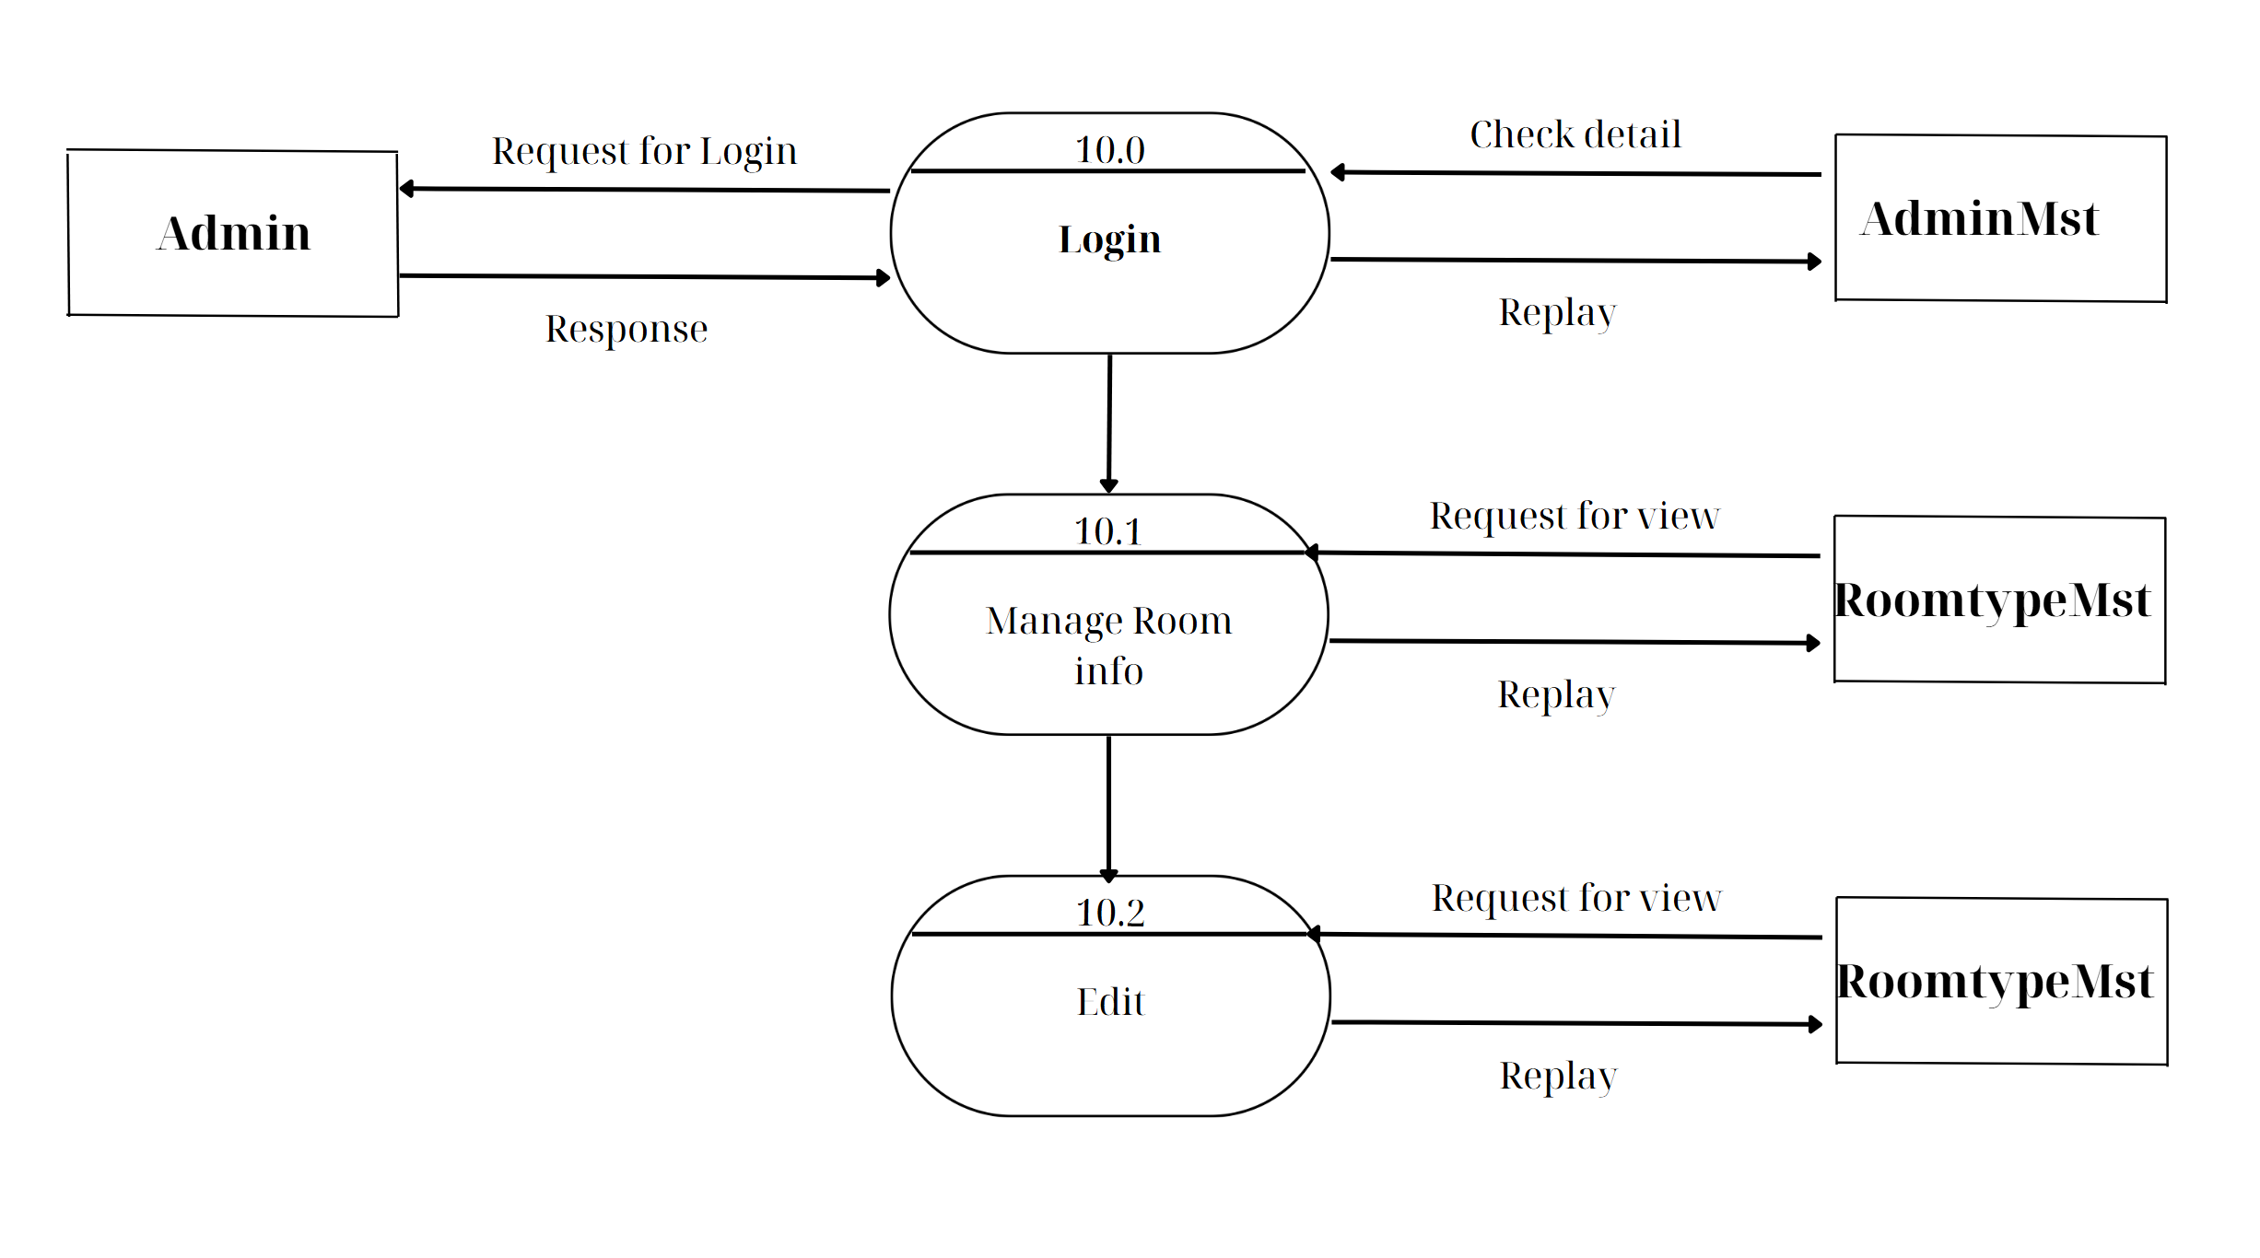

**USERSIDE LEVEL 1**

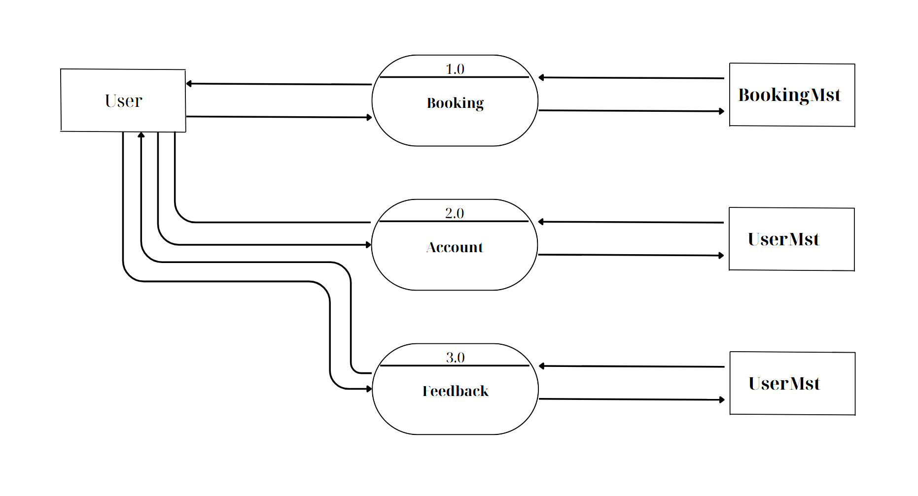

**USERSIDE LEVEL 2**

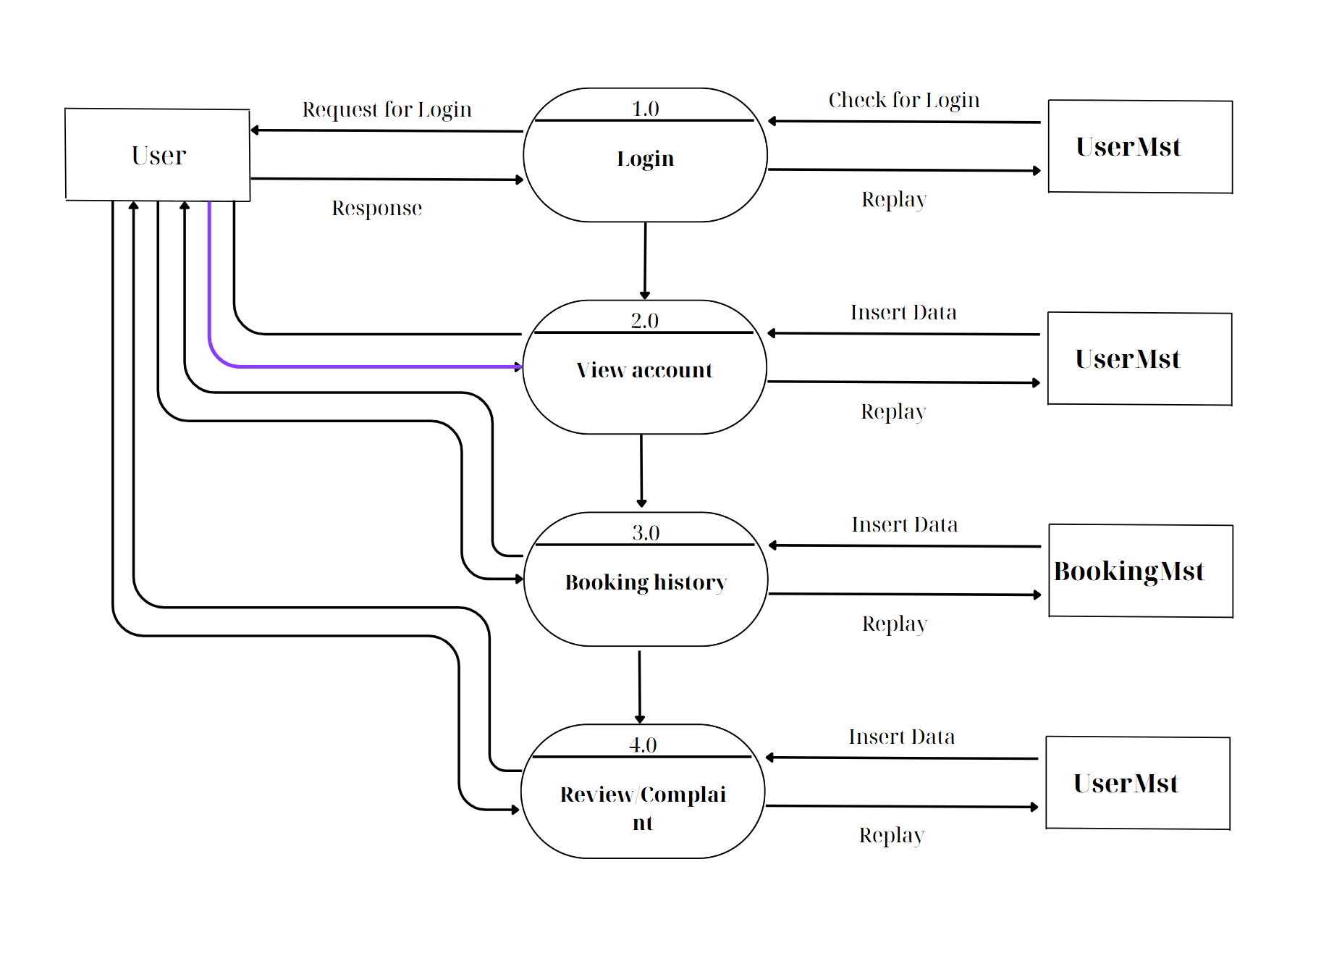

**STAFFSIDE LEVEL 1**

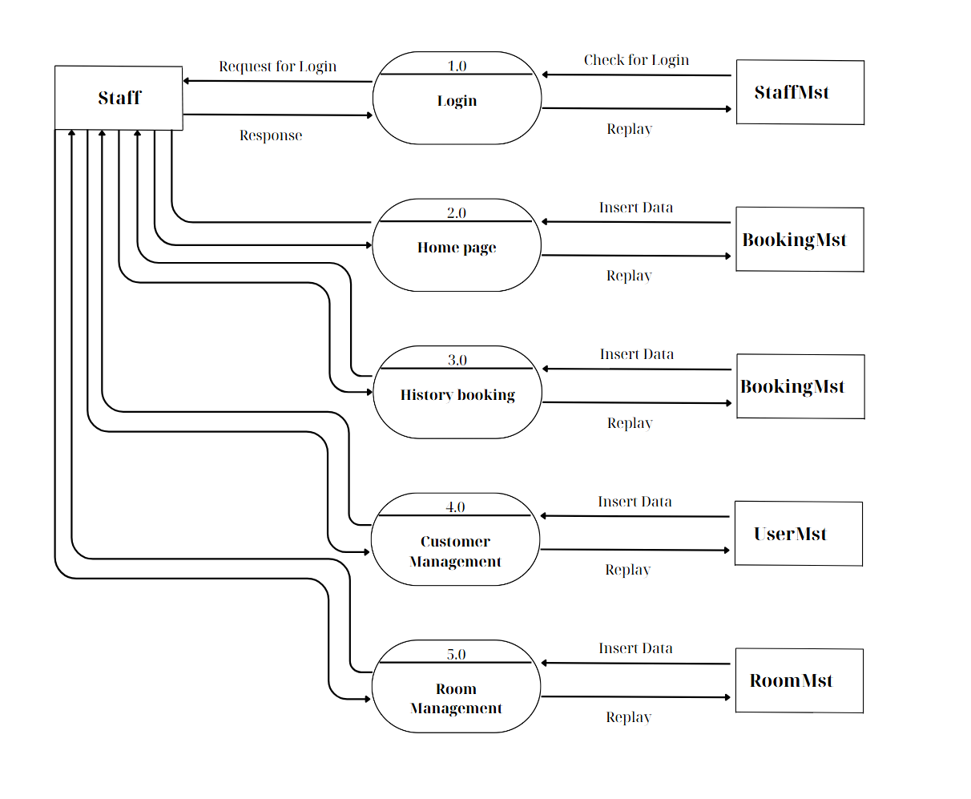

**STAFFSIDE LEVEL 2**

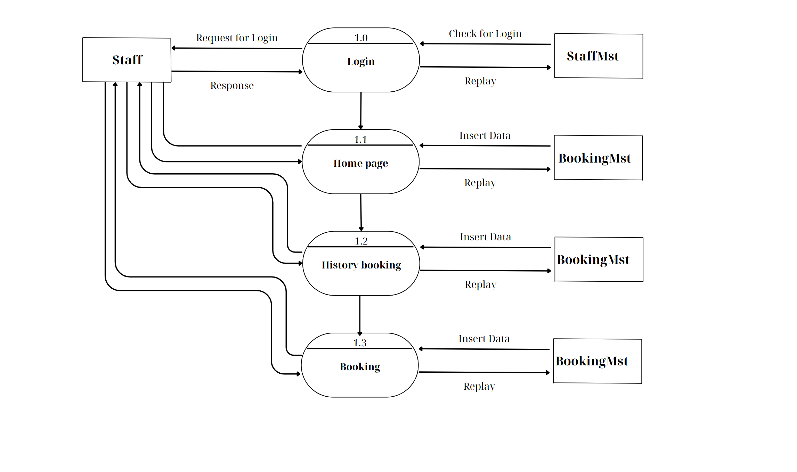

**STAFFSIDE LEVEL 3**

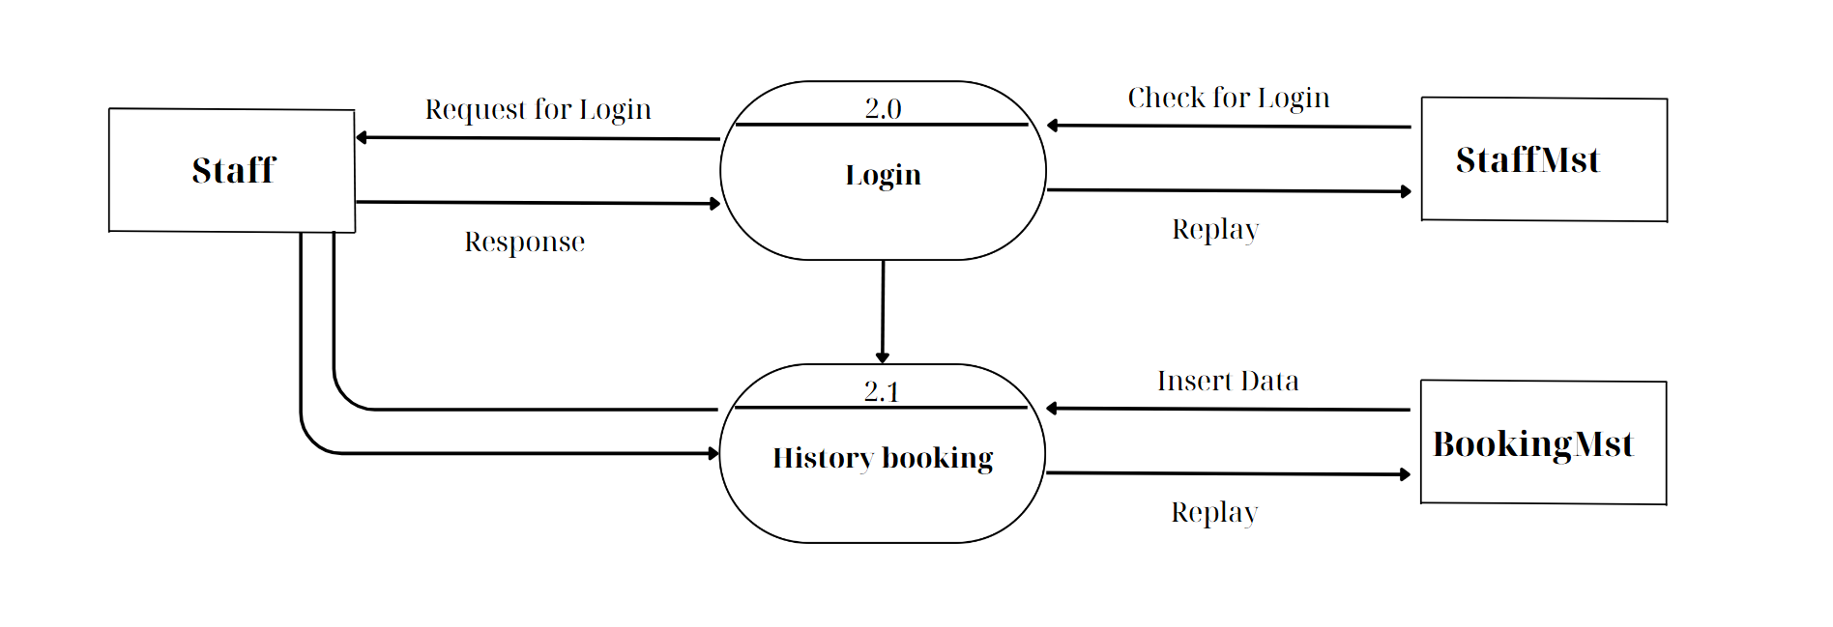

**STAFFSIDE LEVEL 4**

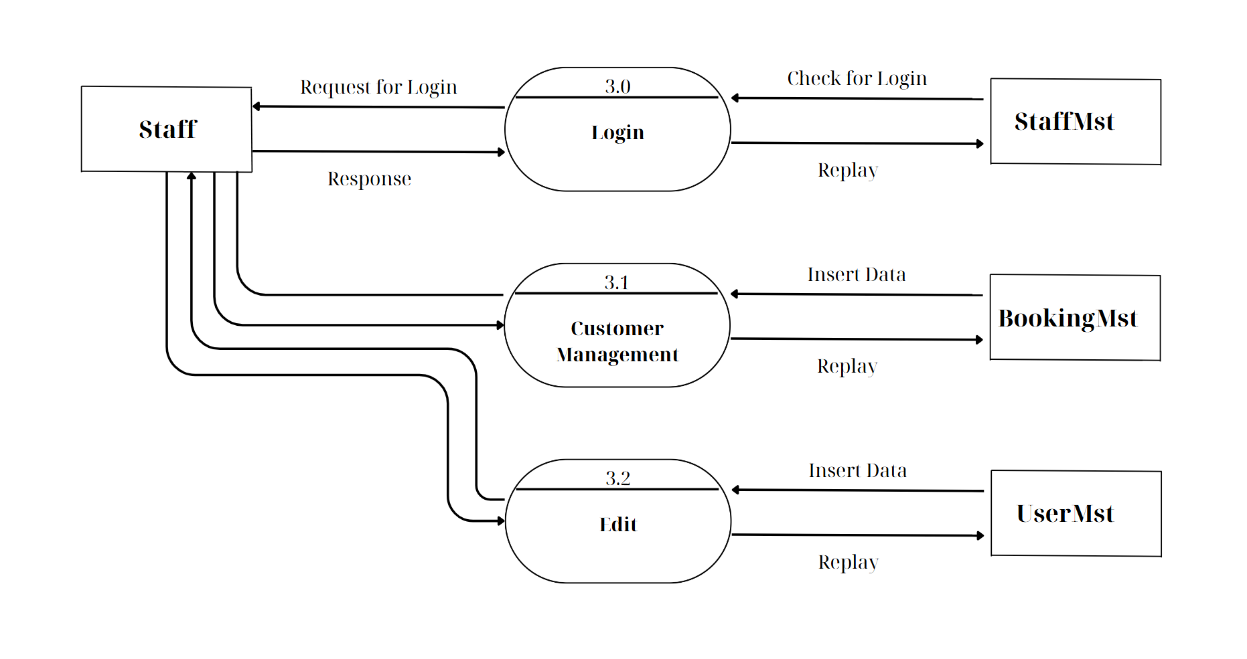

**STAFFSIDE LEVEL 5**

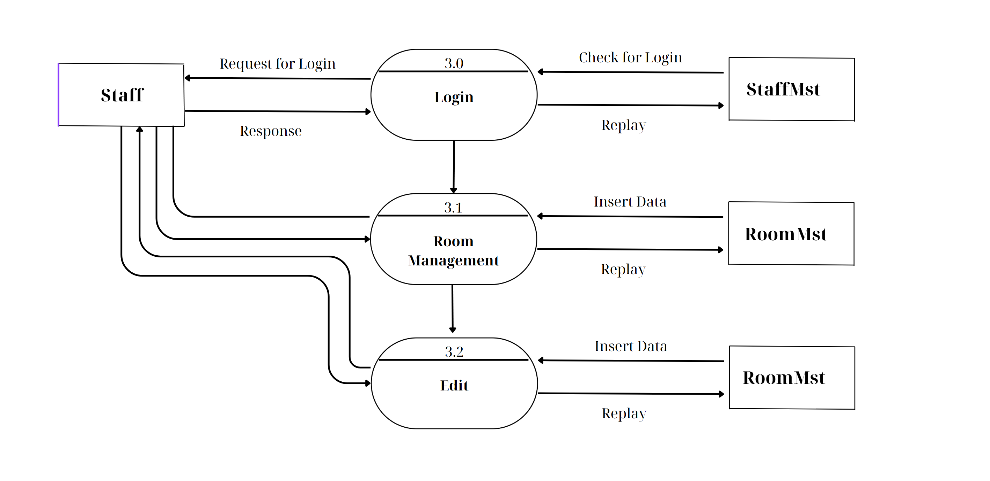

## ENTITY PROPERTIES

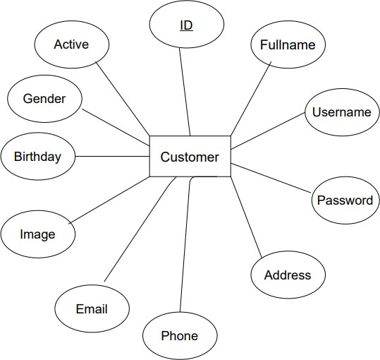**CUSTOMER**

**ROOMS**

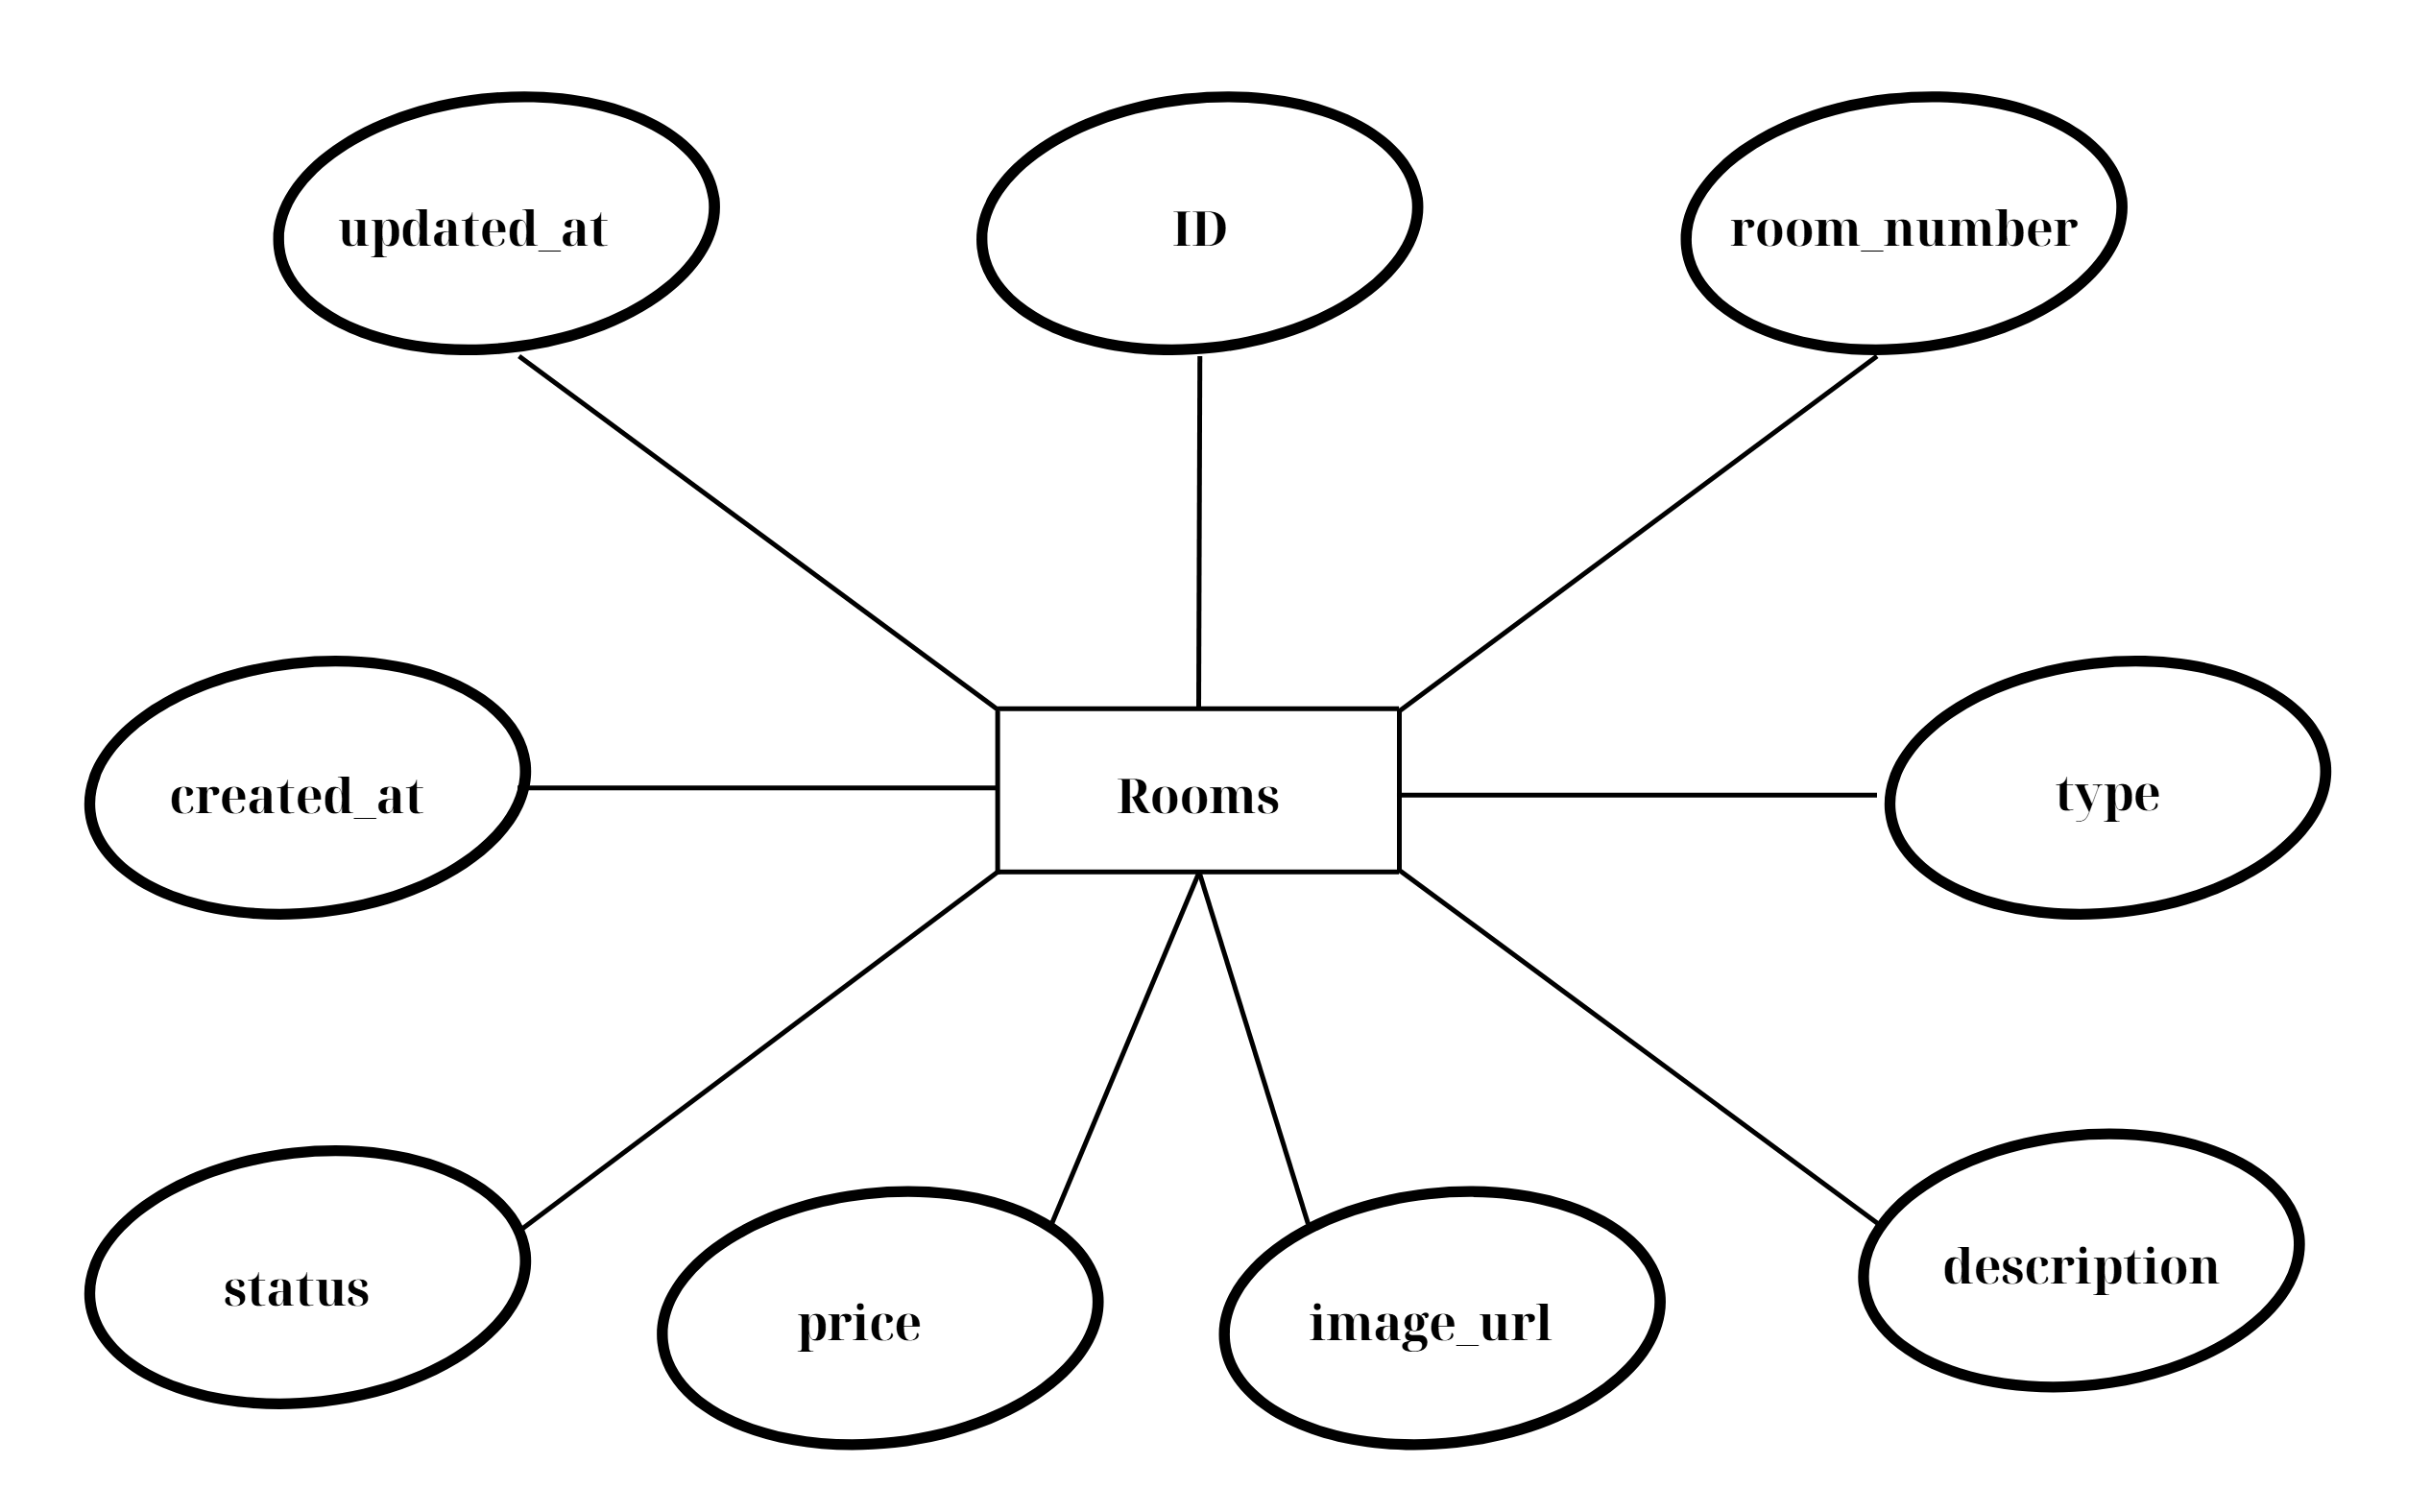

**SPECIAL OFFER**

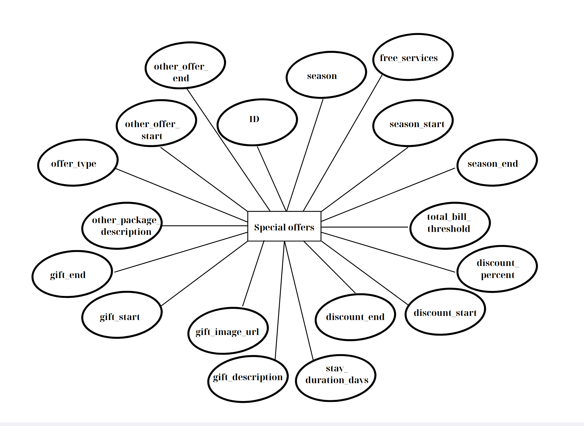

**VIEW_ROOM_TYPES**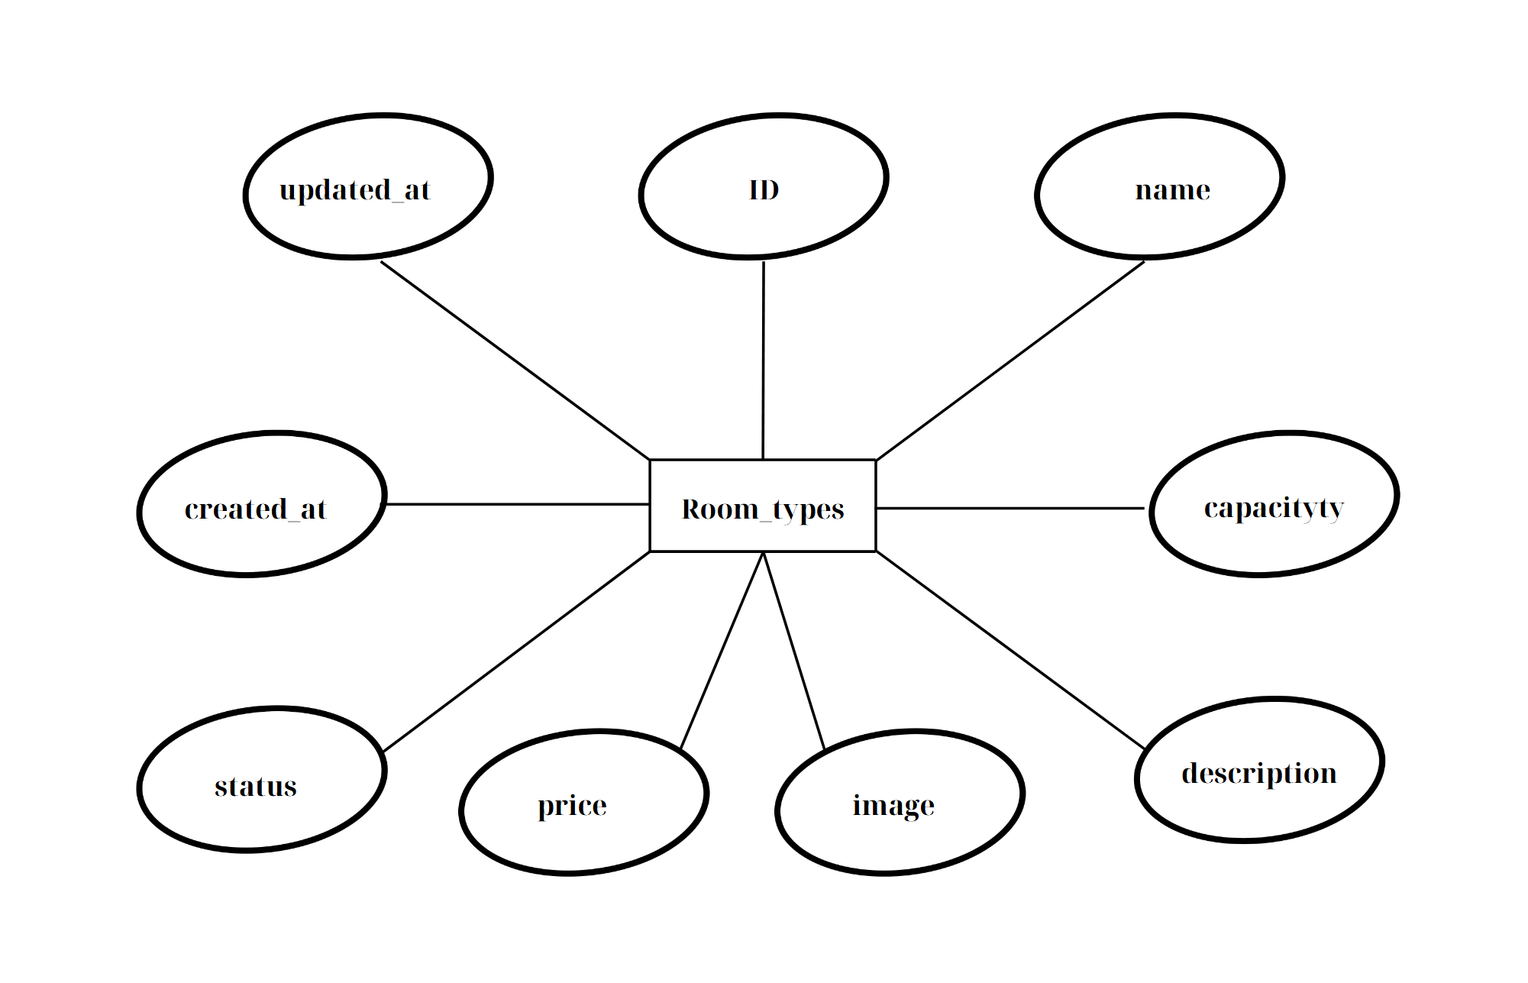

**ADMIN**

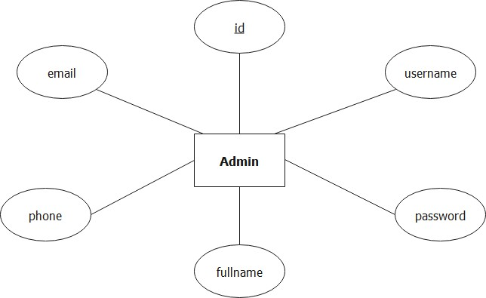

1. **ENTITY RELATIONSHIP DIAGRAM (ERD)**

**LOGICAL ERD**

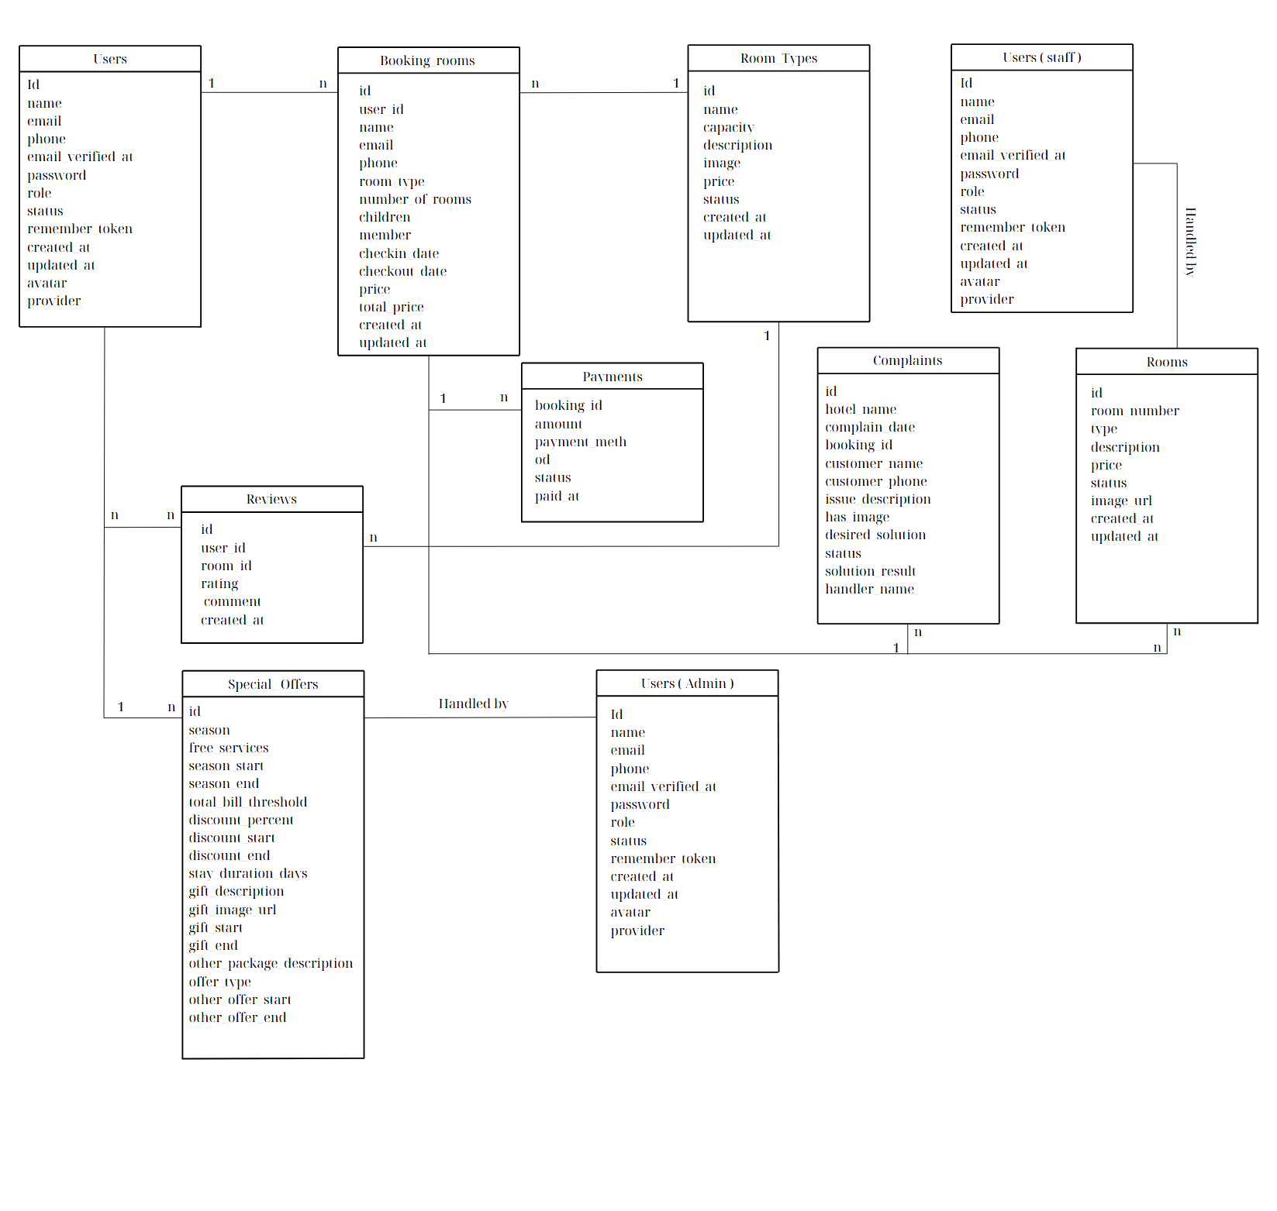

**PHYSICAL ERD**

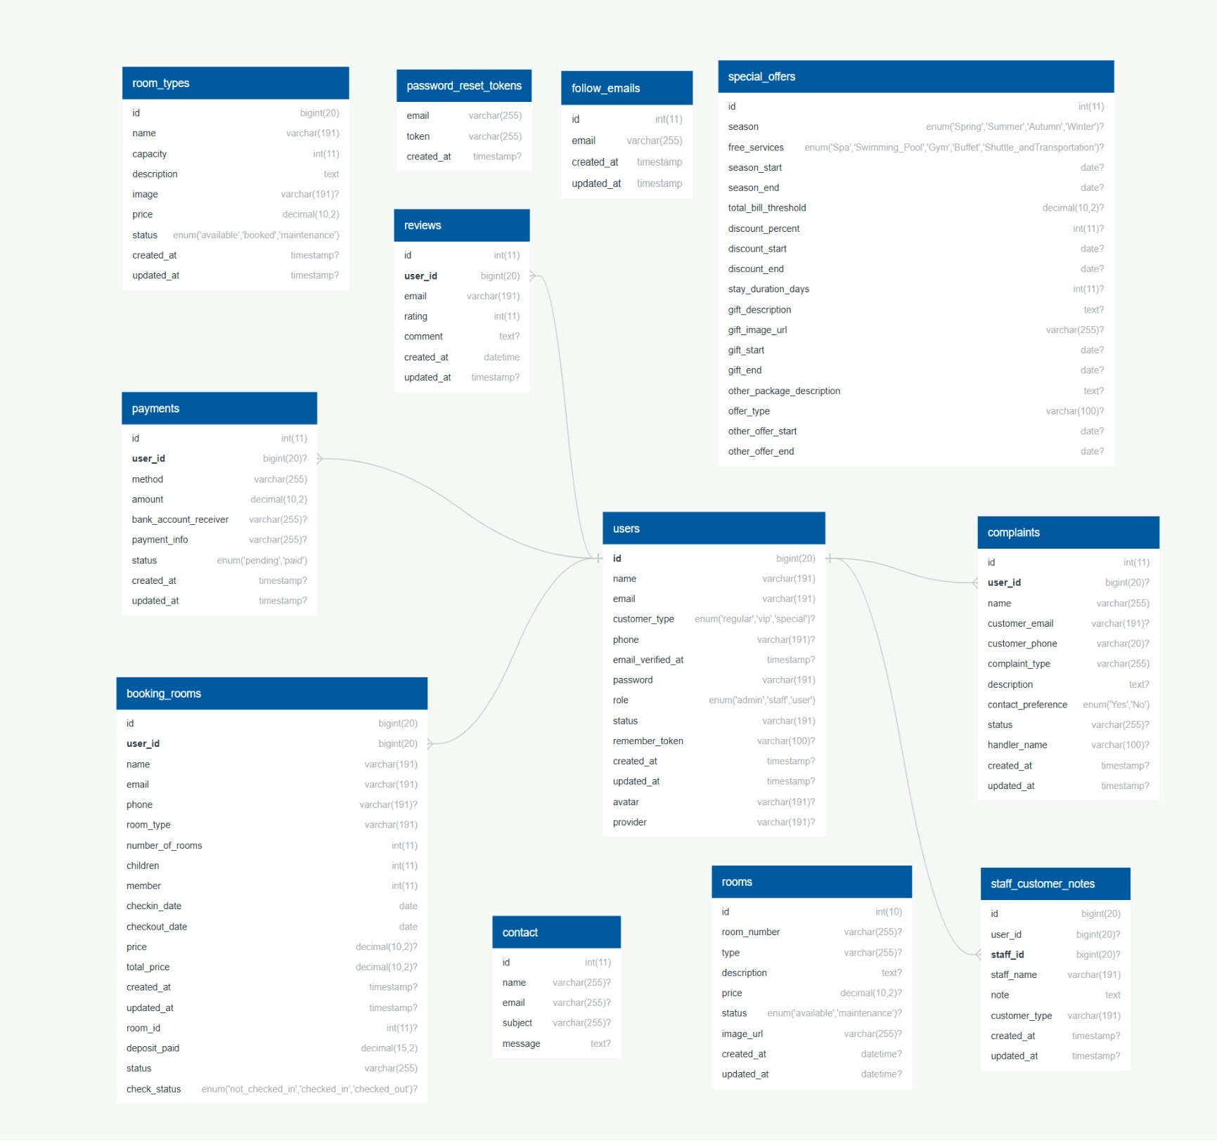

## TABLE DESIGN

**TABLE STRUCTURE FOR TABLE BOOKING_ROOMS**

|  |  |  |  |
| --- | --- | --- | --- |
| **TABLE BOOKING_ROOMS** | | | |
| **Column** | **Type** | **Null** | **Default** |
| **id** | bigint(20) | No |  |
| **user_id** | bigint(20) | No |  |
| **name** | varchar(191) | No |  |
| **email** | varchar(191) | No |  |
| **phone** | varchar(191) | No |  |
| **room_type** | varchar(191) | No |  |
| **number_of_rooms** | int(11) | No |  |
| **children** | int(11) | No |  |
| **member** | int(11) | No |  |
| **checkin_date** | datetime | No |  |
| **checkout_date** | datetime | No |  |
| **price** | decimal(10,2) | No |  |
| **total_price** | decimal(10,2) | No |  |
| **created_at** | timestamp | Yes |  |
| **updated_at** | Timestamp | Yes |  |
| **room_id** | int(11) | Yes |  |
| **deposit_paid** | decimal(15,2) | No |  |
| **status** | varchar(255) | No | |  |  | | --- | --- | | pending_payment |  | |
| **check_status** | text | Yes | not checked in |

**TABLE STRUCTURE FOR TABLE FOLLOW_EMAIL**

|  |  |  |  |
| --- | --- | --- | --- |
| **TABLE FOLLOW_EMAIL** | | | |
| **Column** | **Type** | **Null** | **Default** |
| **id** | int(11) | No |  |
| **email** | varchar(255) | Yes |  |
| **creat_at** | timestamp | Yes |  |
| **updated_at** | timestamp | Yes |  |

**TABLE STRUCTURE FOR TABLE COMPLAINTS**

|  |  |  |  |
| --- | --- | --- | --- |
| **TABLE COMPLAINTS** | | | |
| **Column** | **Type** | **Null** | **Default** |
| **id** | int(11) | No |  |
| **hotel_name** | varchar(200) | Yes |  |
| **complain_date** | date | Yes |  |
| **booking_id** | bigint(20) | Yes |  |
| **customer_name** | varchar(100) | Yes |  |
| **customer_phone** | varchar(20) | Yes |  |
| **issue_description** | text | Yes |  |
| **has_image** | tinyint(1) | Yes |  |
| **desired_solution** | varchar(255) | Yes |  |
| **status** | enum('pending', 'resolved', 'rejected') | Yes |  |
| **solution_result** | text | Yes |  |
| **handler_name** | varchar(100) | Yes |  |

**TABLE STRUCTURE FOR TABLE CONTACT**

|  |  |  |  |
| --- | --- | --- | --- |
| **TABLE CONTACT** | | | |
| **Column** | **Type** | **Null** | **Default** |
| **id** | int(11) | No |  |
| **name** | varchar(255) | Yes |  |
| **email** | varchar(255) | Yes |  |
| **subject** | varchar(255) | Yes |  |
| **message** | text | Yes |  |

**TABLE STRUCTURE FOR TABLE PAYMENTS**

|  |  |  |  |
| --- | --- | --- | --- |
| **TABLE PAYMENTS** | | | |
| **Column** | **Type** | **Null** | **Default** |
| **id** | int(11) | No |  |
| **booking_id** | bigint(20) | No |  |
| **amount** | decimal(10,2) | No |  |
| **payment_method** | enum('credit_card', 'paypal', 'bank_transfer') | No |  |
| **status** | enum('pending', 'paid', 'failed') | No | paid |
| **paid_at** | datetime | Yes |  |
| **is_deposit** | tinyint(1) | No |  |
| **total_amount** | decimal(15,2) | No |  |

**TABLE STRUCTURE FOR TABLE REVIEWS**

|  |  |  |  |
| --- | --- | --- | --- |
| **TABLE REVIEWS** | | | |
| **Column** | **Type** | **Null** | **Default** |
| **id** | int(11) | No |  |
| **user_id** | bigint(20) | No |  |
| **room_id** | int(10) | No |  |
| **rating** | int(11) | No |  |
| **comment** | text | Yes |  |
| **created_at** | datetime | No |  |
| **updated_at** | datetime | Yes |  |
| **admin_reply** | text | Yes |  |

**TABLE STRUCTURE FOR TABLE ROOMS**

|  |  |  |  |
| --- | --- | --- | --- |
| **TABLE ROOMS** | | | |
| **Column** | **Type** | **Null** | **Default** |
| **id** | bigint(20) | No |  |
| **room_number** | varchar(255) | Yes |  |
| **type** | varchar(255) | Yes |  |
| **description** | text | Yes |  |
| **price** | decimal(10,2) | Yes |  |
| **status** | enum('available', 'booked', 'maintenance') | Yes |  |
| **image_url** | varchar(255) | Yes |  |
| **created_at** | datetime | Yes |  |
| **updated_at** | datetime | Yes |  |

**TABLE STRUCTURE FOR TABLE ROOMS_TYPES**

|  |  |  |  |
| --- | --- | --- | --- |
| **TABLE ROOMS_TYPES** | | | |
| **Column** | **Type** | **Null** | **Default** |
| **id** | bigint(20) | No |  |
| **name** | varchar(191) | No |  |
| **capacity** | int(11) | No |  |
| **description** | text | No |  |
| **image** | varchar(191) | Yes |  |
| **price** | decimal(10,2) | No |  |
| **status** | enum('available', 'booked', 'maintenance') | No |  |
| **created_at** | timestamp | Yes |  |
| **updated_at** | timestamp | Yes |  |

**TABLE STRUCTURE FOR TABLE USERS**

|  |  |  |  |
| --- | --- | --- | --- |
| **TABLE USERS** | | | |
| **Column** | **Type** | **Null** | **Default** |
| **Id** | bigint(20) | No |  |
| **name** | varchar(191) | No |  |
| **email** | varchar(191) | No |  |
| **phone** | varchar(191) | No |  |
| **email_verified_at** | timestamp | Yes |  |
| **password** | varchar(191) | No |  |
| **role** | enum('admin', 'staff', 'user') | No |  |
| **status** | varchar(191) | No |  |
| **remember_token** | varchar(100) | Yes |  |
| **created_at** | timestamp | Yes |  |
| **updated_at** | timestamp | Yes |  |
| **avatar** | varchar(191) | Yes |  |
| **provider** | varchar(191) | Yes |  |
| **is_banned** | tinyint(4) | Yes |  |

**TABLE STRUCTURE FOR TABLE PASSWORD_RESET_TOKENS**

|  |  |  |  |
| --- | --- | --- | --- |
| **TABLE PASSWORD_RESET_TOKENS** | | | |
| **Column** | **Type** | **Null** | **Default** |
| **email** | varchar(255) | No |  |
| **token** | varchar(255) | No |  |
| **created_at** | timestamp | Yes |  |

**TABLE STRUCTURE FOR TABLE SPECIAL OFERS**

|  |  |  |  |
| --- | --- | --- | --- |
| **TABLE**  **SPECIAL OFERS** | | | |
| **Column** | **Type** | **Null** | **Default** |
| **id** | int(11) | No |  |
| **season** | enum('Spring', 'Summer', 'Autumn', 'Winter') | Yes |  |
| **free_services** | |  |  | | --- | --- | | enum('Spa', 'Swimming Pool', 'Gym', 'Buffet', 'Shu... |  | | Yes |  |
| **season_start** | date | Yes |  |
| **season_end** | date | Yes |  |
| **total_bill_threshold** | decimal(10,2) | Yes |  |
| **discount_percent** | int(11) | Yes |  |
| **discount_start** | date | Yes |  |
| **discount_end** | date | Yes |  |
| **stay_duration_days** | int(11) | Yes |  |
| **gift_description** | text | Yes |  |
| **gift_image_url** | varchar(255) | Yes |  |
| **gift_start** | date | Yes |  |
| **gift_end** | date | Yes |  |
| **other_package_description** | text | Yes |  |
| **offer_type** | varchar(100) | Yes |  |
| **other_offer_start** | date | Yes |  |
| **other_offer_end** | date | Yes |  |

**TABLE STRUCTURE FOR TABLE STAFF_CUSTOMER_NOTES**

|  |  |  |  |
| --- | --- | --- | --- |
| **TABLE STAFF_CUSTOMER_NOTES** | | | |
| **Column** | **Type** | **Null** | **Default** |
| **id** | bigint(20) | No |  |
| **user_id** | bigint(20) | Yes |  |
| **staff_id** | bigint(20) | Yes |  |
| **staff_name** | varchar(191) | No |  |
| **note** | text | No |  |
| **customer_type** | varchar(191) | No |  |
| **created_at** | timestamp | Yes |  |
| **updated_at** | timestamp | Yes |  |

## TASK SHEET REVIEW 2

|  |  |  |  |  |  |  |  |  |
| --- | --- | --- | --- | --- | --- | --- | --- | --- |
| **Project: Moonbay Hotels** | | **Project Name** | **Activity Plan Prepared By** | | **Date of Preparation of Activity Plan:** | | | |
| **Sr./No.** | **Task** | Actual Start Date | Actual Days | Team member name | Status |
| **2** | **Data Flow Diagram (DFD)** | **Moonbay Hotels** | Hùng | | 4- May -25 | 3 | Hùng | Completed |
| **3** | **Entity Relationship Diagram (ERD)** | 3- May -25 | 3 | Huy | Completed |
| **4** | **Entity Properties** | 3- May -25 | 3 | Long | Completed |
| **5** | **Table Design** | 4- May -25 | 3 | Đạt | Completed |
| **Date 13 MAY 2025** | | | | | | | | |
| **Signature of Instructor:**  **Ms. LE MONG THUY** | | | | **Signature of Team Leader:**  **ĐỖ THANH HÙNG** | | | | |

# REVIEW 3

## SITE MAP

**HOME SITE MAP**

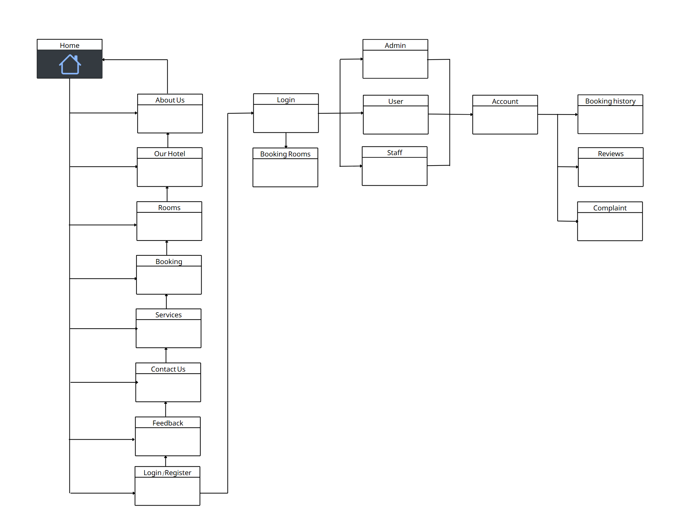

**ADMIN’S SITE MAP**

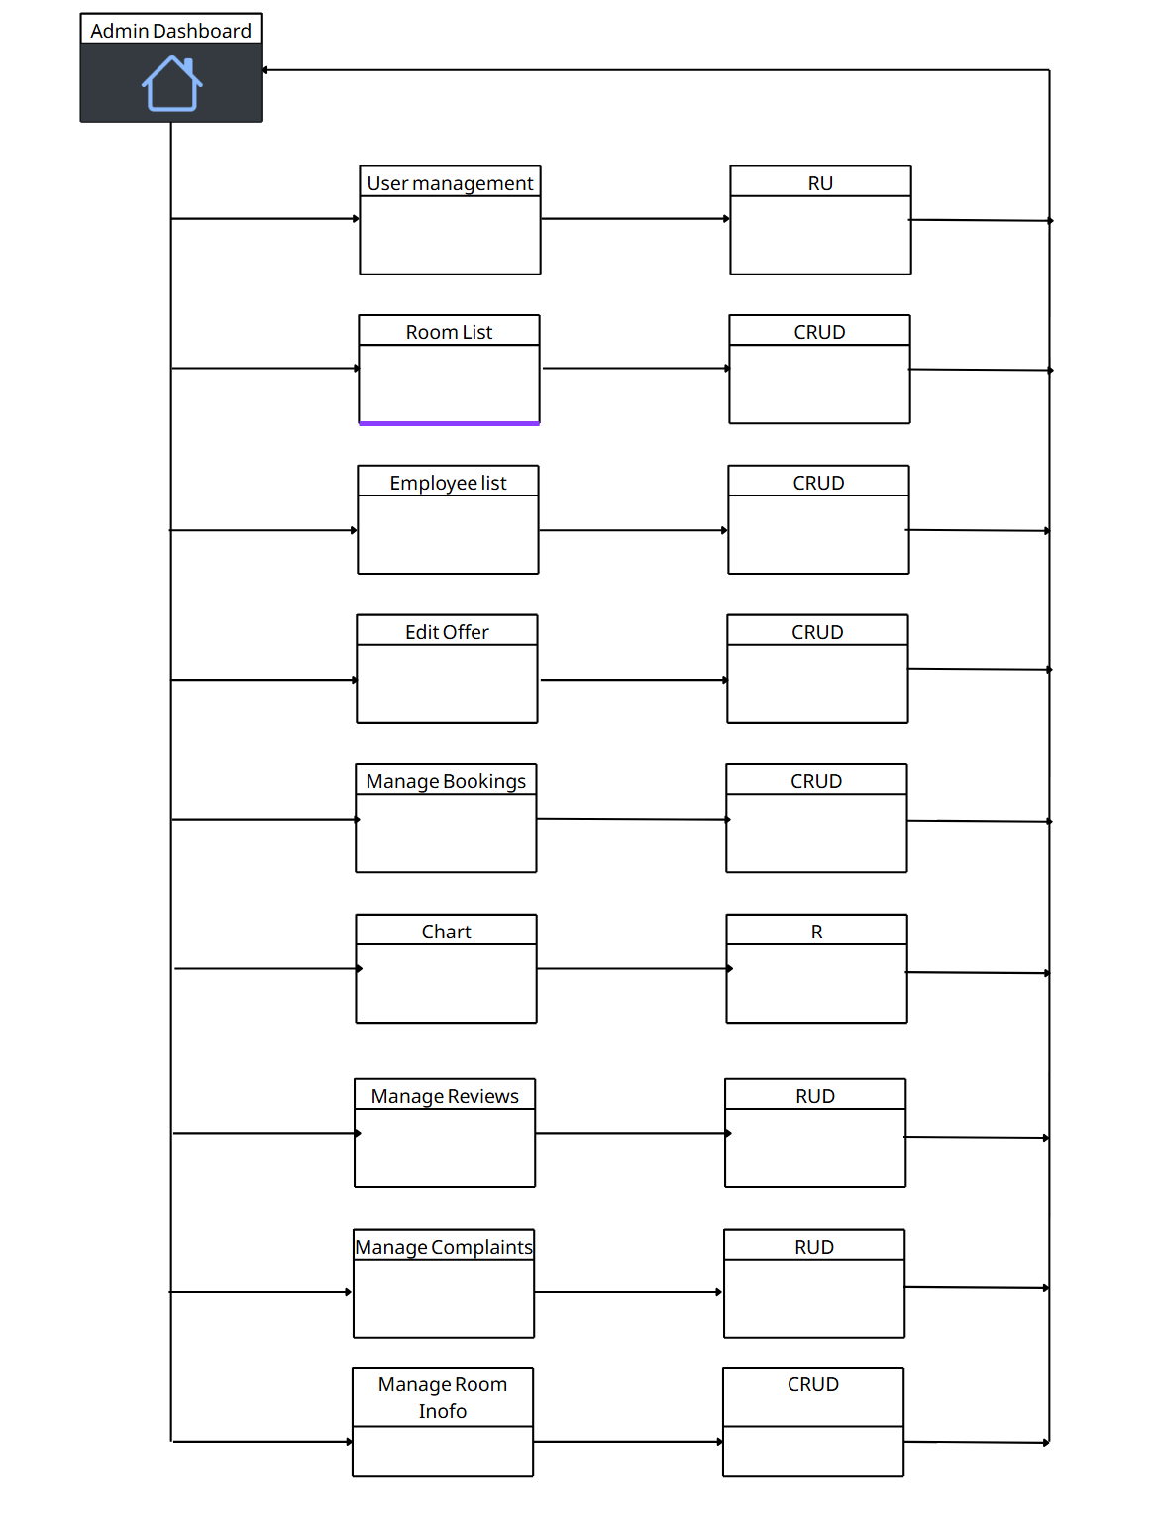

**STAFF SITE MAP**

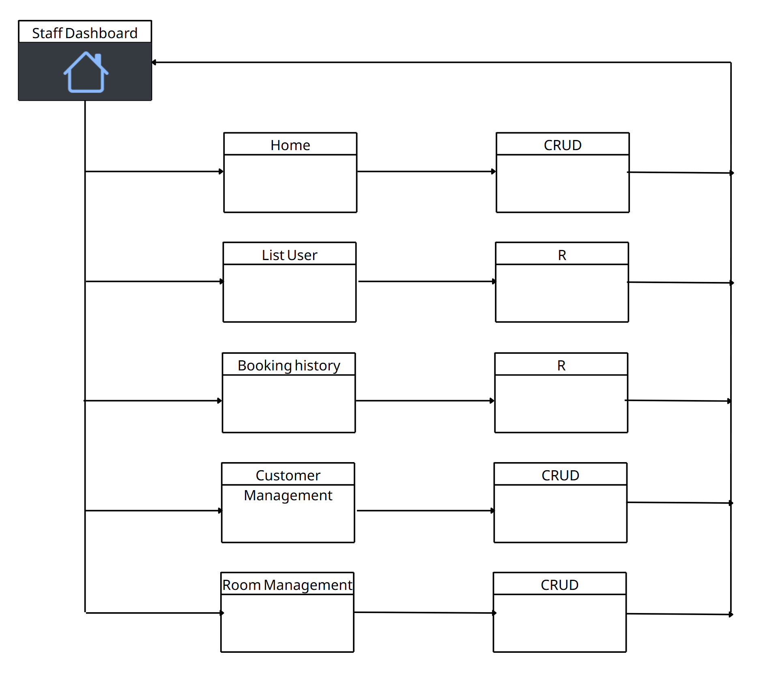

## MOONBAY HOTELS WIREFRAME

**HOMEPAGE**

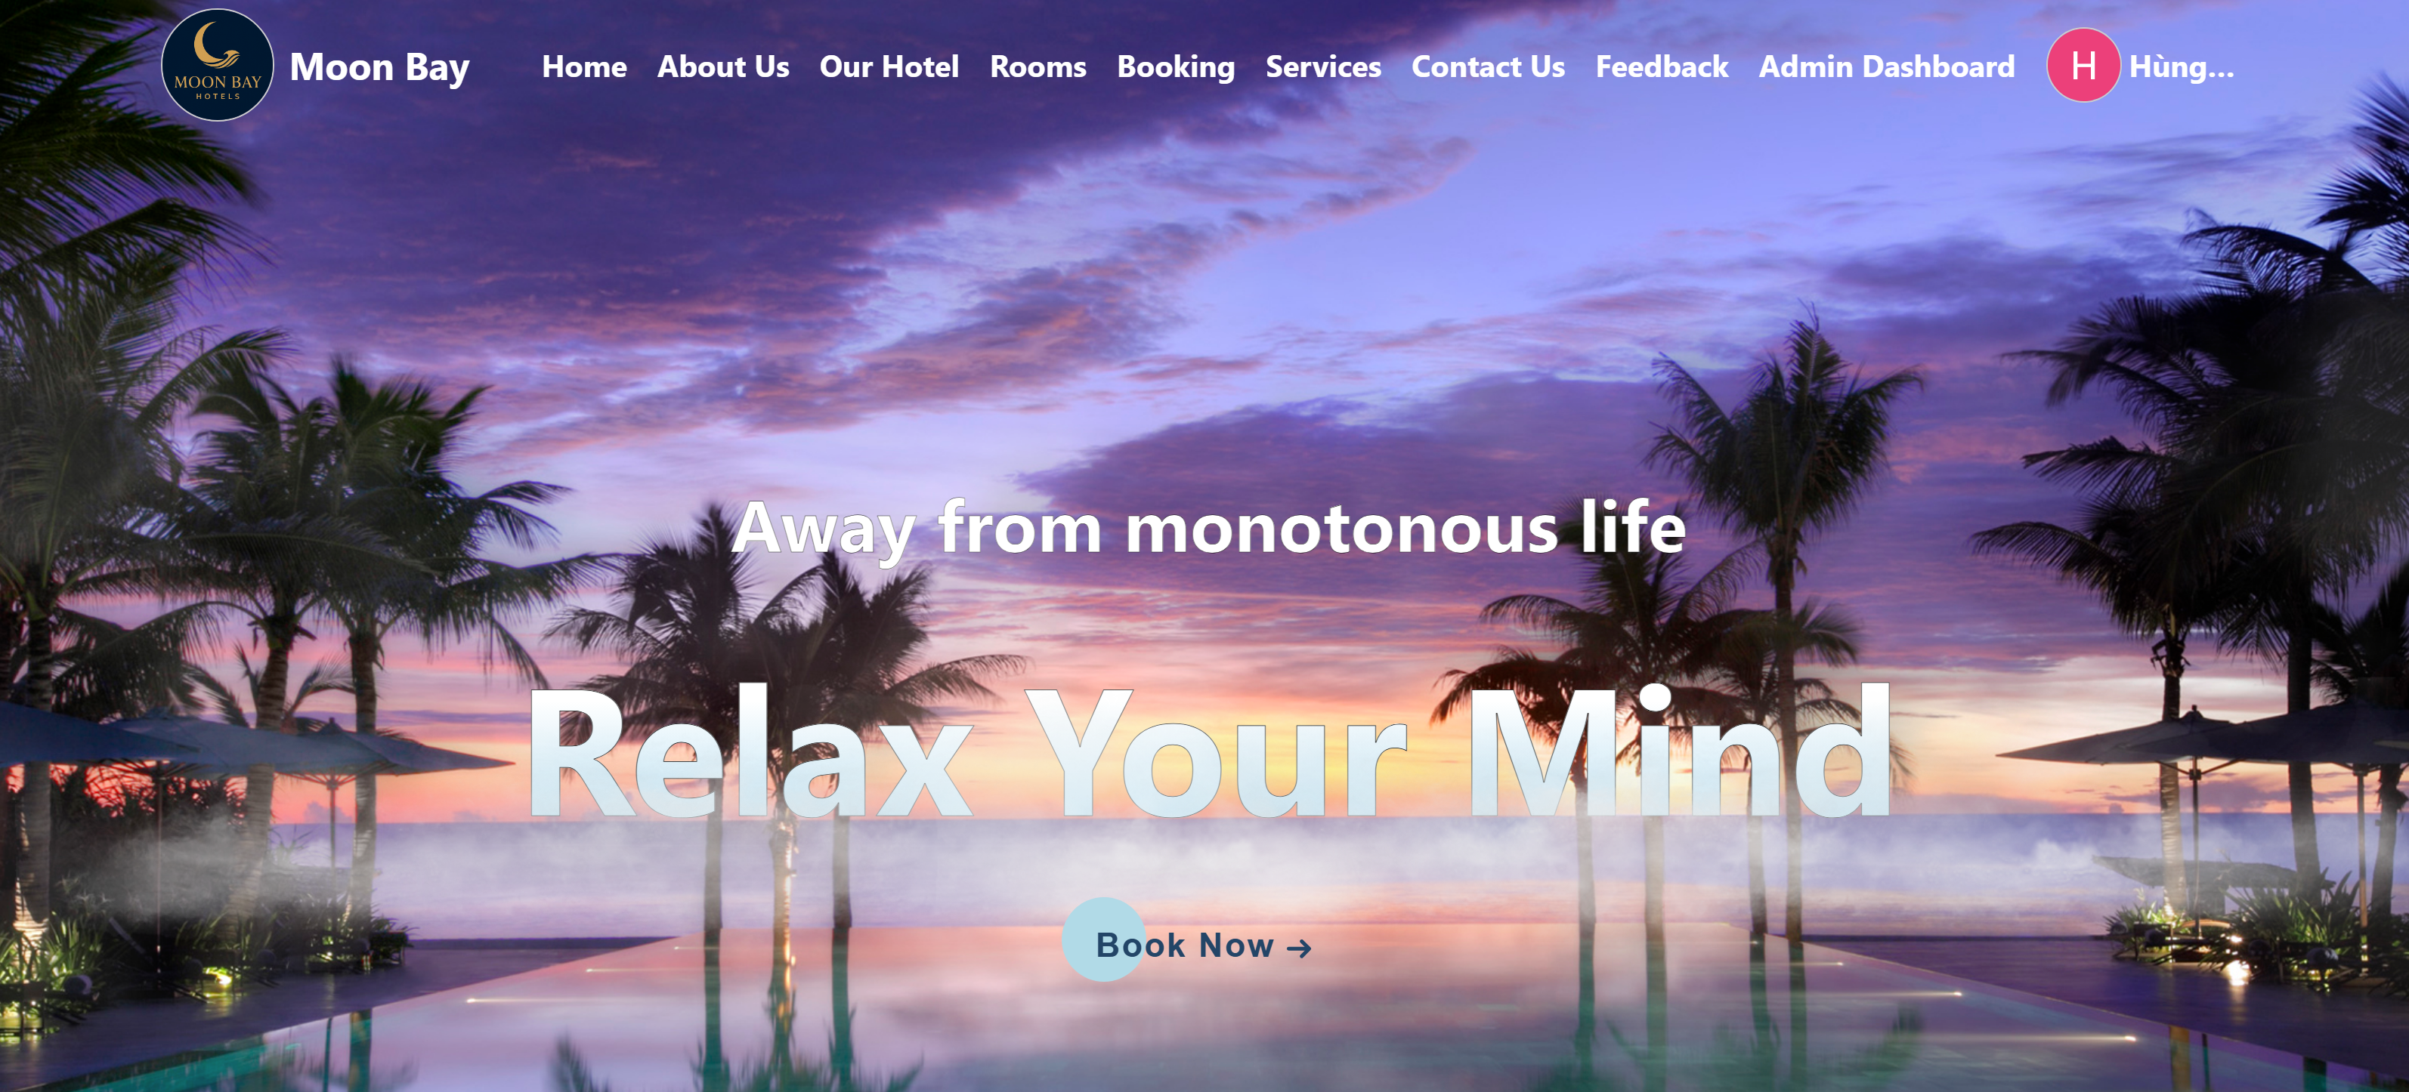

**ADMIN**

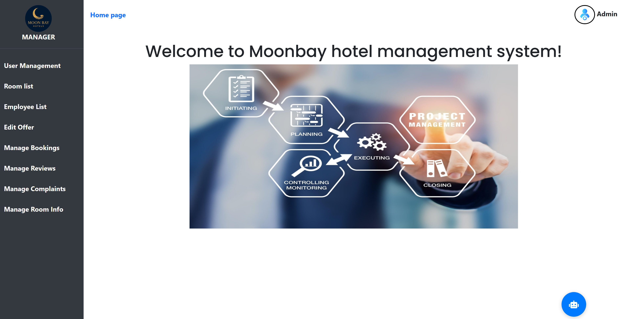

**USER MANAGEMENT**

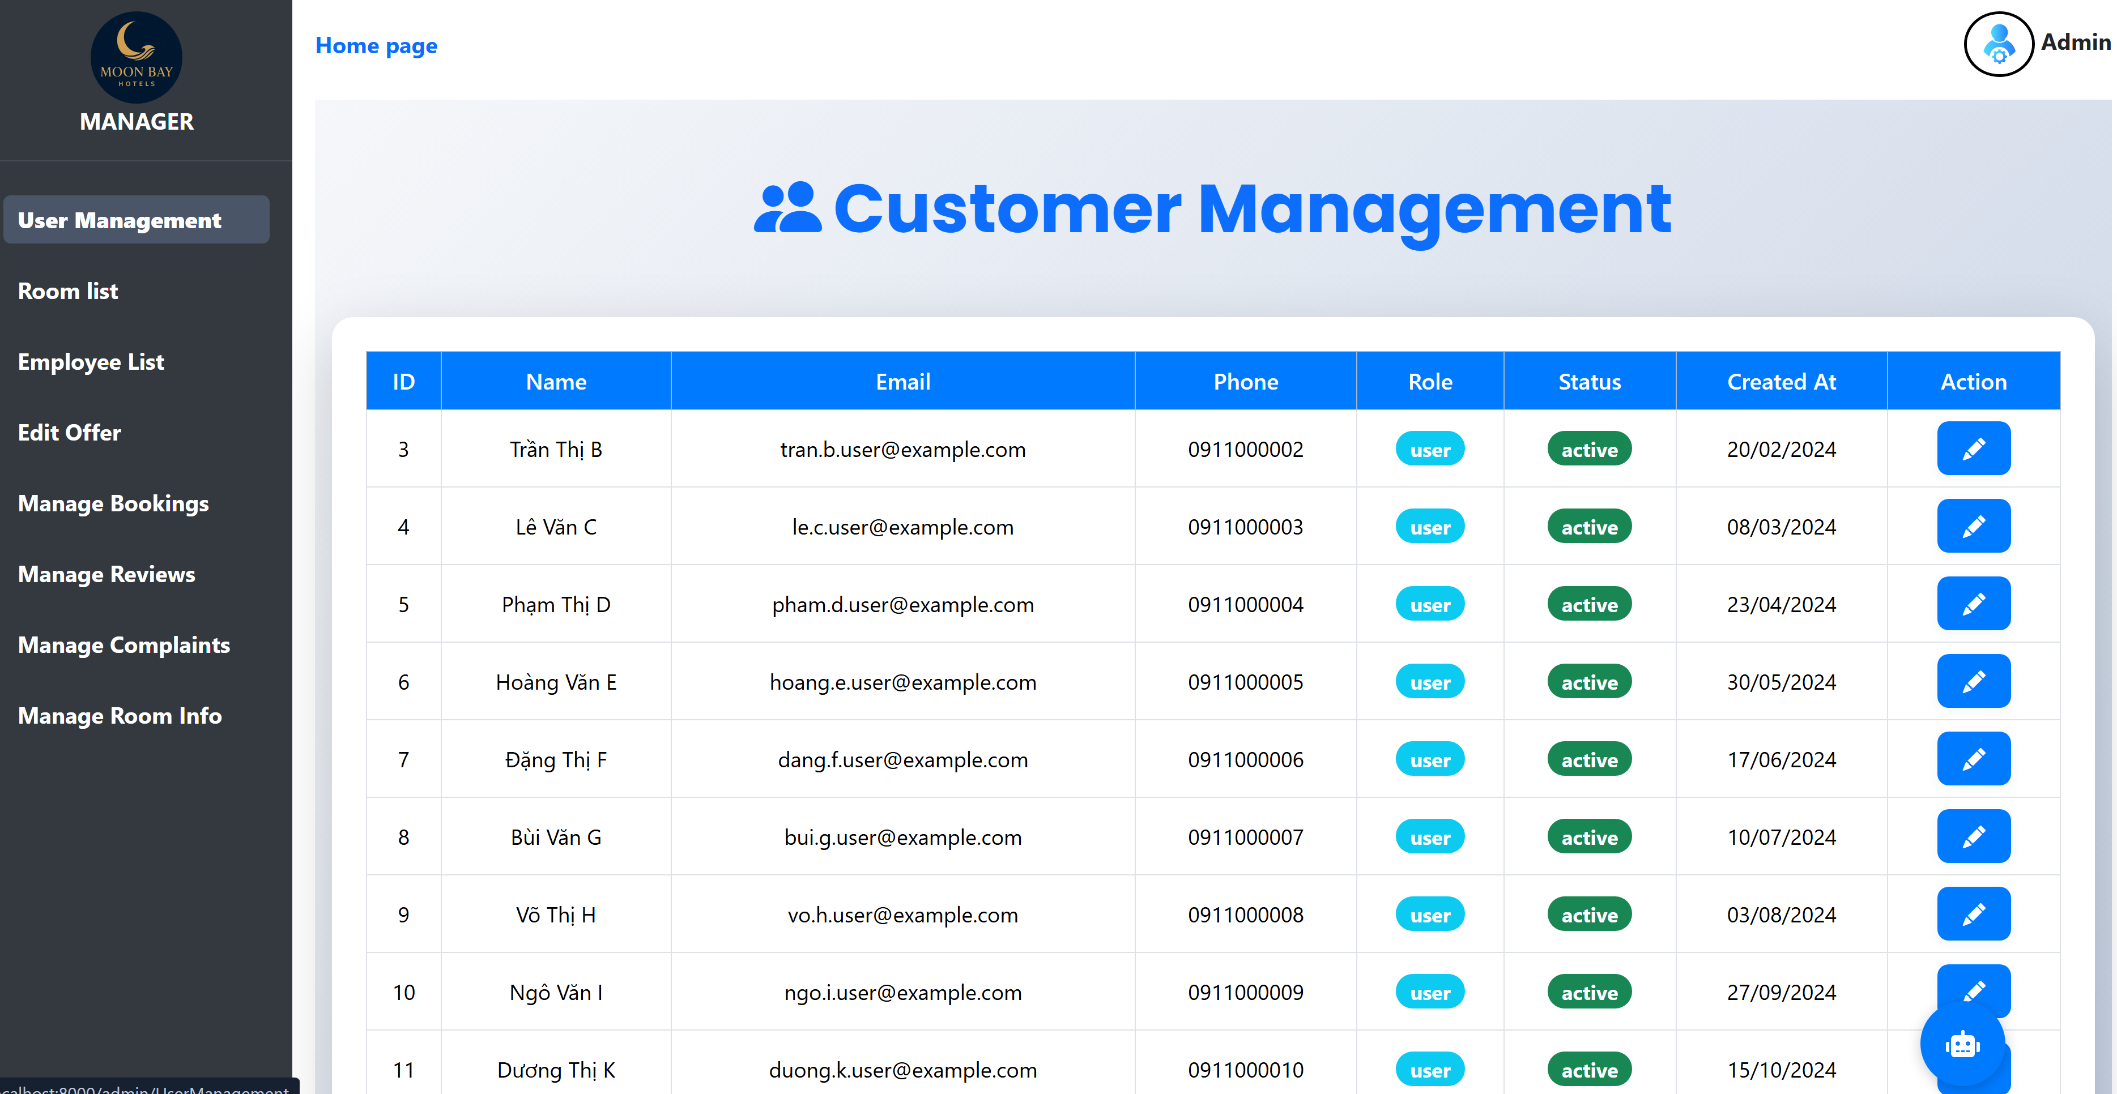

**ROOM LIST**

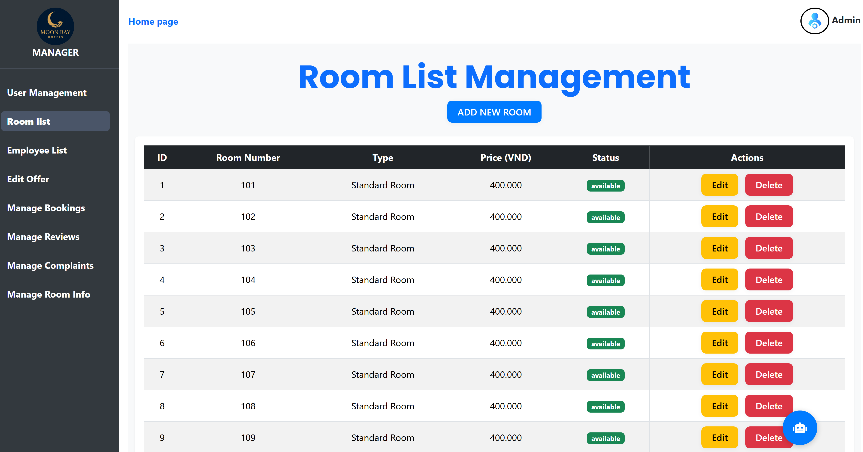

**EMPLOYEE LIST**

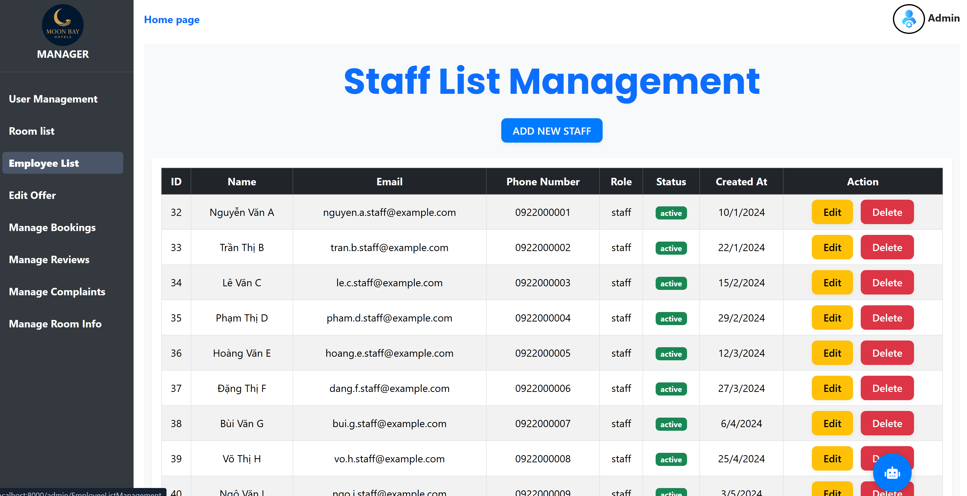

**EDIT OFFER**

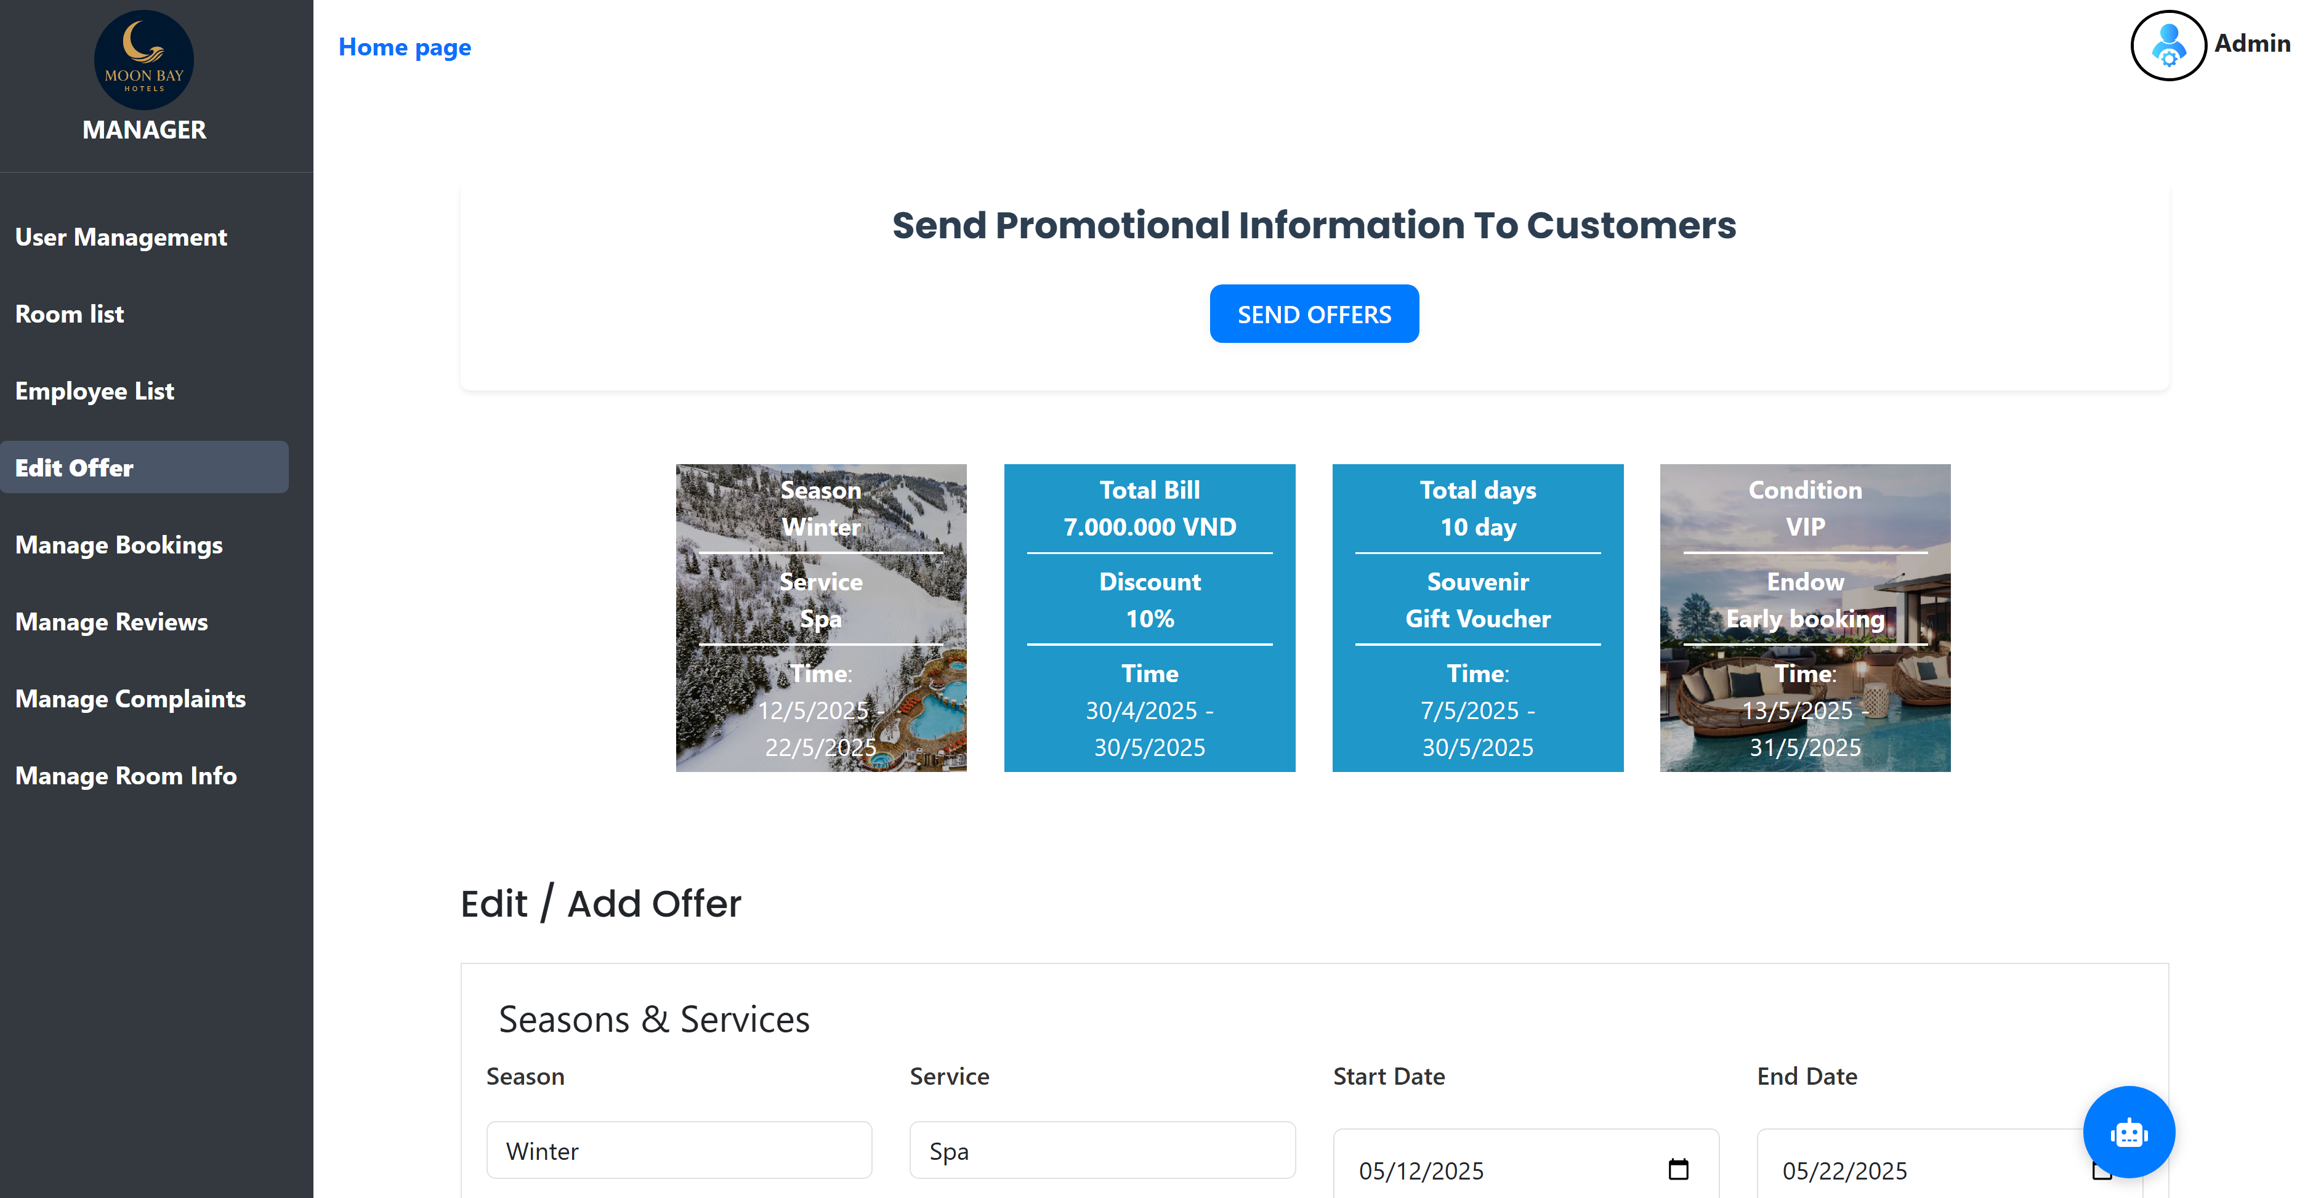

**MANAGE BOOKINGS**

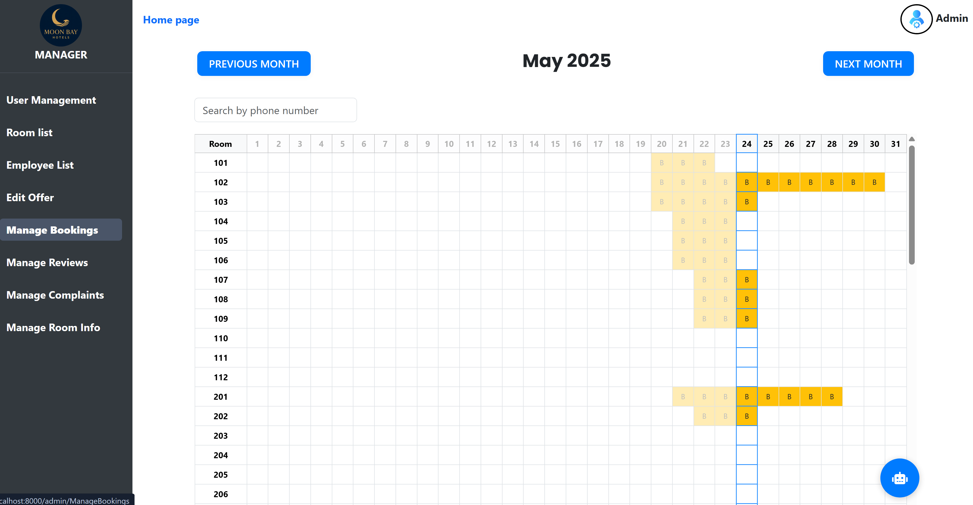

**CHART**

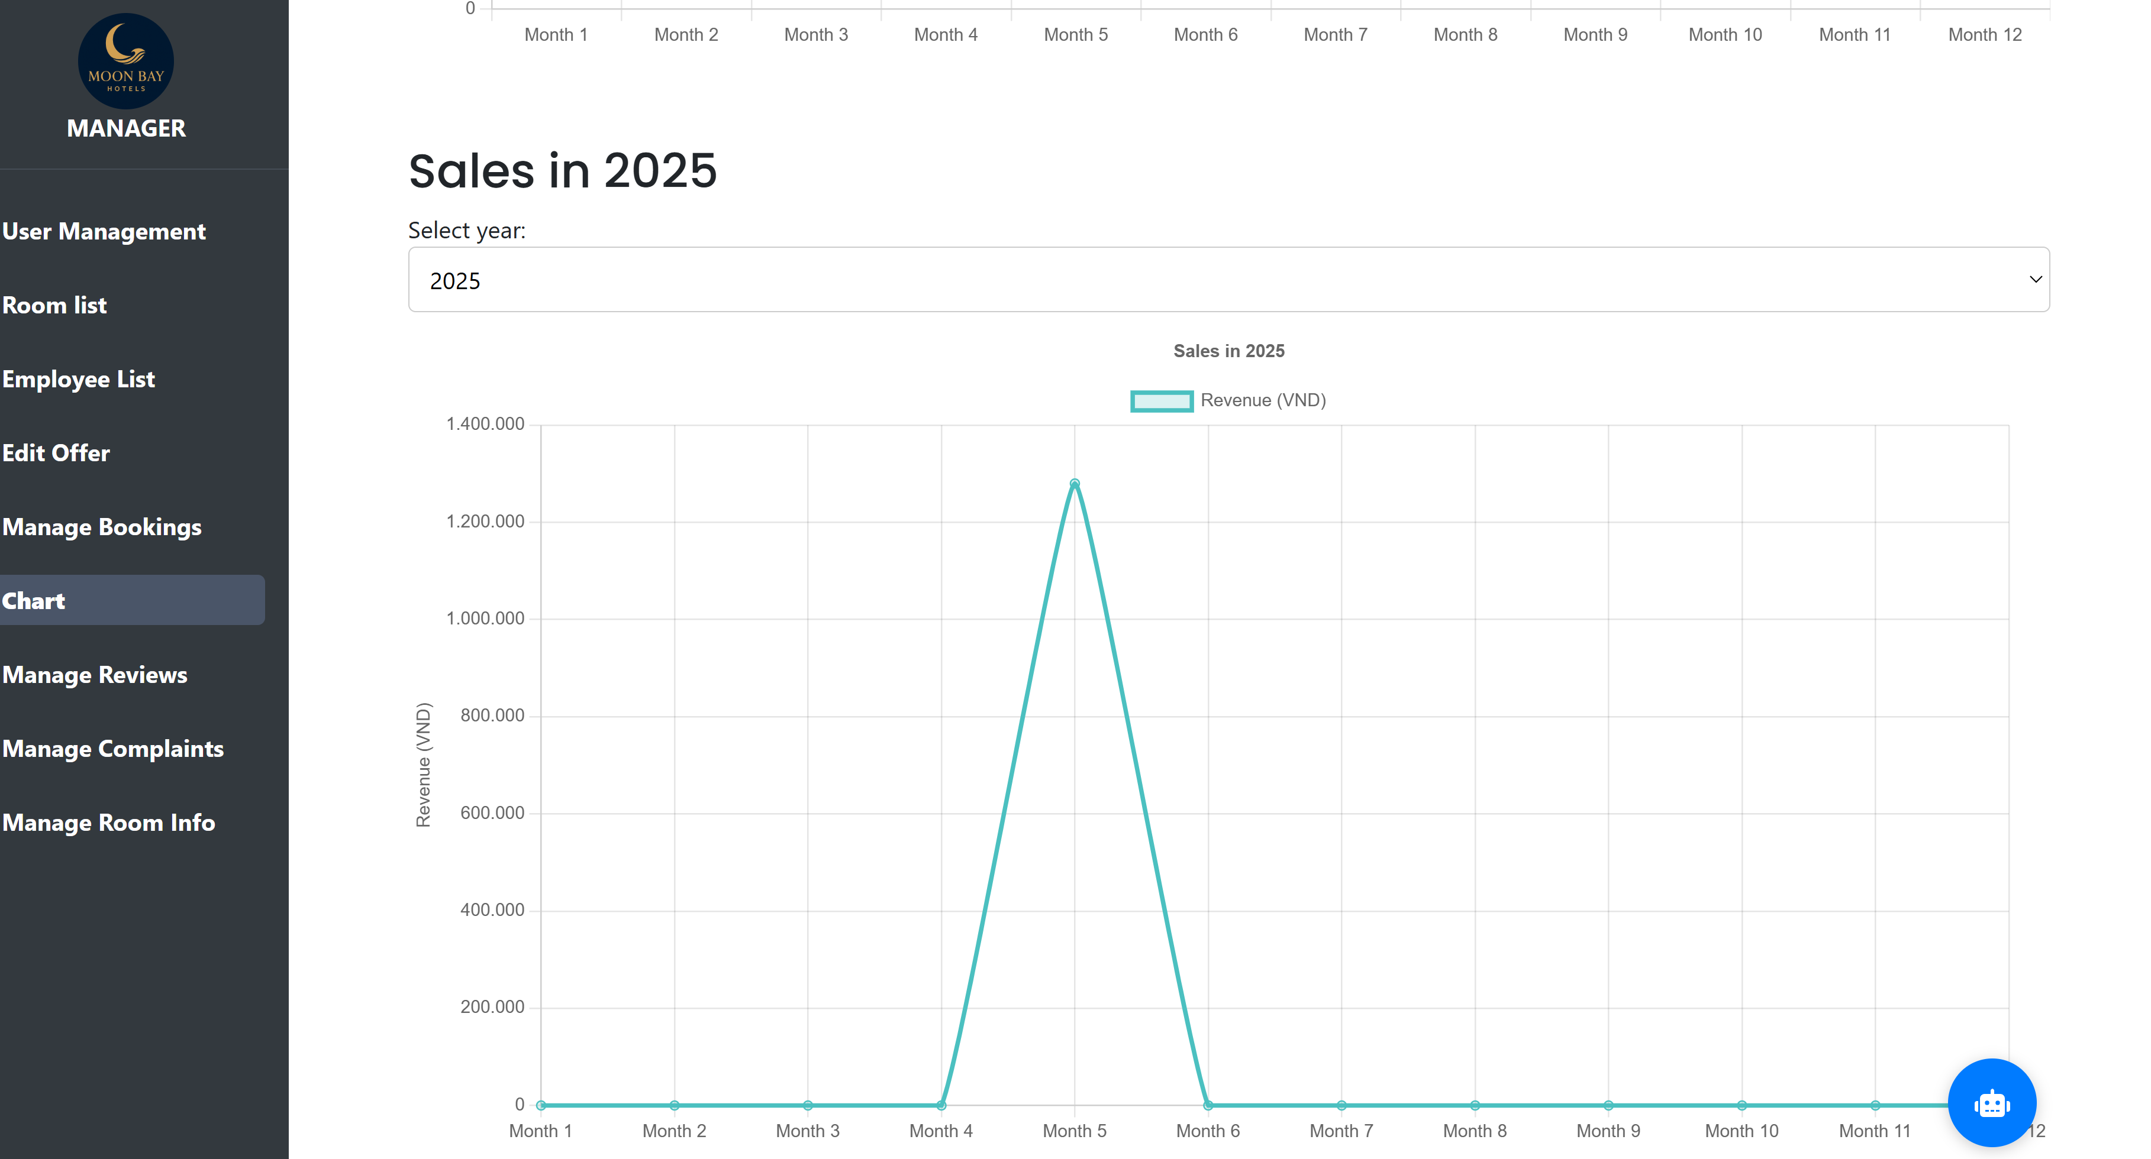

**MANAGE REVIEWS**

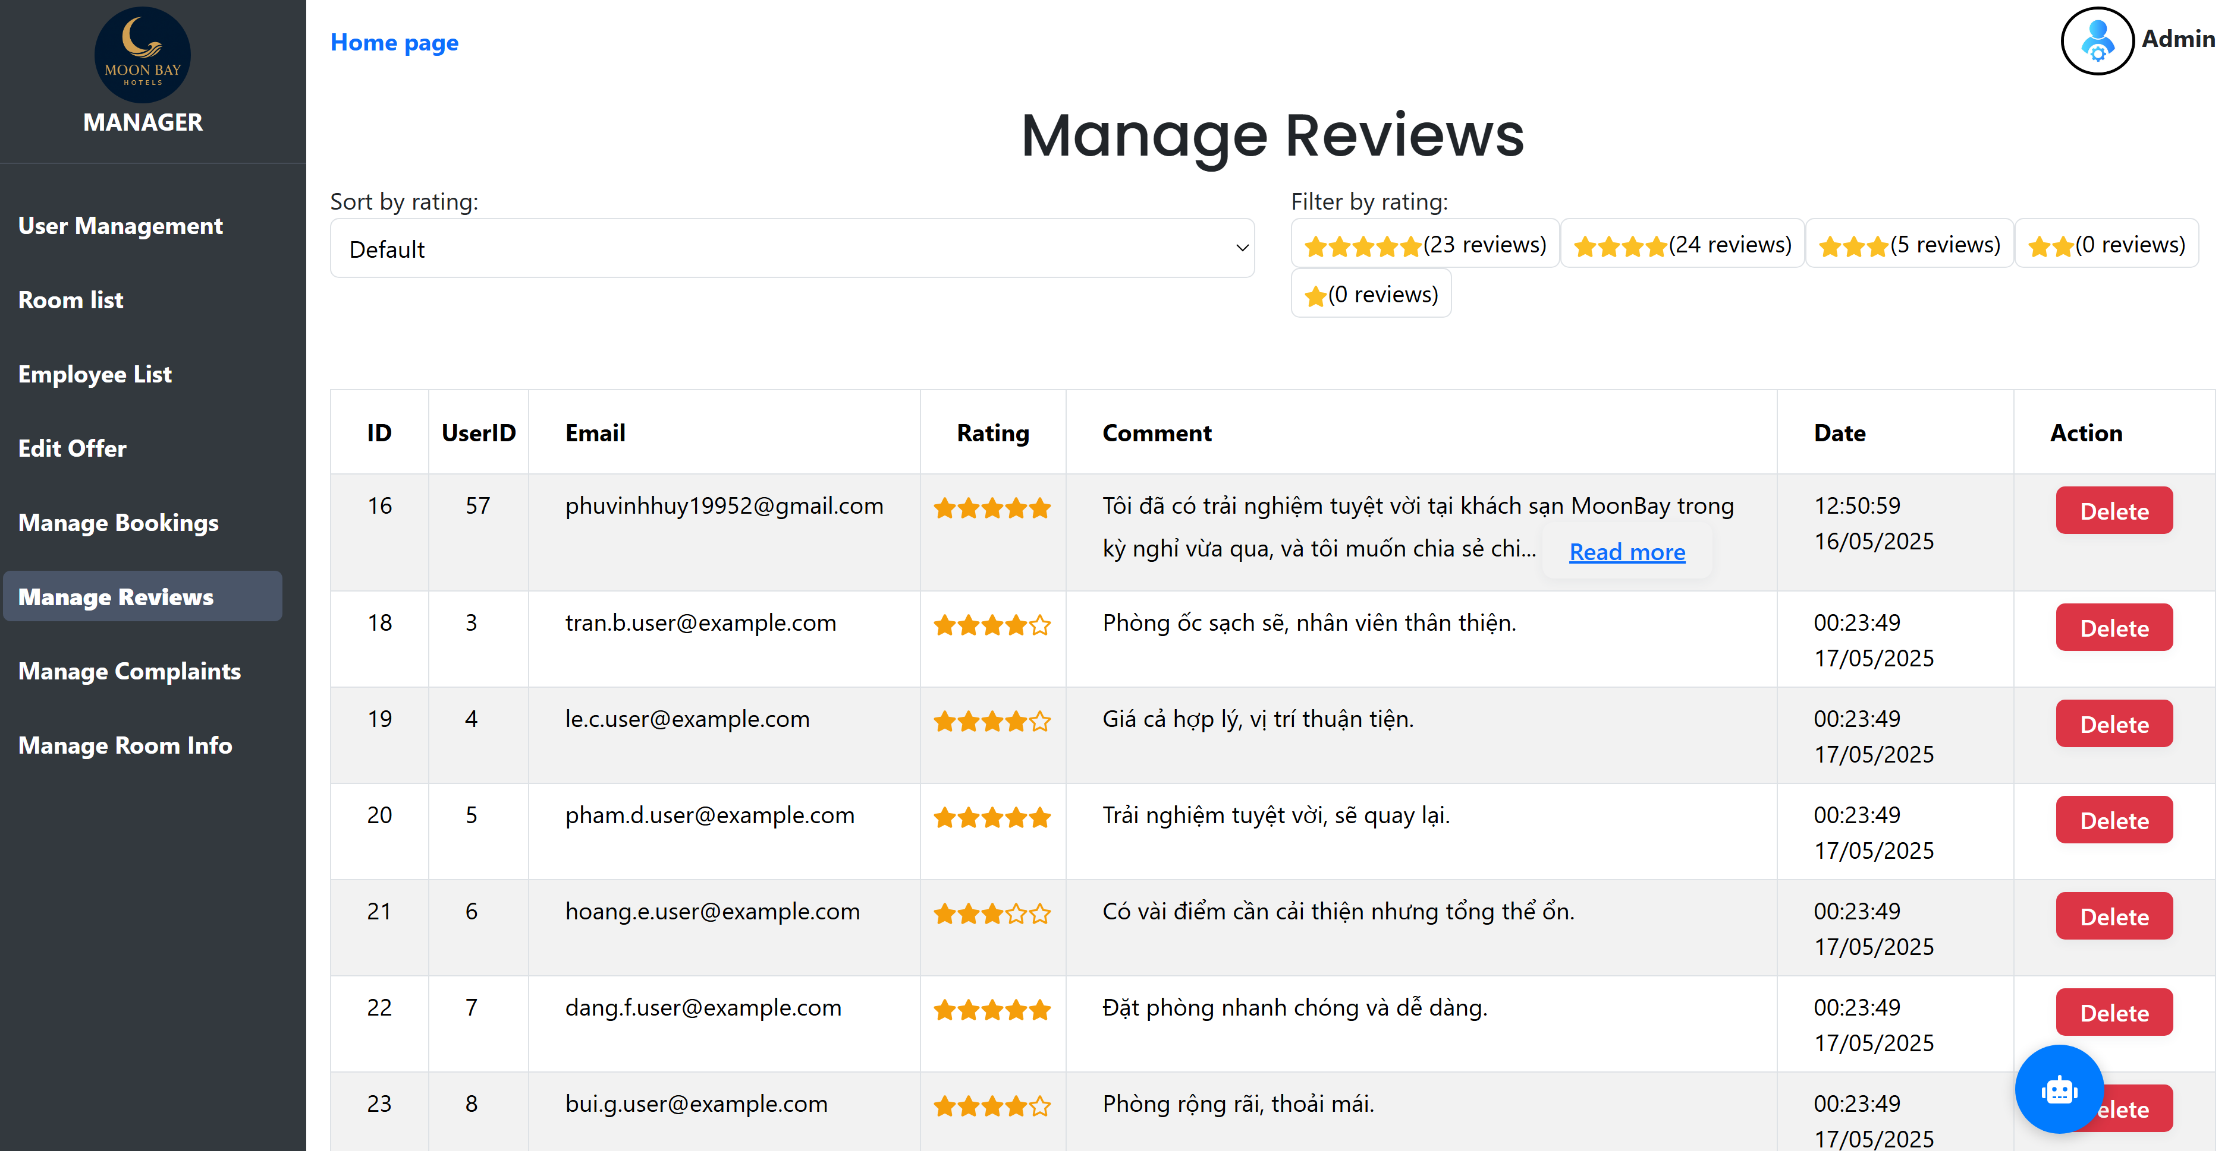

**MANAGE COMPLAINT**

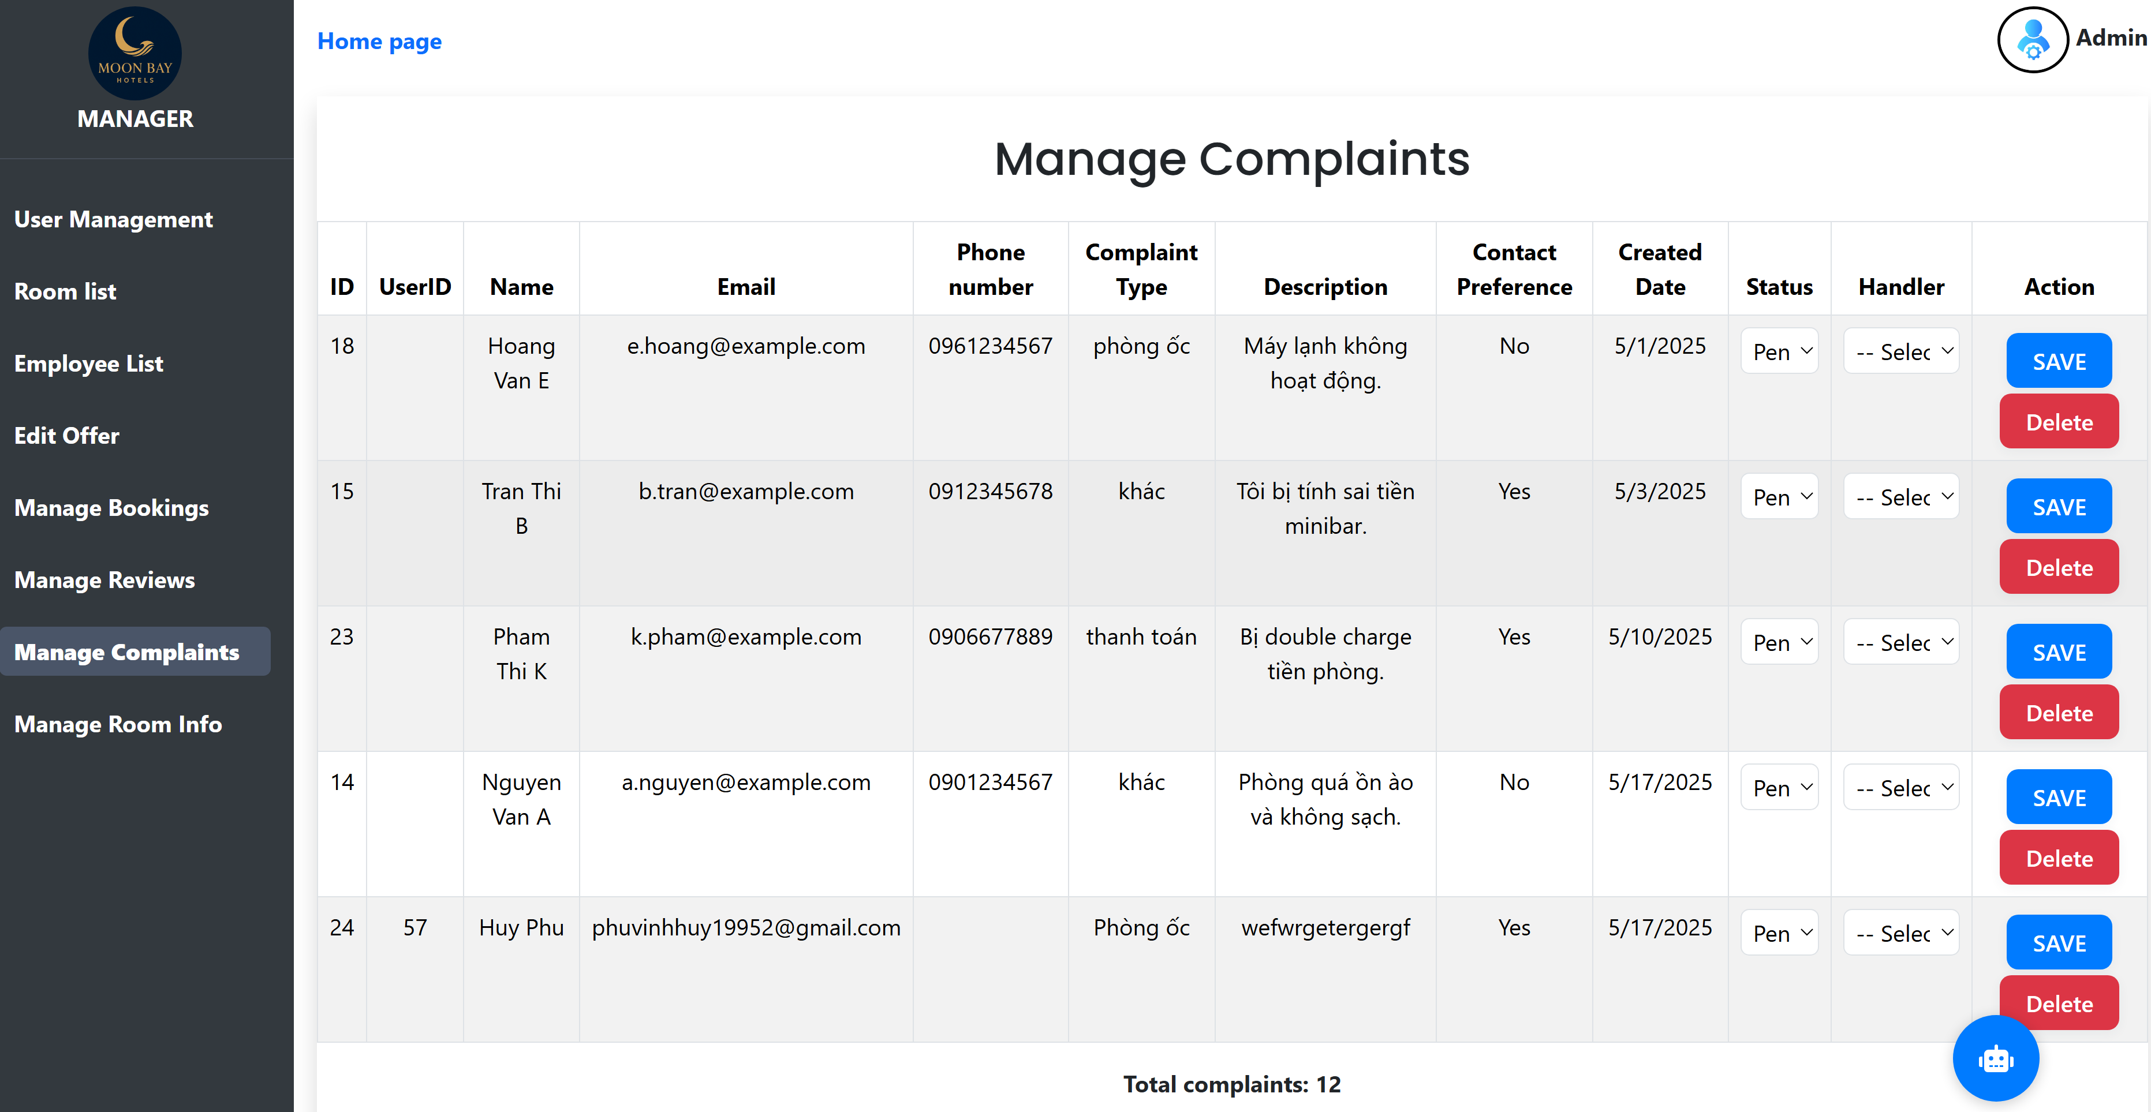

**MANAGE ROOM INFO**

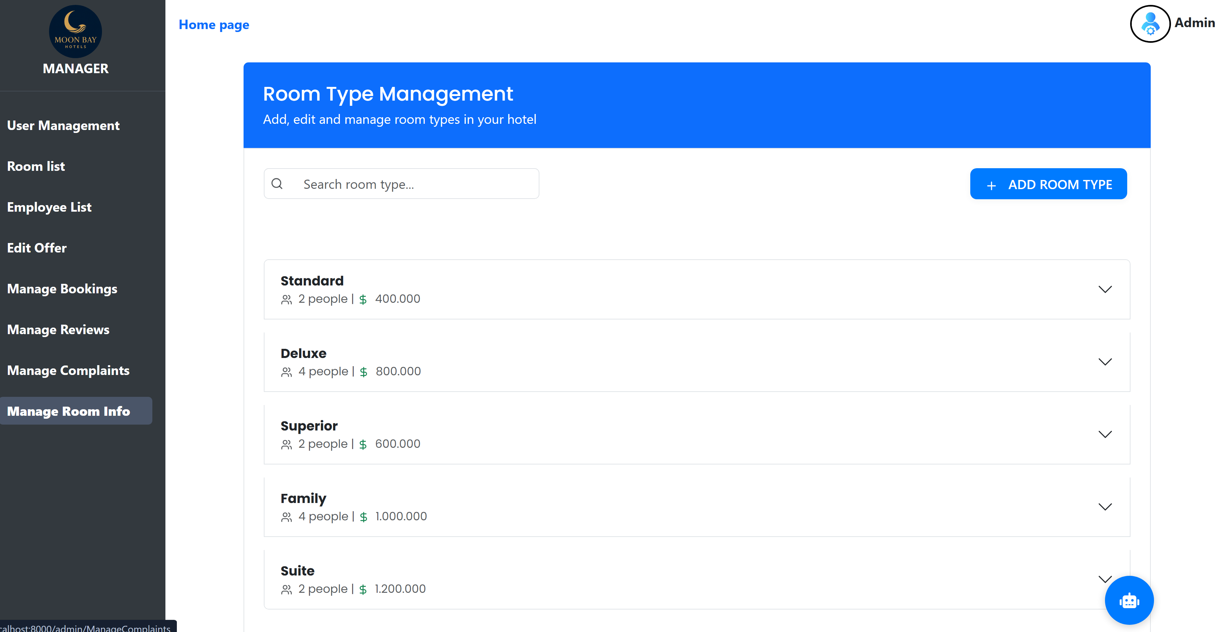

**STAFF**

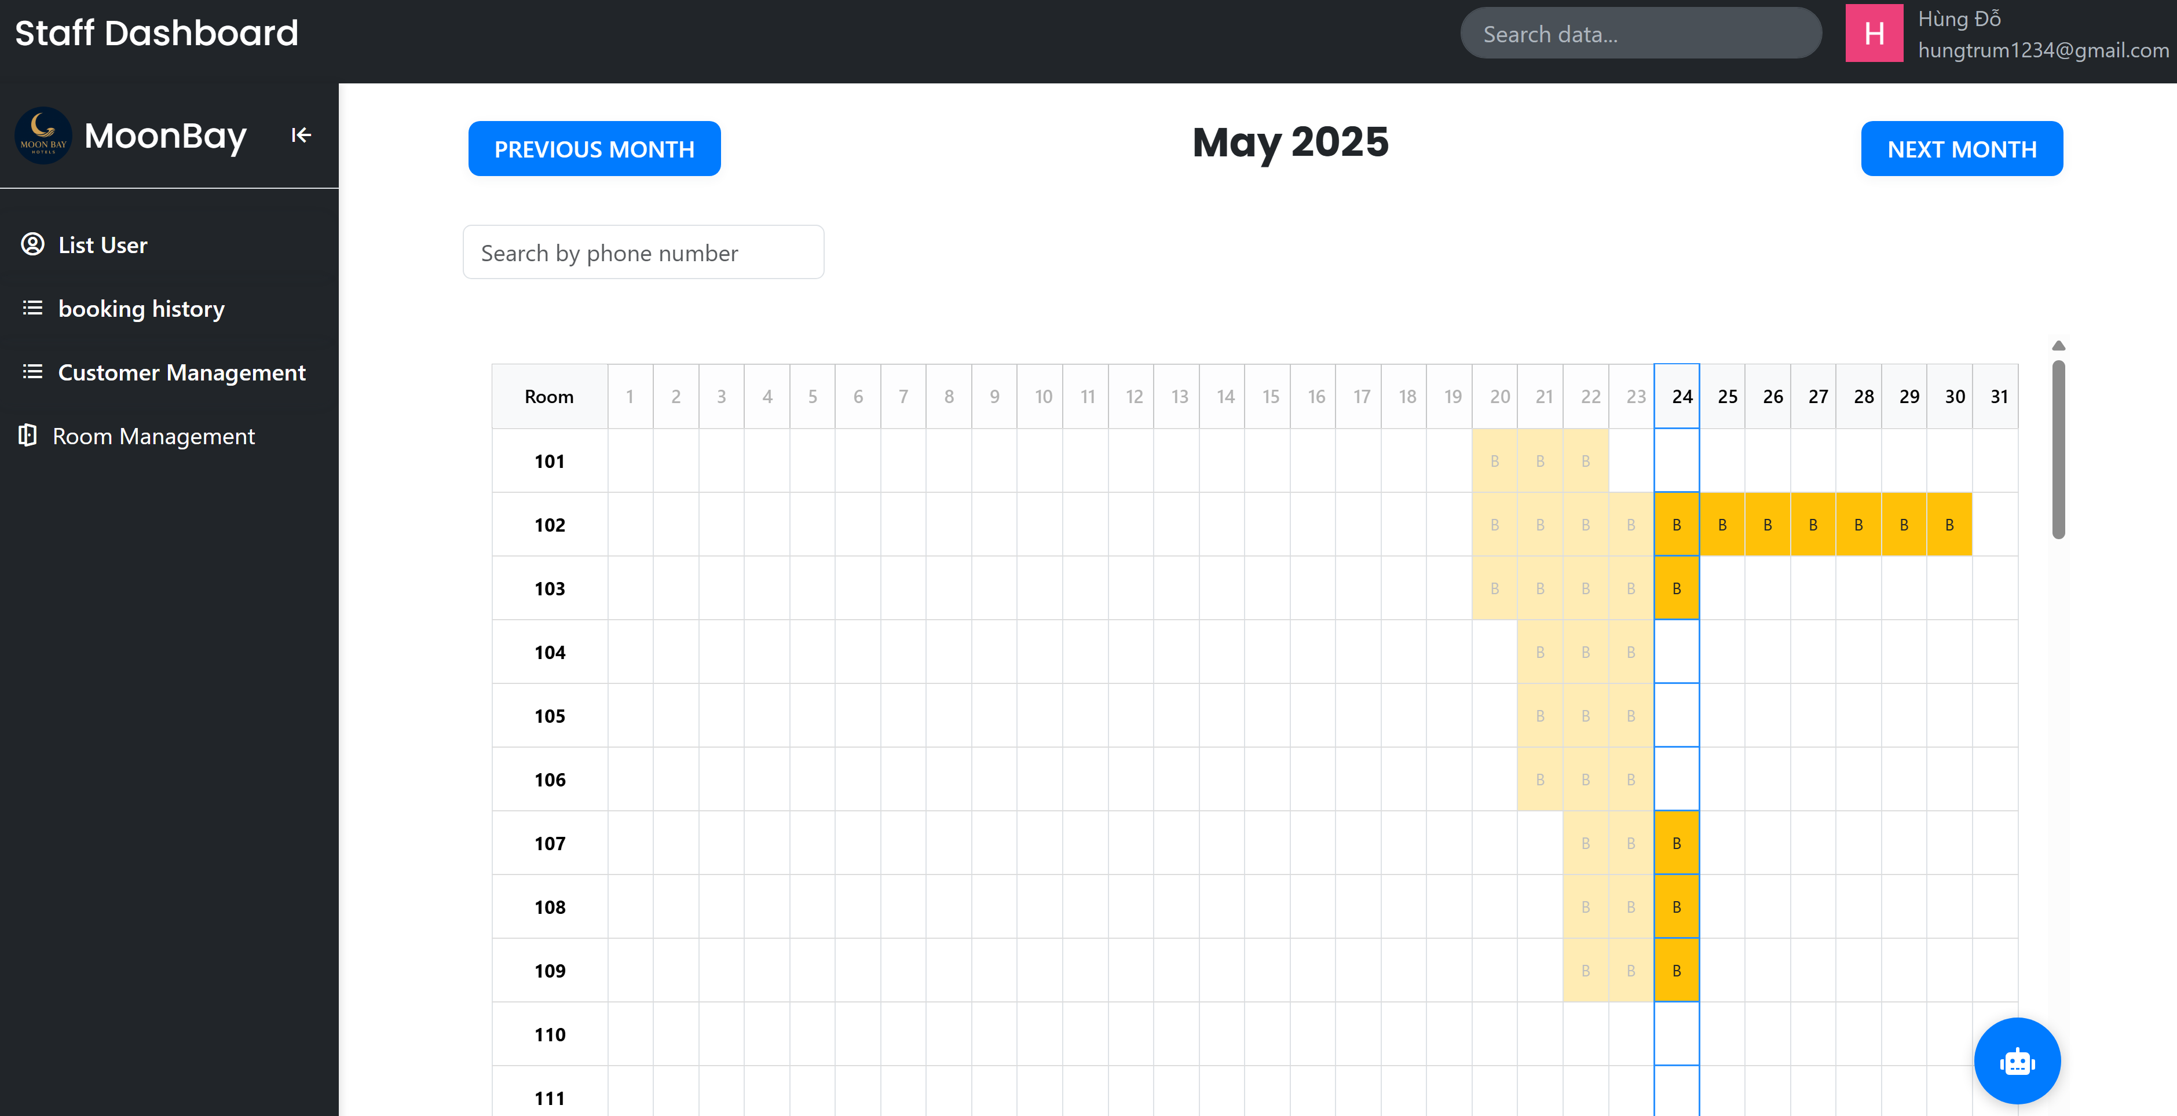

**LIST USER**

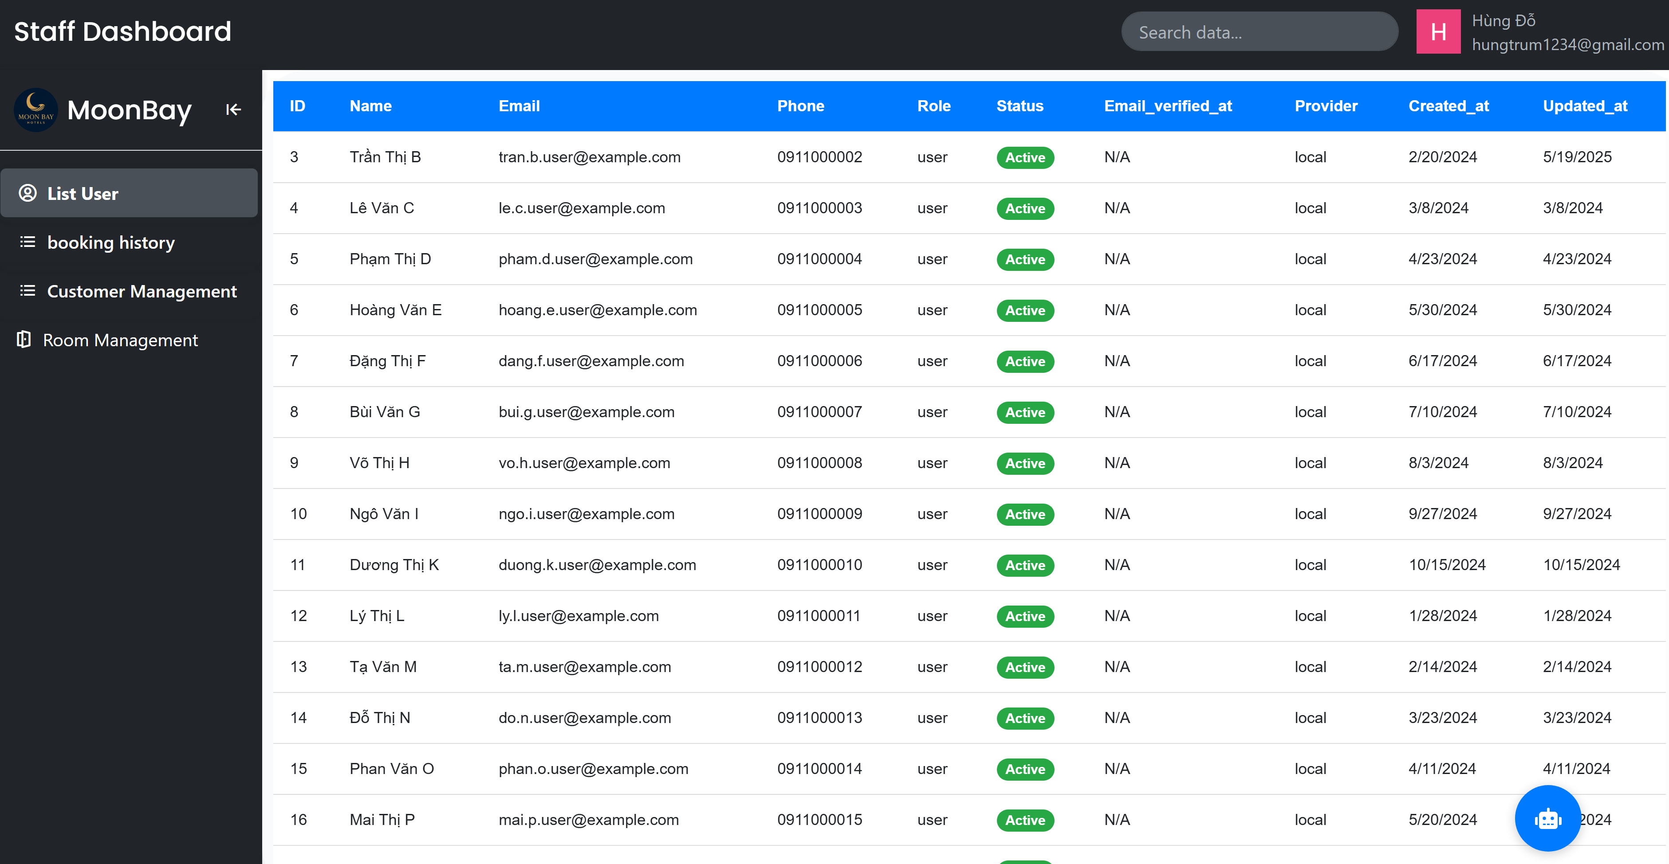

**BOOKING HISTORY**

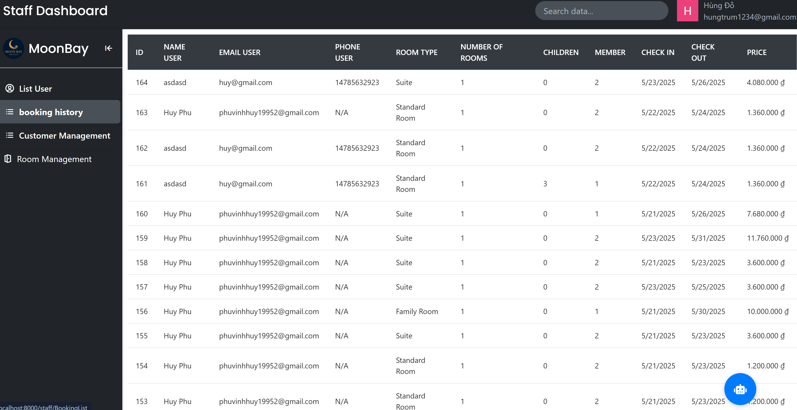

**CUSTOMER MANAGEMENT**

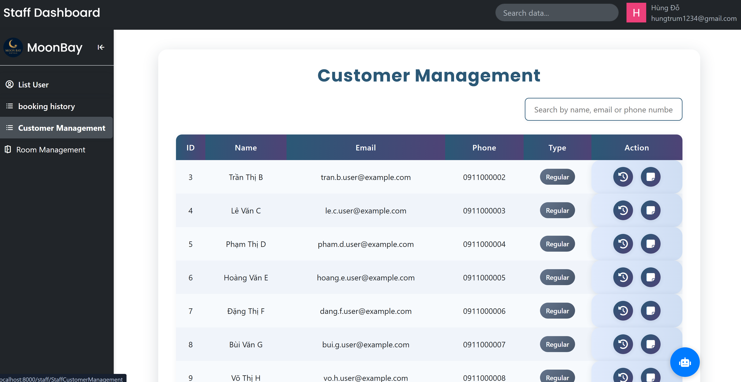

**ROOM MANAGEMENT**

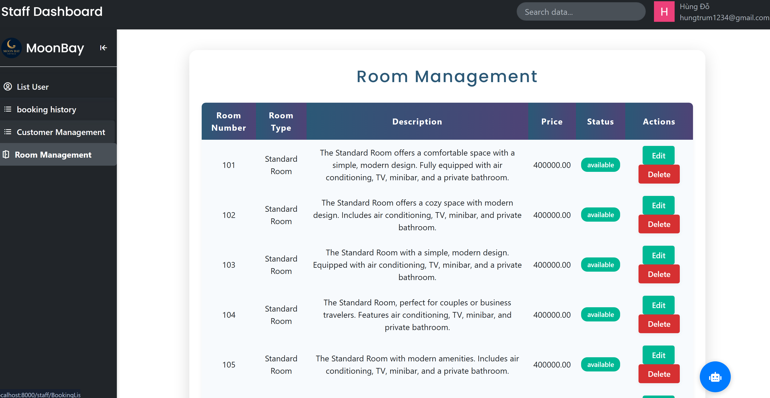

## MOONBAY HOTELS SCREENSHOT

**HOME PAGE**

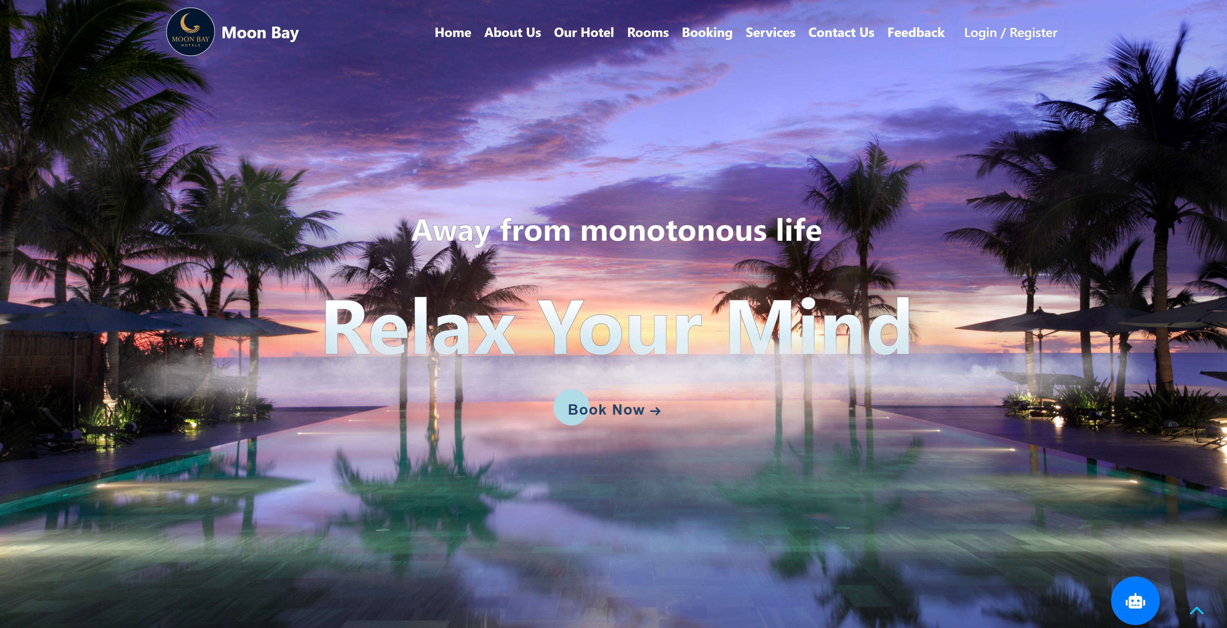

**REGISTER PAGE**

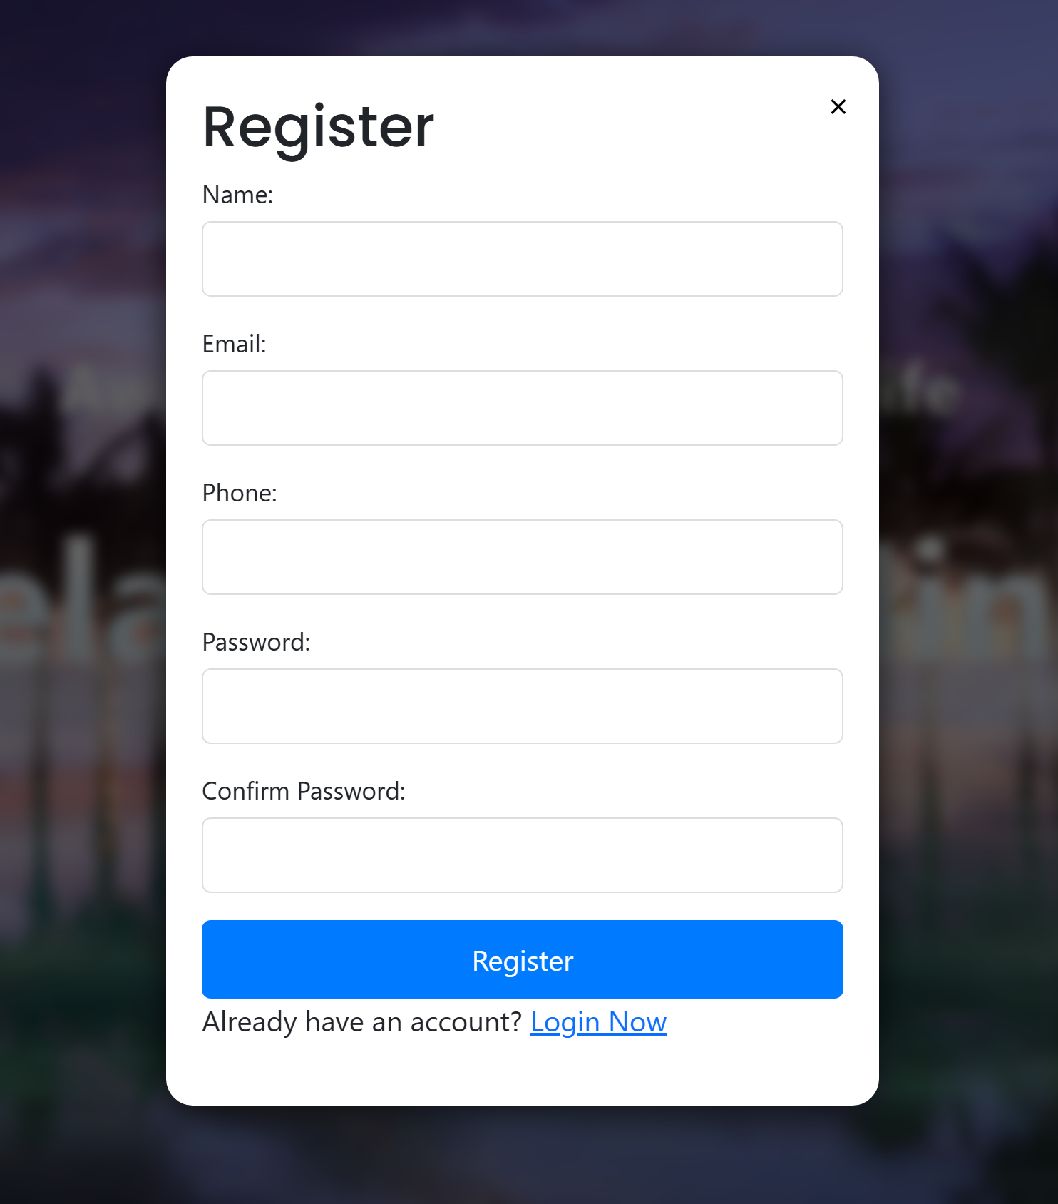

**LOGIN PAGE**

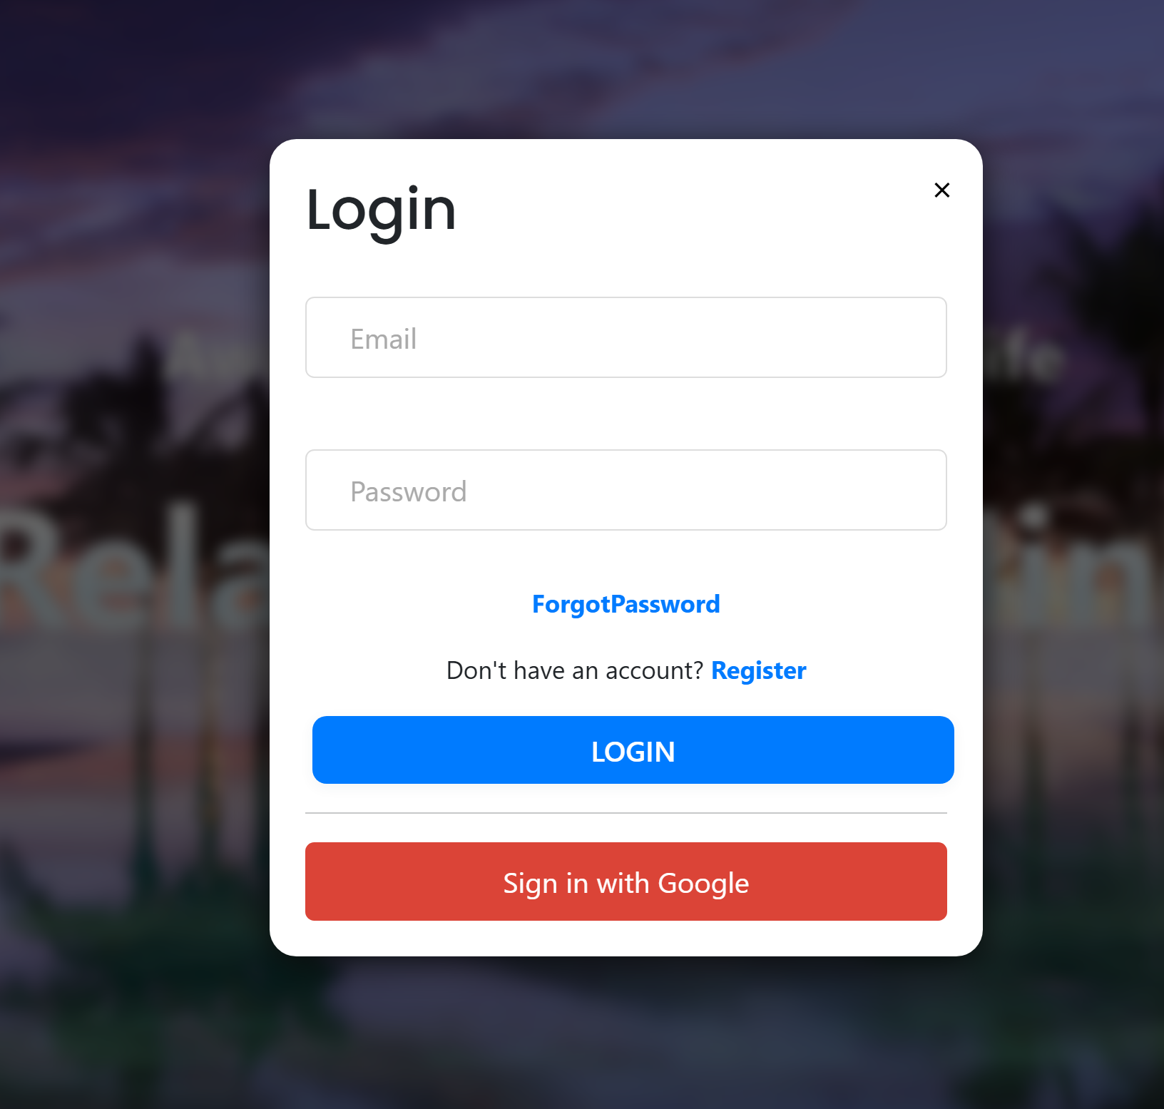

**ABOUT US**

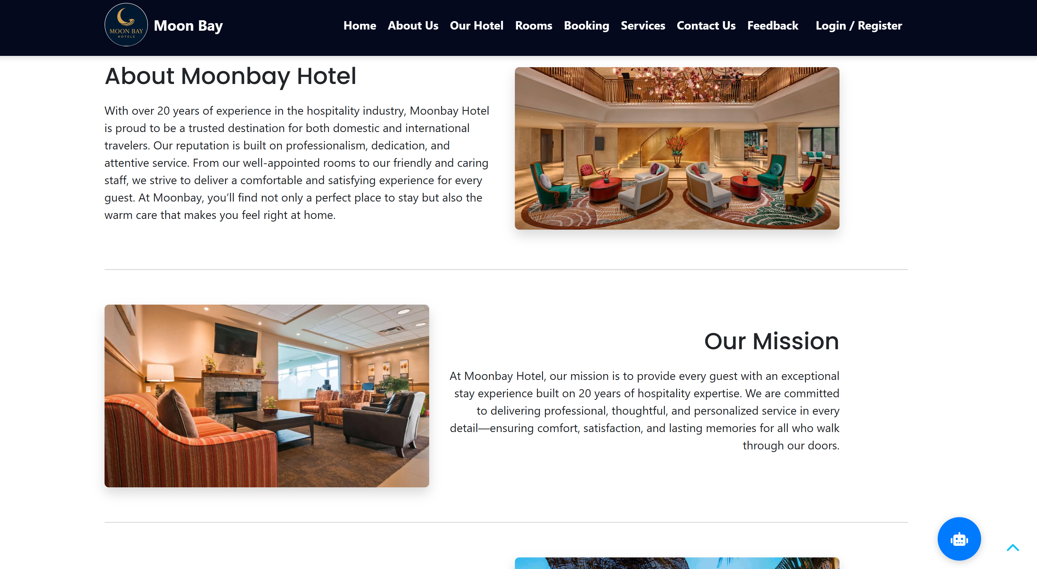

**OUR HOTEL**

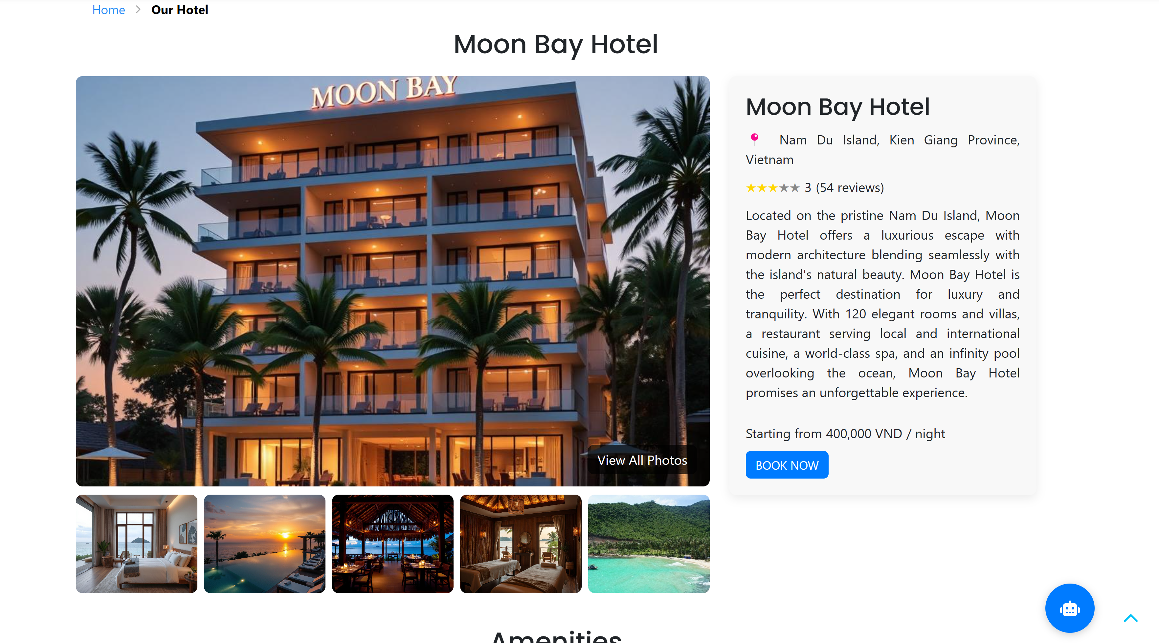

**ROOMS**

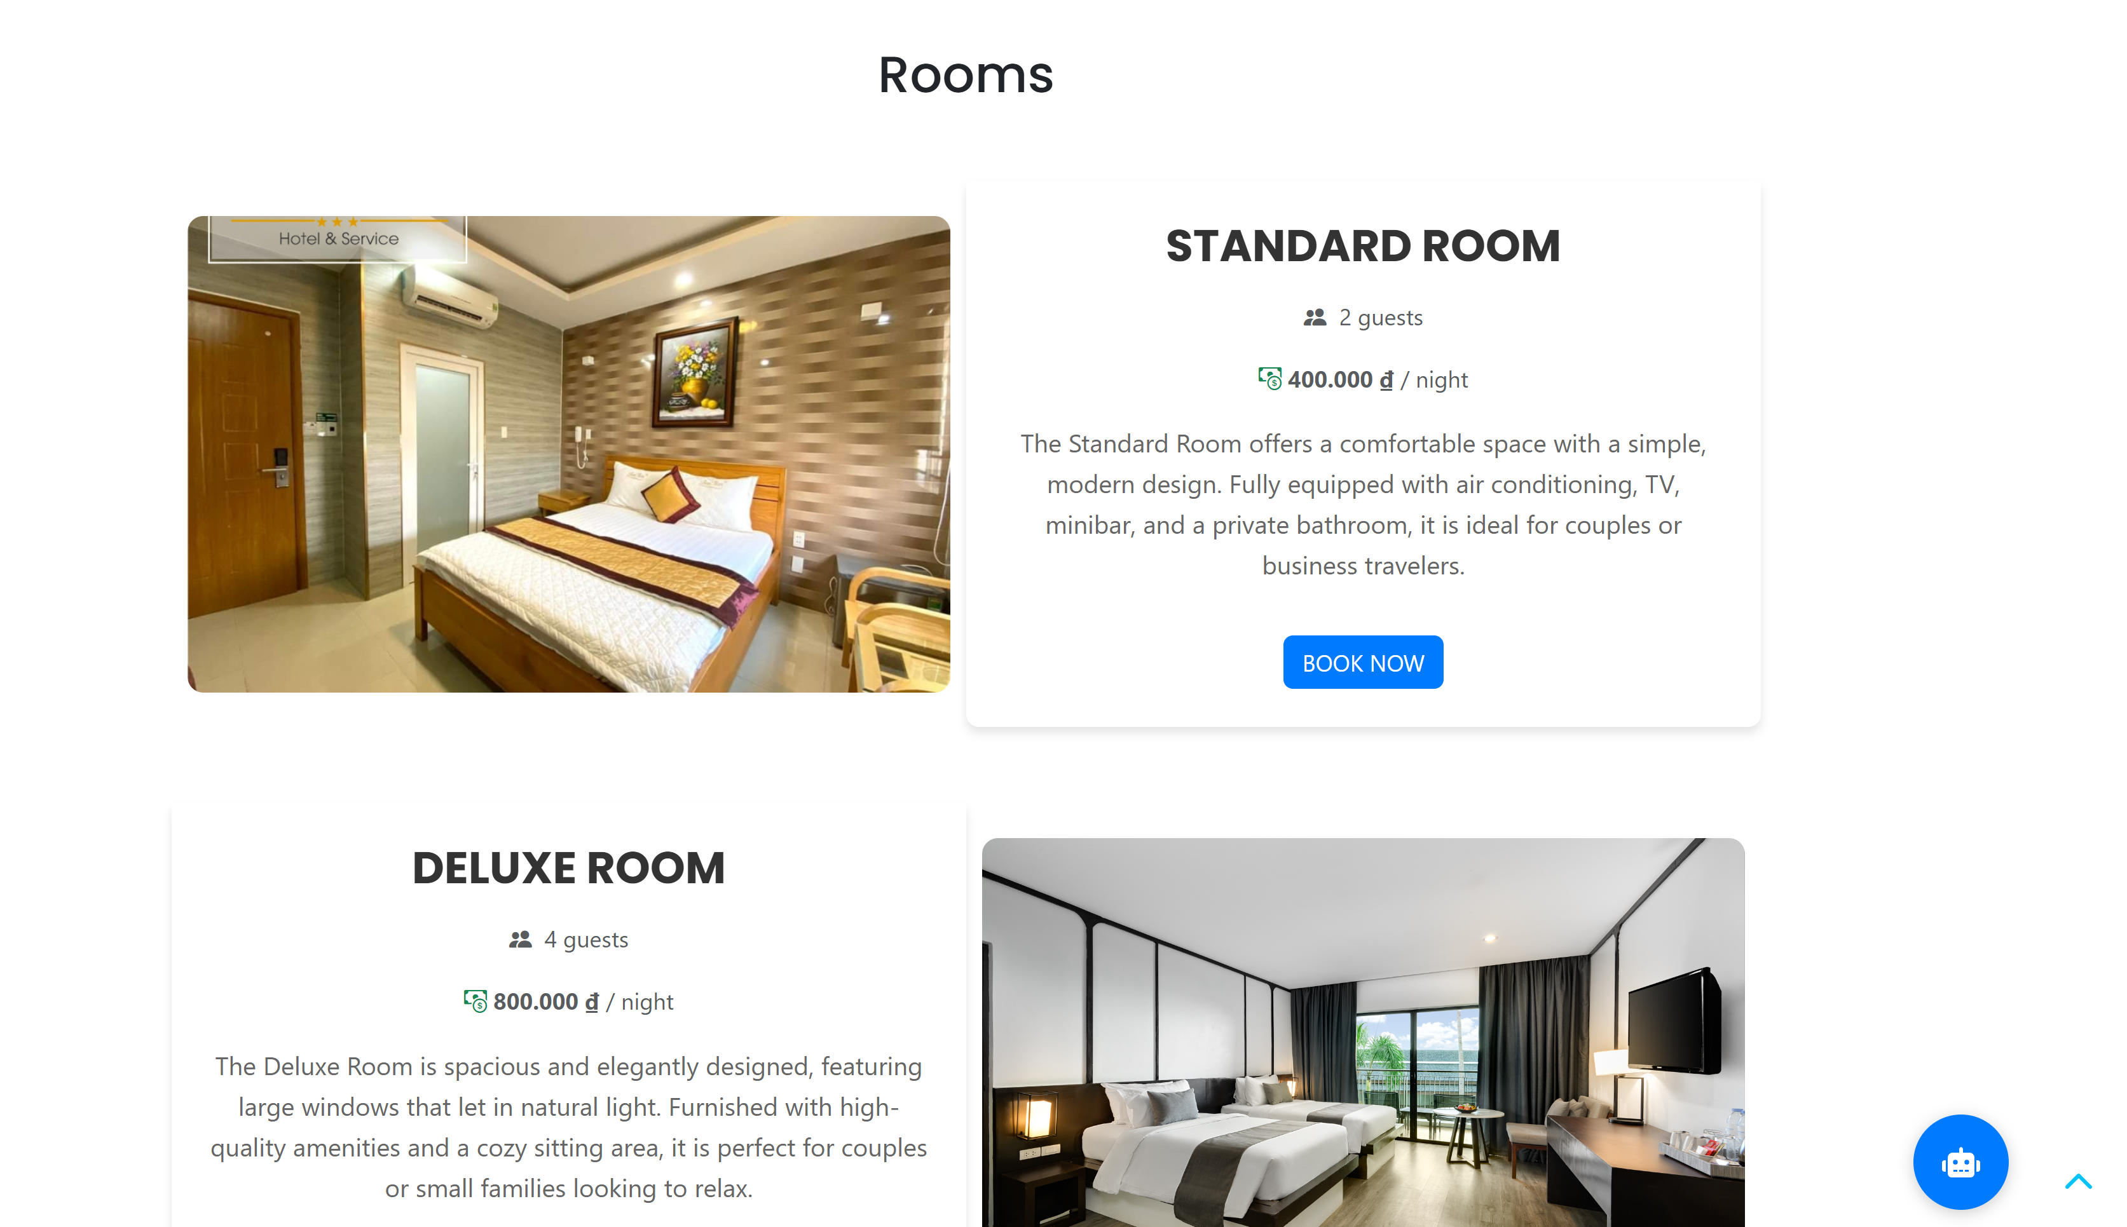

**BOOKING**

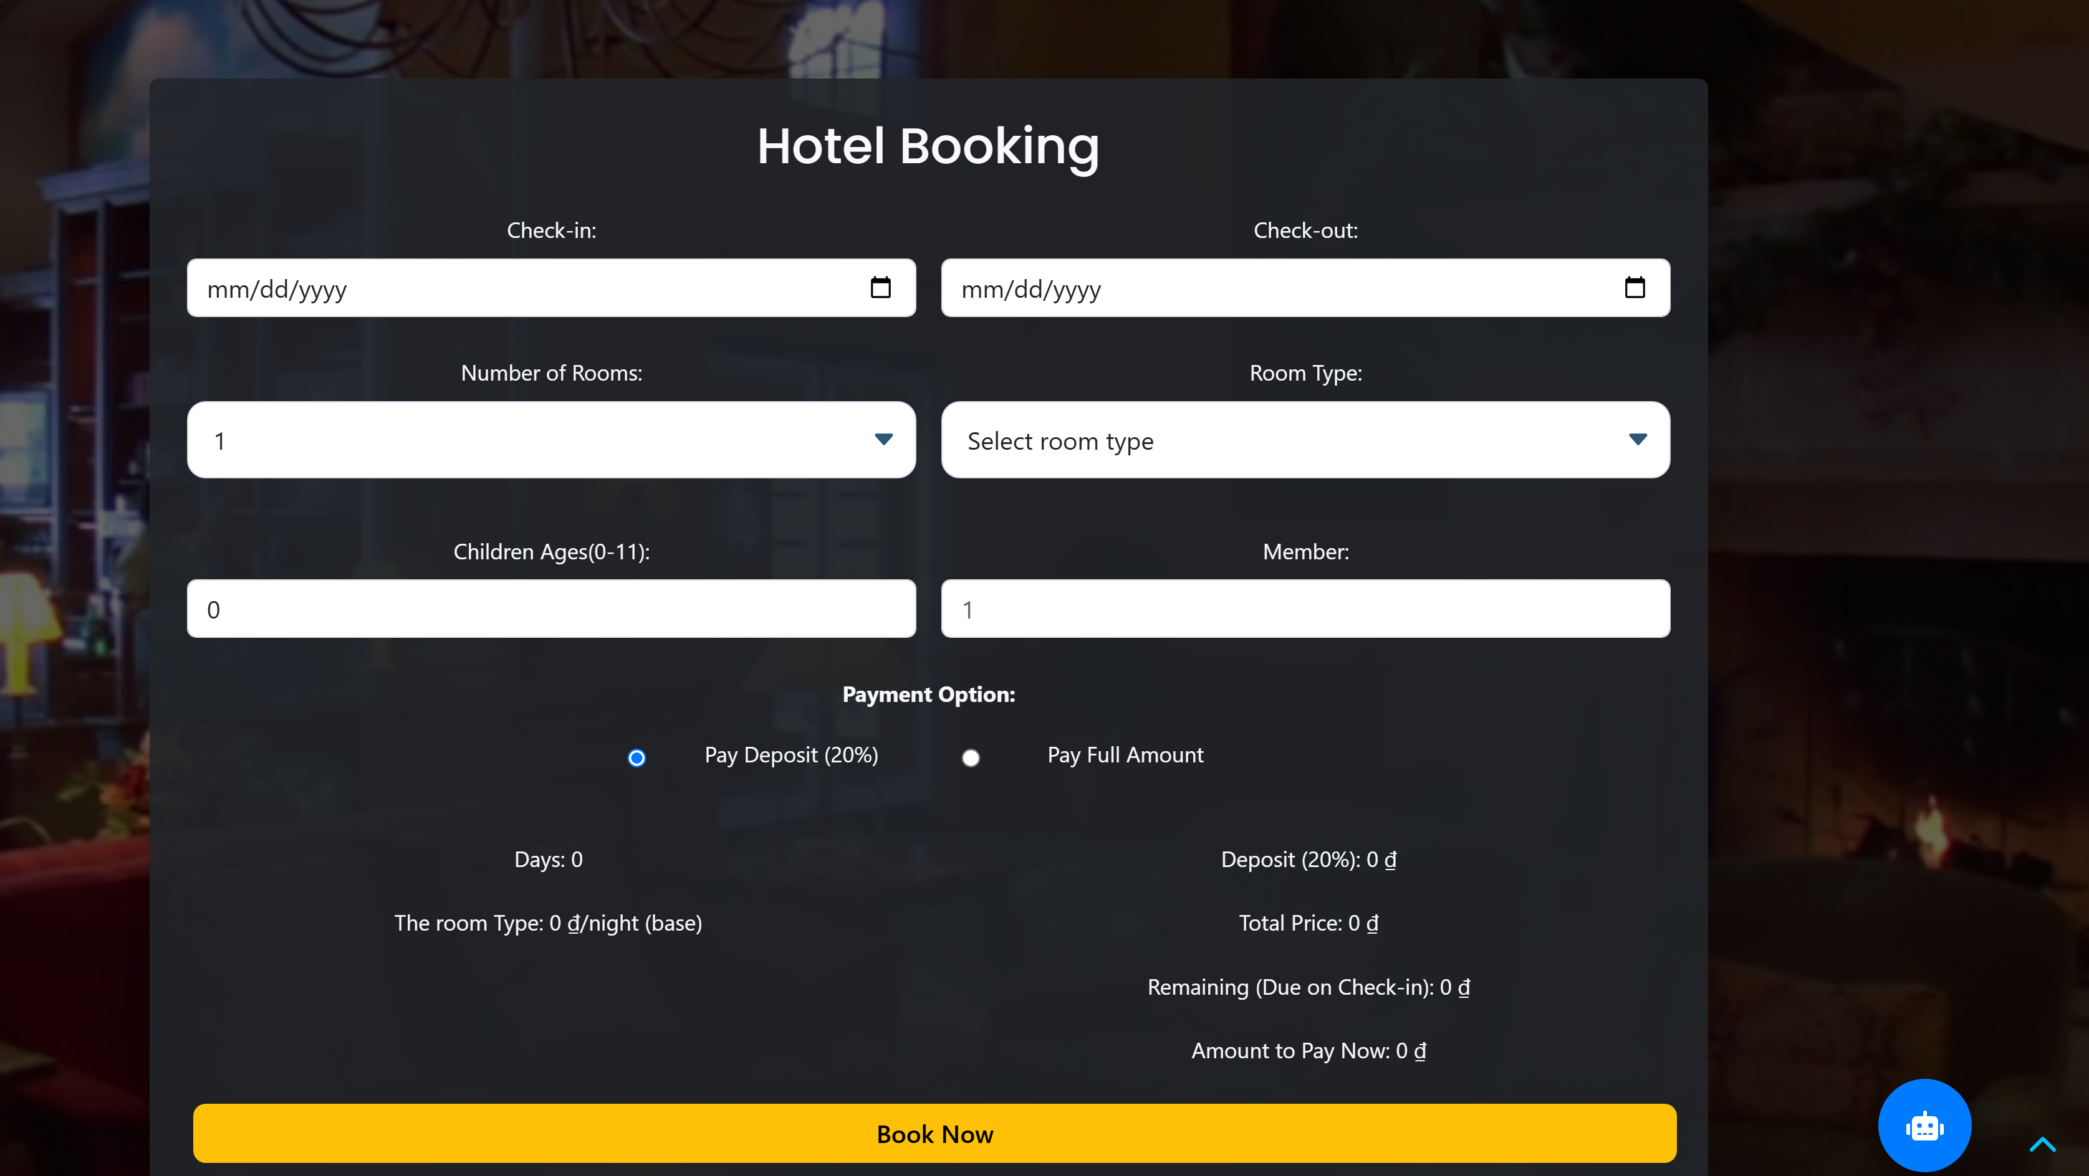

**SERVICE**

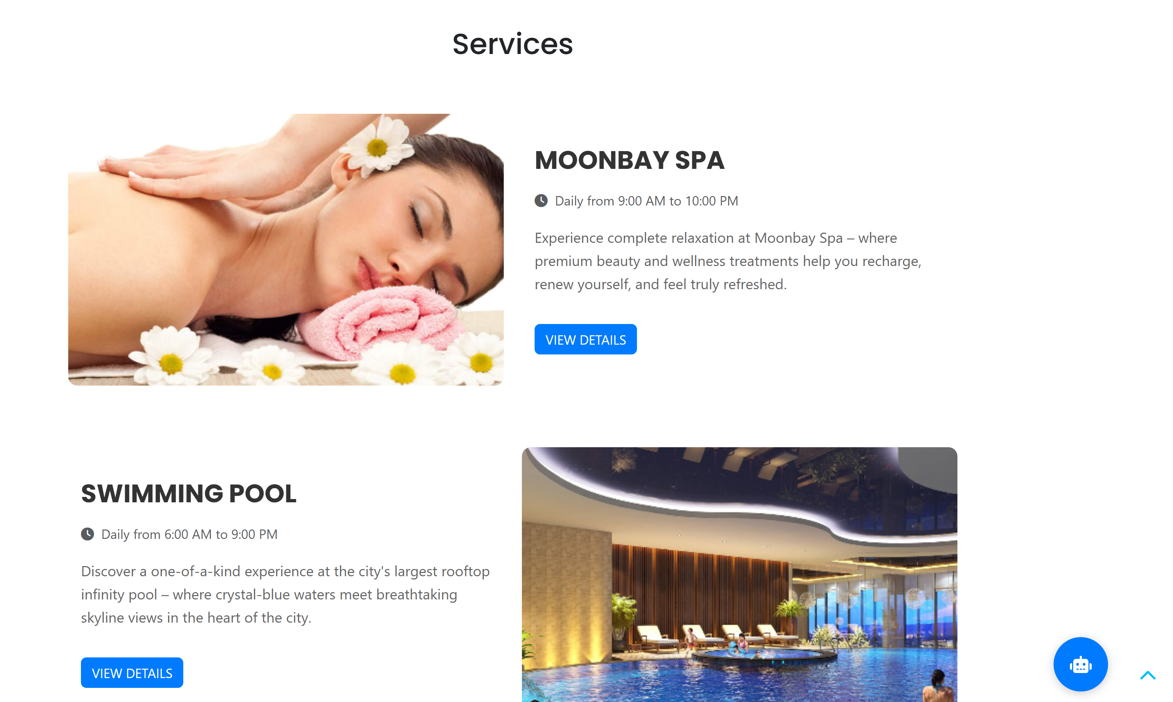

**CONTACT US**

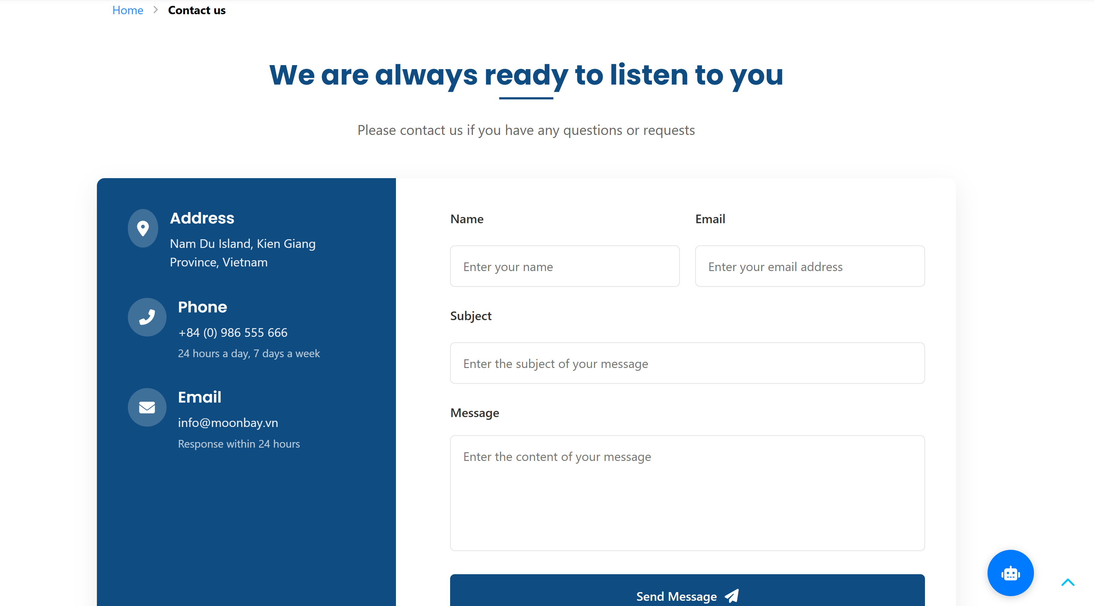

**REVIEWS**

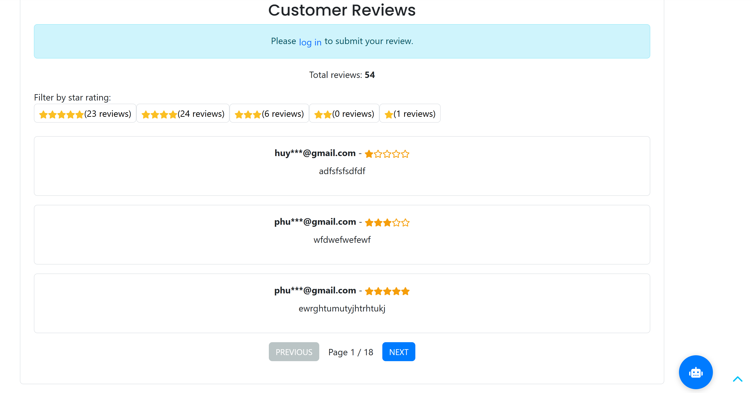

**COMPLAINTS**

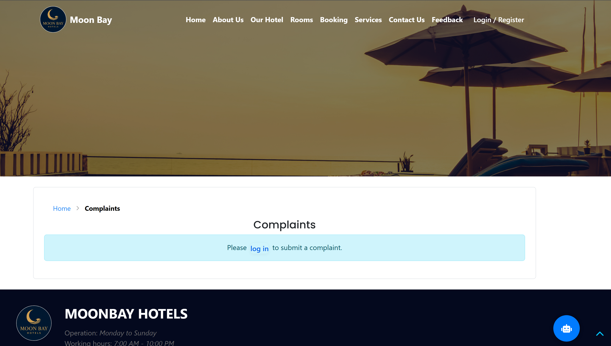

**FORGET PASSWORD**

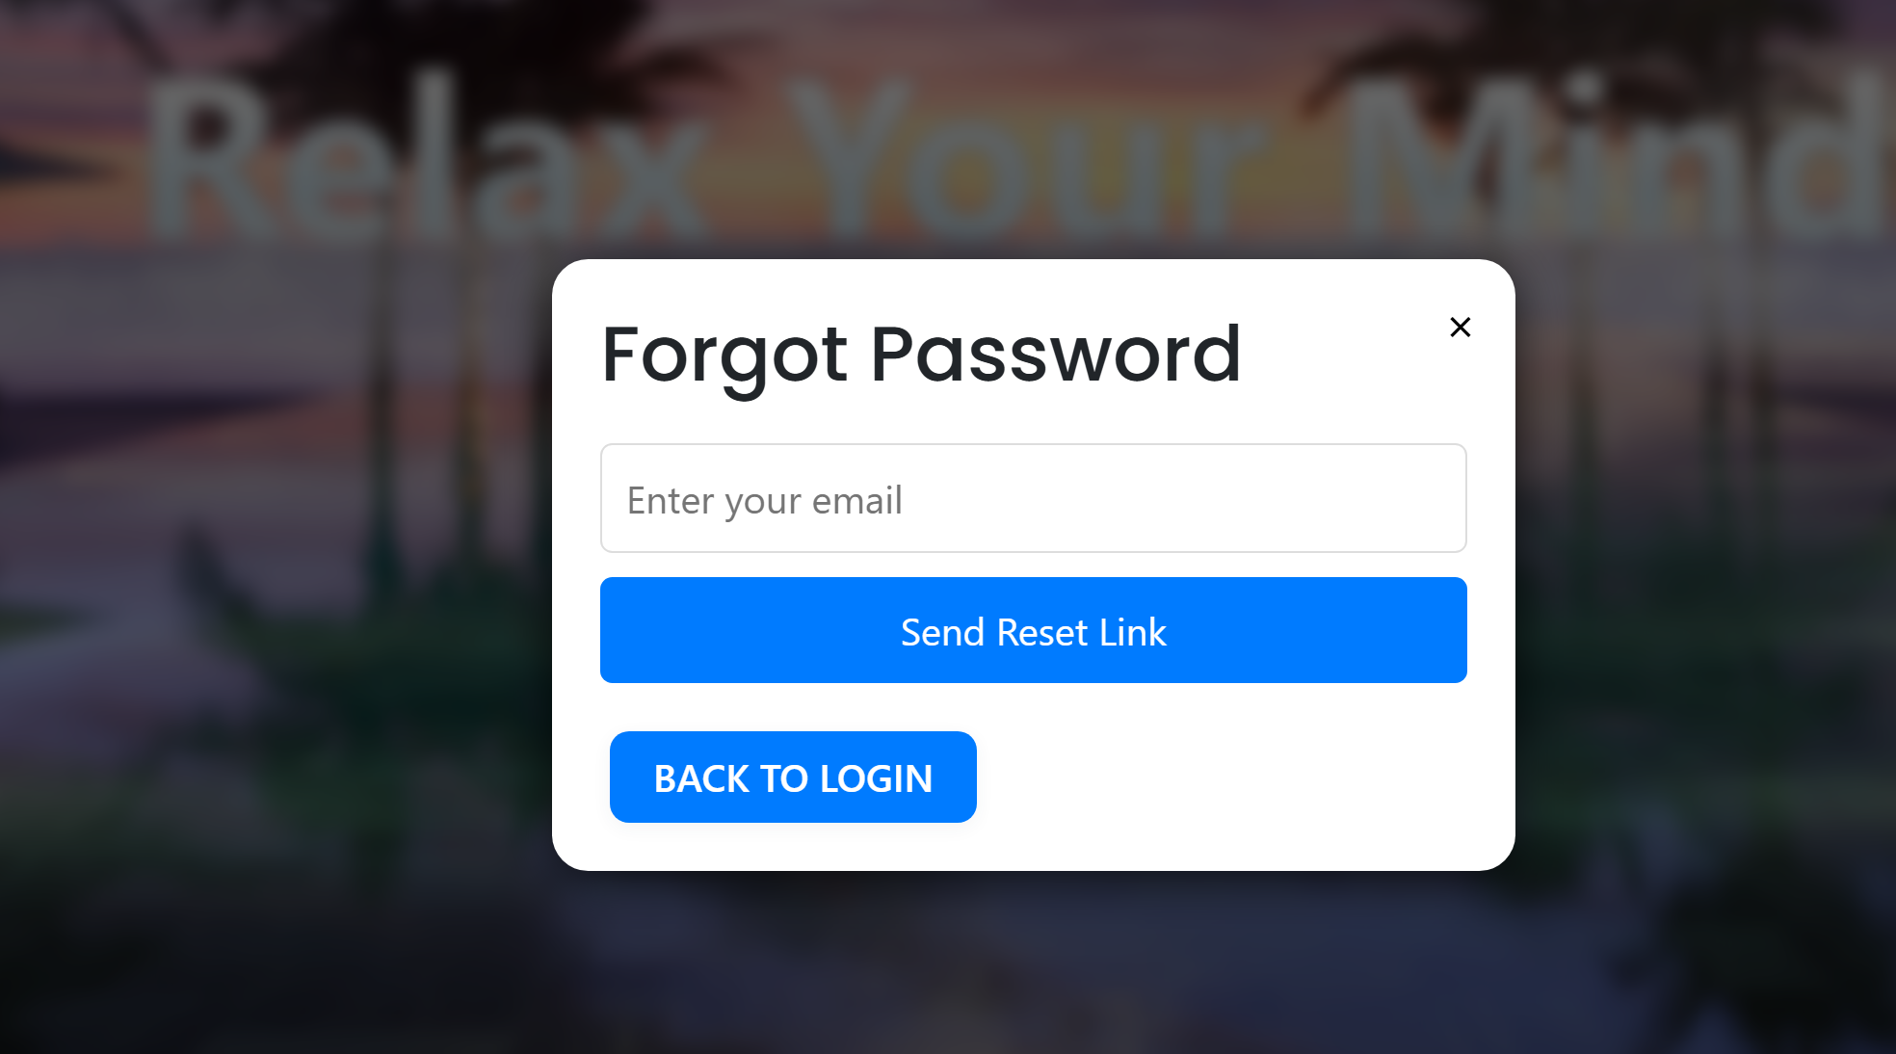

## TASK SHEET REVIEW 3

|  |  |  |  |  |  |  |  |
| --- | --- | --- | --- | --- | --- | --- | --- |
| **Project: Moonbay Hotels** | | **Project Name** | **Activity Plan Prepared By** | **Date of Preparation of Activity Plan:** | | | |
| **No** | **Task** | **Actual Start Date** | **Actual Days** | **Team member name** | **Status** |
| **1** | **Database Design** | **Moonbay Hotels** | Hùng | 20-April-25 | 25 | All members | Completed |
| **2** | **Front-end layout** | 27-April-25 | 1 | All members | Completed |
| **3** | **Back-end layout** | 27-April-25 | 1 | All members | Completed |
| **4** | **Admin dashboard** | 20-April-25 | 25 | Hùng/Huy | Completed |
| **5** | **Staff dashboard** | 20-April-25 | 25 | Đạt/Long | Completed |
| **6** | **CRUD – post, post_comment** | 27-April-25 | 3 | Huy/Đạt | Completed |
| **7** | **CRUD – Rooms, Rooms-types, image_room, comment, offer** | 27-April-25 | 3 | Huy/Hùng | Completed |
| **8** | **User Account** | 27-April-25 | 3 | Đạt | Completed |
| **9** | **Admin SendEmail** | 27-April-25 | 3 | Hùng | Completed |
| **10** | **Home page** | 27-April-25 | 1 | Hùng | Completed |
| **11** | **About Us** | 27-April-25 | 1 | Hùng | Completed |

|  |  |  |  |  |  |  |  |
| --- | --- | --- | --- | --- | --- | --- | --- |
| **12** | **Our Hotel** |  |  | 27-April-25 | 1 | Huy | Completed |
| **13** | **Rooms** | 27-April-25 | 1 | Huy | Completed |
| **14** | **Booking** | 27-April-25 | 1 | Đạt/Huy/Hùng | Completed |
| **15** | **Services** | 27-April-25 | 3 | Long | Completed |
| **16** | **Contact Us** | 27-April-25 | 2 | Long | Completed |
| **17** | **Feedback** | 27-April-25 | 2 | Huy | Completed |
| **18** | **Login/Register** | 27-April-25 | 10 | Đạt | Completed |
| **19** | **CRUD – post, post_complaint** | 27-April-25 | 3 | Huy | Completed |
| **20** | **CRUD staff customer management** | 27-April-25 | 5 | Long | Completed |
| **25** | **UI/UX testing** | 27-April-25 | 30 | Huy/Hùng/Đạt | Completed |
| **26** | **Music Video Promotion** | 27-April-25 | 3 | Đạt | Completed |
| **27** | **Images Searching** | 27-April-25 | 3 | Long | Completed |
| **Date: 27 May 2025** | | | | | | | |
| **Signature of Instructor:**  **Ms. Le Mong Thuy** | | | | **Signature of Team Leader:**  **ĐỖ THANH HÙNG** | | | |